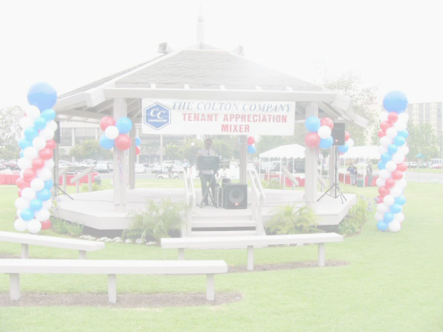

**Business Name**

**Event Planning**

*Follow this Event Planning Template to Make your Upcoming Event More Organized…..*

**Company Mission:**

-----------------------------------------------------------------------------------------------------------------------------------------------------------------------------------------------------------------------------------------------------------------------------------------------

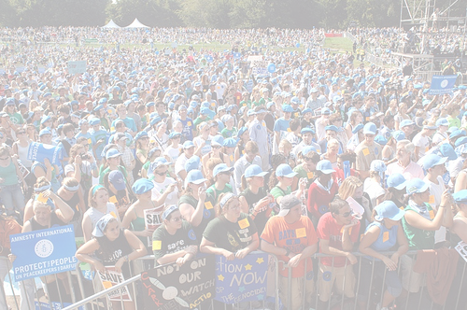

**Brief About Plan:**

------------------------------------------------------------------------------------------------------------------------------------------------------------------------------------------------------------------------------------------------------------------------------------------------------------------------------------------------------------------------------------------------------------------------------------------------------------------------------------------------------------------------------------------------------------------------------------------------------------------------------------------------------------------------------------------------------------------------------------------------------------------------------------------------------------------------------------------------------------------------------------------------------------------------



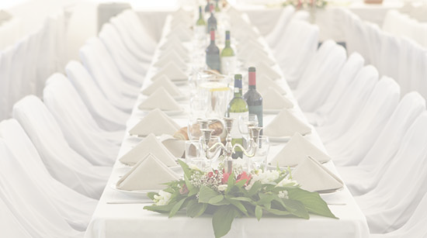

**Company Address**

**Phone: 123-456-1323456**

**City, State, Zip Code**

**Event Planning Template**

|  |  |  |
| --- | --- | --- |
| **Event’s Name** |  | |
| **Event’s Date** |  | |
| **Event’s Time** |  | |
| **Location** |  | |
| **Event coordinator/contact person** | |  |
| **About Target Audience:**  *Set Your Questions in this box and give answer in the box to right side.* | | |
| **Message To Be Communicated**  *Set questions about the message to be sent according to nature of event and think answers.* | | |
| **Objectives of Organizing the Event**  *Be clear about what you hope to achieve with this event.* | | |
| **Description of event** | | |
| **Risk assessment**  Identify possible risks and make sure to develop strategies to minimize risks. | | |
| **Evaluation criteria established**  *Set criteria for establishment and make sure that rest of event plan and arrangements are made according to the set criteria. Make a list of question about criteria in this section of the plan.* | | |
| **Checklist**  *Make a checklist of all equipments and special arrangements to be made and ensure that you have made all necessary arrangements before time. You can build this checklist either in tabular form or in sentence style.* | | |

**Event Planning Template**

|  |  |  |  |
| --- | --- | --- | --- |
| **Event Planning Before Time** | **Who Will Do What?** | **Actions Required** | **Completion Date** |
| **Budget Planning**  *Plan out all expenses and prepare a budget by mentioning all expenses here.* |  |  |  |
| **Set of Rules**  *Outline all rules and regulations for the smooth ongoing of event. State what protocol is to be given, by whom and how and when in the columns.* |  |  |  |
| **Invitations**  *This section of event plan will include detailed information about sending invitations tasks that is the most important task in event planning. Make sure to state information about who will design and send invitations, how invitations will be sent and at what exact time invitation is to be sent.* |  |  |  |

**Event Planning Template**

|  |  |  |  |
| --- | --- | --- | --- |
| **Event Planning Before Time** | **Who Will Do What?** | **Actions Required** | **Completion Date** |
| **Plan to Advertise**  *State what means will be used to advertise the event to get the expected gathering. Make sure to state who will act for advertisements, what actions will be taken and at what time.* |  |  |  |
| **Talent**  Book and brief  Rehearsals |  |  |  |
| **Signage**  *Provide Necessary information in this section of event plan.* |  |  |  |
| **Activities for Program**  *Make outlines for what will happen in the event, who person will perform, how to perform and exact time for each performance. Set separate time for making rehearsals for the program.* |  |  |  |
| **Value added for guests**  *How you will give value to all esteemed guests will be mentioned in this section of plan. What you can do for this is the main point of discussion.* |  |  |  |

**Event Planning Template**

|  |  |  |  |
| --- | --- | --- | --- |
| **Event Planning Before Time** | **Who Will Do What?** | **Actions Required** | **Completion Date** |
| **Security**  *Security is the issue that can never be compromised with while planning for any event either social gathering or business event.* |  |  |  |
| **Musical Arrangements**  *Plan to make all musical arrangements according to theme of event by collecting CDs, DVDs and music system in time and making list of songs to be played during the event.* |  |  |  |
| **Assistant Staff Members**  *Access your staffing needs and if you want assistant staff then make sure to arrange your staff before time and provide them instructions accordingly.* |  |  |  |
| **Cleaning and Proper Keeping**  *State duties of cleaning staff to ensure cleanliness during entire event.* |  |  |  |
| **Atmosphere**  *What look you want to give to the event atmosphere will be planned in this section of event plan.* |  |  |  |
| **Once the Event is Over**  Don’t forget to fulfill after event formalities like sending thank you note to all guests for joining you or presenting event favors etc. |  |  |  |

**Event Planning Template**