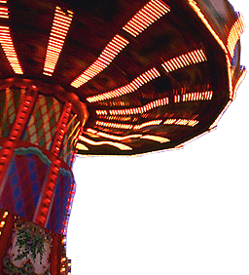

**Event Ticket**

CELEBRATING 100 YEARS OF ART FAIR

Ticket No. 000012

Good for one admission only

**NO REFUNDS**

CELEBRATING 100 YEARS OF ART FAIR

Ticket No. 000012

Good for one admission only

**NO REFUNDS**

CELEBRATING 100 YEARS OF ART FAIR

Ticket No. 000012

Good for one admission only

**NO REFUNDS**