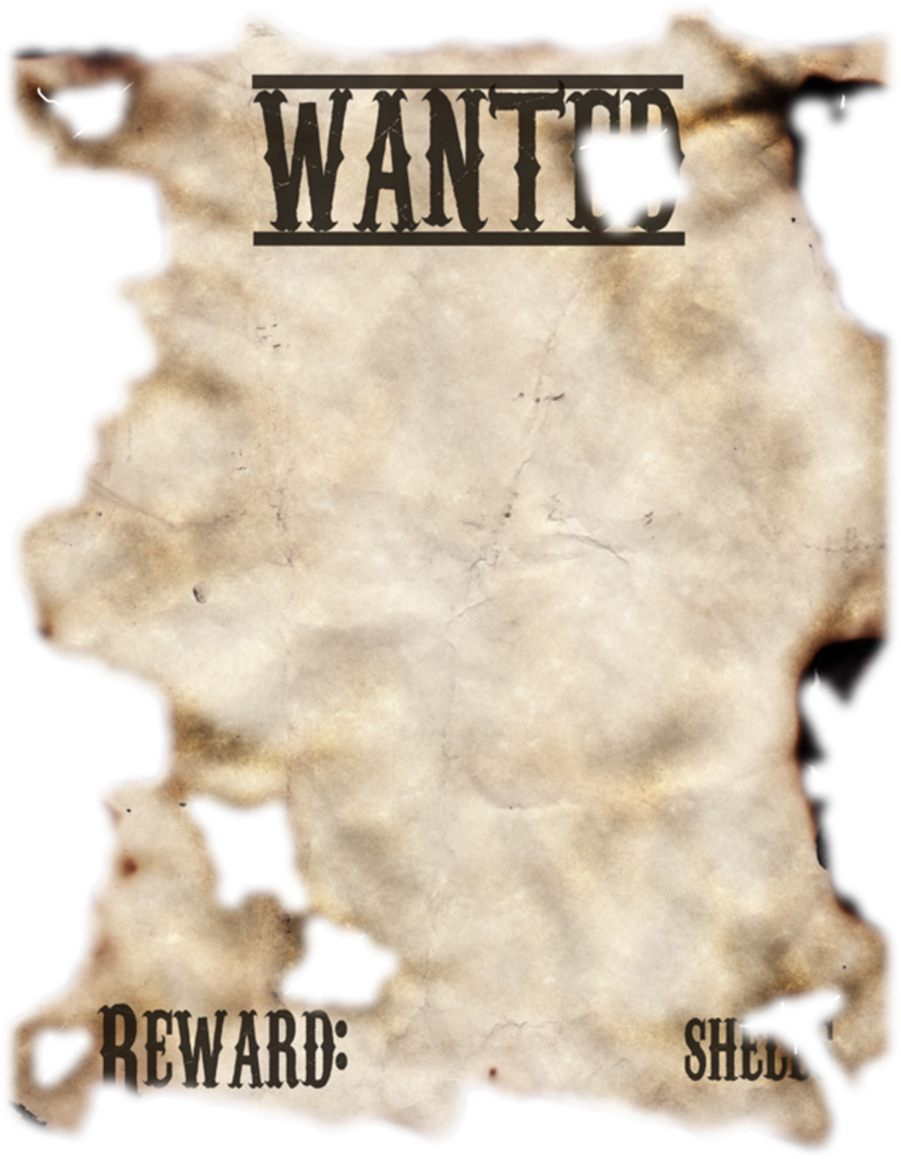

REWARD $0,00,000

PLEASE CONTACT ON CALLING NUMBERS

111-111-01234