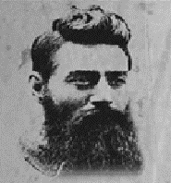

ADDRESS LINE 1 ADDRESS LINE 2  
STREET NO, CITY STATE ZIP  
COUNTRY NAME

*PLEASE CONTACT ON CALLING NUMBERS*

**111-111-01234 OR 555-555-55555**

Last seen Saturday Noon

**__ Day of ___ Month of 20__**

PERSON’S NAME

WANTED