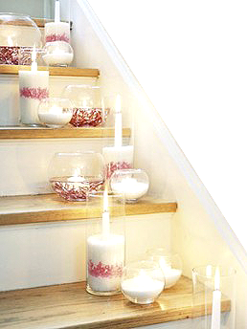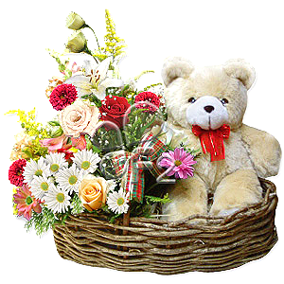

I may not be your side…..

Celebrating your special day with you….

But I want you to know that I’m thinking of you…

& wishing you a wonderful

**Anniversary**!