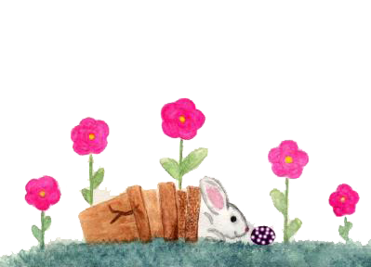

I wish you

EASTER

GREETING

**HAPPY EASTER!**