1111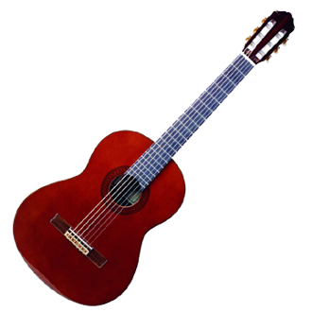1

1-888-667-4433    4 Tickets

*Band Flyer Template*

Event Location: _________________________

Date: _________________________________

Time: _________________________________

