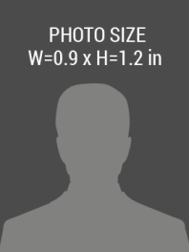barcode.png

**123 Anywhere Street, City, 0000+1 000 888 1111**

02/02/2018

EXPIRIES

02/02/2017

ISSUE

DESIGNATION

First Name, Last Name

**COMPANY NAME**