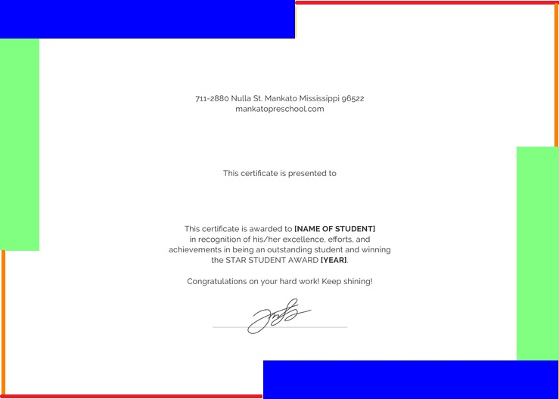

**Candidate Name Here**

**Internship Certificate**

**Company Name Here**