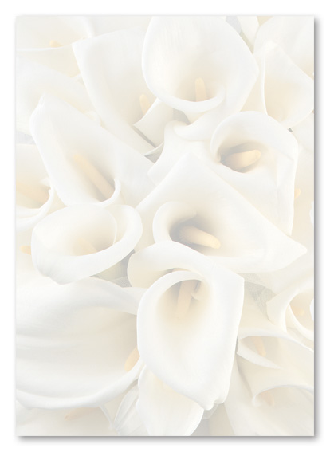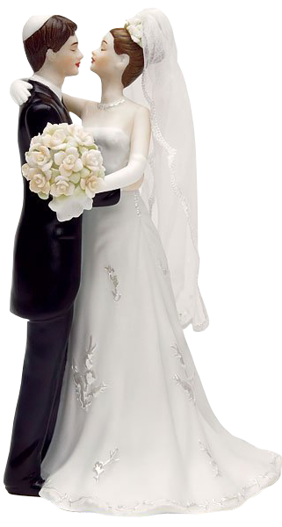

**To Liza….**

**Wedding Card Template**

Showers of Blessings and Lots of Wishes for You

You are Wished to Have a

Happy Wedded Life

**From ______**

Happy Wedded Life