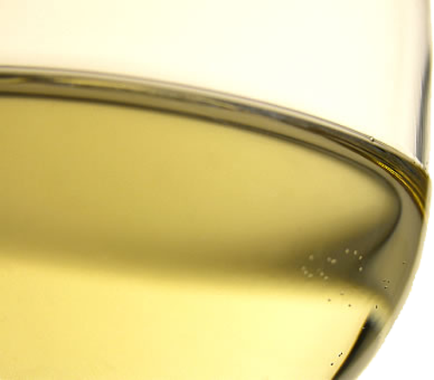
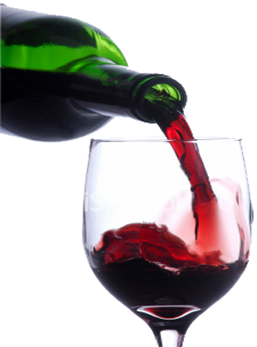
BAN FRANSISCO BRONICLE
WINE LABEL TEMPLATE
2016
PUBLIC TASTING
FORT MASON – SAN FRANSISCO
NOVEMBER 15 – 2 TO 5 PM
Presented by:

LARGEST COMPETITION OF AMERICAN WINES IN THE WORLD
FOR INFORMATION AND TICKETS, VISIT www.example.com
Wine Label Template

