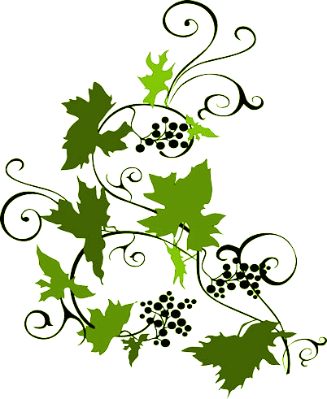

**TRALSEN**

Vineyards

2005

Sonoma Couty

**ZINFANDEL**

Produced and bottles by:

Tralsen vineyards, Calistoga, CA, U.S.A.

Bonded Winery #48900, ALCOHOL 12% by Volume

**TRALSEN**

Vineyards

2005

Sonoma Couty

**ZINFANDEL**

Produced and bottles by:

Tralsen vineyards, Calistoga, CA, U.S.A.

Bonded Winery #48900, ALCOHOL 12% by Volume

**TRALSEN**

Vineyards

2005

Sonoma Couty

**ZINFANDEL**

Produced and bottles by:

Tralsen vineyards, Calistoga, CA, U.S.A.

Bonded Winery #48900, ALCOHOL 12% by Volume

**TRALSEN**

Vineyards

2005

Sonoma Couty

**ZINFANDEL**

Produced and bottles by:

Tralsen vineyards, Calistoga, CA, U.S.A.

Bonded Winery #48900, ALCOHOL 12% by Volume