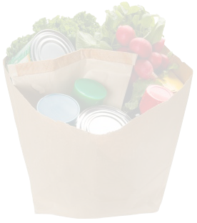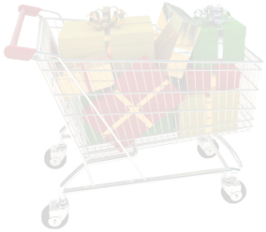

**Free Grocery List Template**

**Home Grocery List**

**Important Notes:** ________________________________________ _____________________________________________________________________________________________________________________________________________________________________

|  |  |
| --- | --- |
| **Misc.** | |
| **Item Name** | **Quantity** |
|  |  |
|  |  |
|  |  |
|  |  |
|  |  |
|  |  |
|  |  |
|  |  |
|  |  |
|  |  |
|  |  |
|  |  |
|  |  |
|  |  |

|  |  |
| --- | --- |
| **Snacks** | |
| **Item Name** | **Quantity** |
|  |  |
|  |  |
|  |  |
|  |  |
|  |  |
|  |  |
|  |  |
|  |  |
|  |  |

|  |  |
| --- | --- |
| **Vegetables** | |
| **Item Name** | **Quantity** |
|  |  |
|  |  |
|  |  |
|  |  |
|  |  |
|  |  |
|  |  |
|  |  |
|  |  |

|  |  |
| --- | --- |
| **Produce** | |
| **Item Name** | **Quantity** |
|  |  |
|  |  |
|  |  |
|  |  |
|  |  |
|  |  |
|  |  |
|  |  |
|  |  |

|  |  |
| --- | --- |
| **Cleaning Products** | |
| **Item Name** | **Quantity** |
|  |  |
|  |  |
|  |  |
|  |  |
|  |  |
|  |  |
|  |  |
|  |  |
|  |  |

|  |  |
| --- | --- |
| **Meats** | |
| **Item Name** | **Quantity** |
|  |  |
|  |  |
|  |  |
|  |  |
|  |  |
|  |  |
|  |  |
|  |  |
|  |  |

|  |  |
| --- | --- |
| **Canned/Dry** | |
| **Item Name** | **Quantity** |
|  |  |
|  |  |
|  |  |
|  |  |
|  |  |
|  |  |
|  |  |
|  |  |
|  |  |

|  |  |
| --- | --- |
| **Frozen Food Items** | |
| **Item Name** | **Quantity** |
|  |  |
|  |  |
|  |  |
|  |  |
|  |  |
|  |  |
|  |  |
|  |  |
|  |  |

|  |  |
| --- | --- |
| **Dairy** | |
| **Item Name** | **Quantity** |
|  |  |
|  |  |
|  |  |
|  |  |
|  |  |
|  |  |
|  |  |
|  |  |
|  |  |