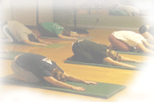

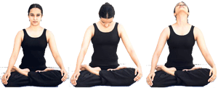
Free Yoga Studio Flyer
Exercise is better for digestion
10 exercise steps do at home
for your fitness and mind relaxation
How yoga boosts brain power. How yoga boosts brain power. How yoga boosts brain power. How yoga boosts brain power. How yoga boosts brain power. How yoga boosts brain power

How yoga boosts brain power. How yoga boosts brain power. Exercise steps do at home for your fitness and mind relaxation. Exercise steps do at home for your fitness and mind relaxation.

