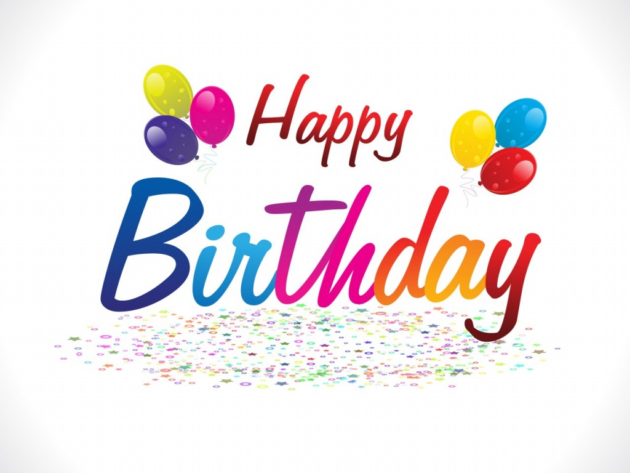 | __________ (Name here)
Birthday girl, today’s your day! Time to eat cake, sing songs, and play! There are so many ways to have birthday fun–Here’s hoping you get to do every one!

Happy, Happy Birthday!
Cordially Yours,
________________
[Type a quote from the document or the summary of an interesting point. You can position the text box anywhere in the document. Use the Text Box Tools tab to change the formatting of the pull quote text box.]

