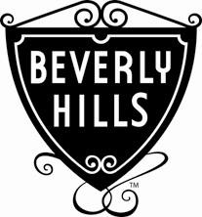
CITY OF BEVERLY HILLS

Office of Emergency Management MEMORANDUM
TO: | Health and Safety Commission
FROM: | Pamela Mottice Muller, Director
DATE: | October 24, 2016
SUBJECT: | Health and Safety Observances

Commemorative observances are used by various governments, groups and organizations to raise awareness of an issue, market a product, commemorate a group or event, or to celebrate something. Commemorative observances could last for a day, week, or month.

For the month of October, the following subjects are observed:

- Health Literacy Month

- Healthy Lung Month

- Breast Cancer Awareness Month

- Crime Prevention Month

- Down Syndrome Awareness Month

- Dwarfism Awareness Month

- Dysautonomia Awareness Month

- Eczema Awareness Month

- Halloween Safety Month

- National Attention Deficit Hyperactive Disorder Awareness Month

- National Bullying Prevention Month

- National Cyber Security Awareness Month

- National Dental Hygiene Month

- National Domestic Violence Awareness Month

- National Fire Prevention Month

- National Pregnancy and Infant Loss Awareness Month

- National Sudden Infant Death Syndrome Awareness Month

- Raynaud’s Awareness Month

- Rett Syndrome Awareness Month

- Selective Mutism Awareness Month

- Spina Bifida Awareness Month

2 of 2

