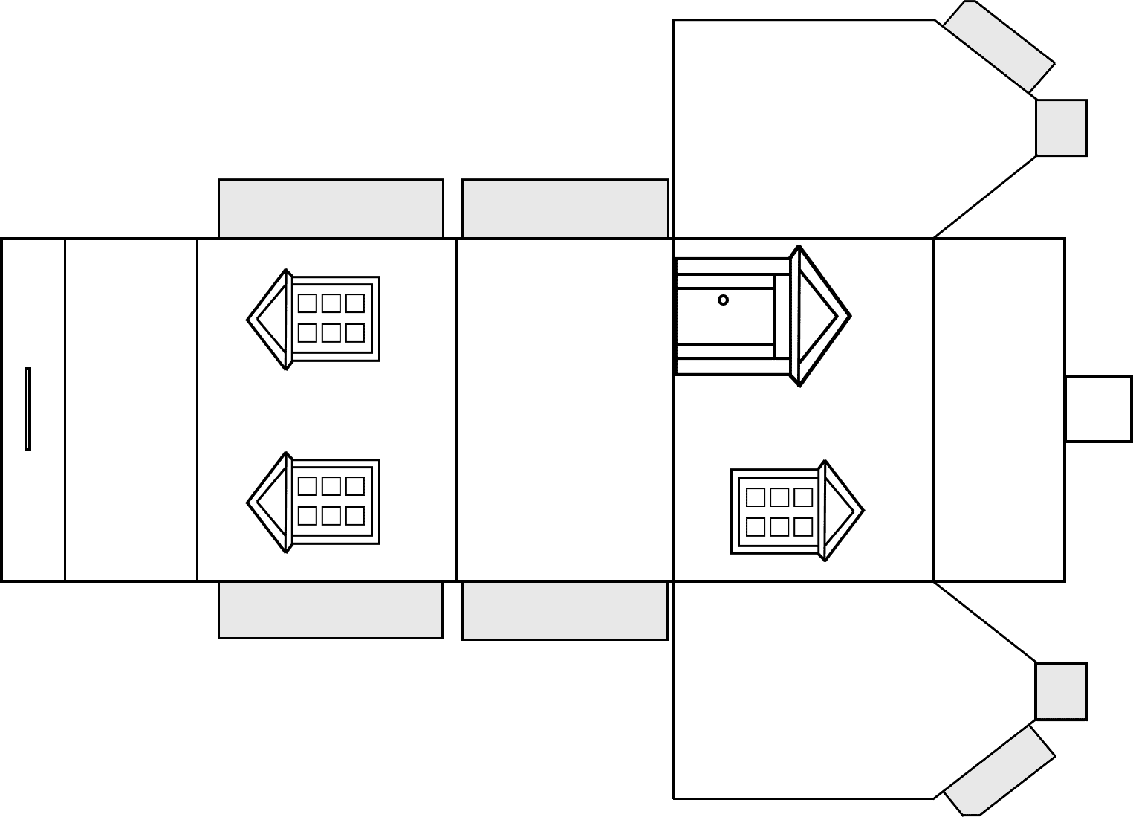
Template for little house gift box
Cut around the outline and turn template over (blank side) to score fold lines for walls, floor, and tabs. Colour in or decorate. Fold and glue tabs inside house. Place small gift within. Fasten together by slotting roof tab through slit on roof top.

