Vendor Credit Memo

Document Overview:

The Vendor Credit Memo (CM) is a Kuali document that is used to enter credits from vendors in Kuali. CM documents can only be entered by individuals in Accounts Payable. Credit memos are used for a variety of reasons. Some of the more common reasons we see credit memos are; credits for overpayment, damaged or missing goods received, and credits for items on backorder that may not allow orders to be fulfilled. If a credit is entered for a vendor then future payments are reduced by any credit amount the vendor has in Kuali. Also, all payments that are reduced by a credit are issued via paper check, payments reduced by a credit will never be issued as an ACH. This prevents the system from inadvertently issuing a negative ACH payment.

How to Complete the Document:

Just like the Payment Request document, only individuals with Accounts Payable access in Kuali will be able to initiate and submit CM documents. All credit memos received from vendors need to be forwarded to Accounts Payable to be processed.

On the Main Menu in Kuali under Purchasing/Accounts Payable there is a link to the Vendor Credit Memo document. To open a new document Accounts Payable will use this link.

Before opening a new document there is required information that needs to be entered. The Credit Memo number, the Credit Memo Date, and the Credit Memo amount are all required fields and must be completed:
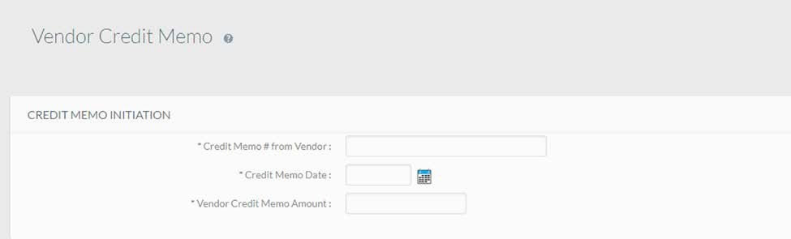

Additionally, one of the three fields below also needs to be completed before the new CM document will be created:
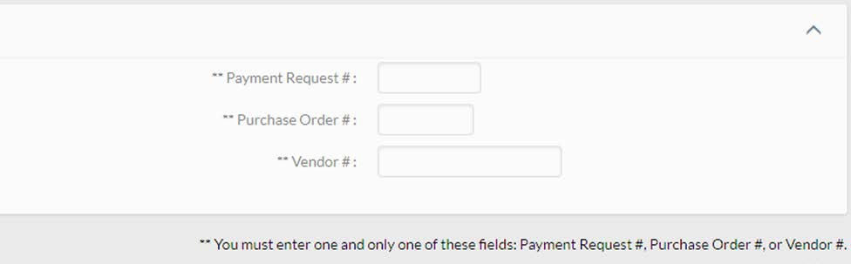

Once all required fields have been completed the user will click the “continue” button. If all required fields are entered correctly a new CM document will open with the initial information entered pre- populated on the new document. The document should be reviewed to make sure that the correct PO has been selected and that the accounting lines and percentage allocations are correct.

When all fields have been entered and verified a copy of the credit memo can be attached to the document in pdf format in the notes and attachments tab and the document can be submitted.

Document Routing:

As soon as documents are submitted without errors the CM goes to final status immediately and does not require any additional approvals. The fiscal officer(s) on any accounts impacted by the CM document are sent an FYI notification in Kuali so they are aware that the credit should show on their Kuali account(s). All completed CM documents related to PO documents can also be found in the “View related documents” tab on PO or PREQ documents for the Purchase Order.

Document Exceptions/Restrictions:

None.

