[open House]
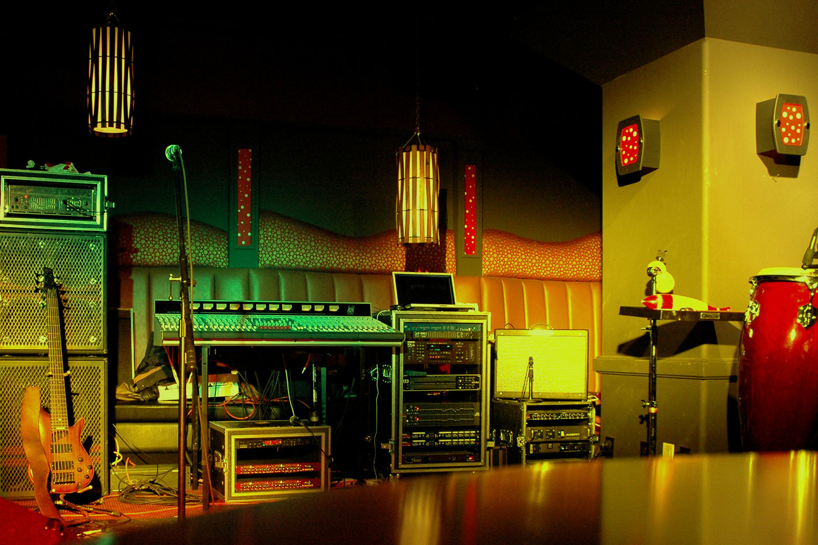
  - [Offered At:]
000,000,000/- Only
[Street Address Here]
Write description of home including number of people who can easily live in this house and explain how many bedrooms, kitchen, washroom, living area, yard, nearby buildings and other facilities. If you demand any dawn payment, then give clear information about your requirements. If there is room for more queries that can come from clients, then given your contact details and open offer to contact you for more information

