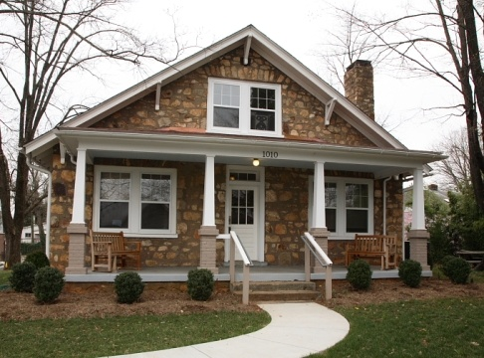

**Open House Flyer**

*Write description of home including number of people who can easily live in this house and explain how many bedrooms, kitchen, washroom, living area, yard, nearby buildings and other facilities*