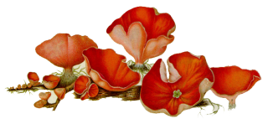

**Best Wishes…**

*Blessed are those who can give without remembering and take without forgetting*