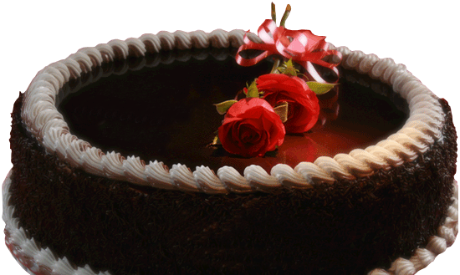

***Hope Your Special Day Brings you All That***

***Your Heart Desires!***

***Here’s Wishing You a Day***

***Full of Pleasant Surprises!***

***Wish You to Have a Day as Special as You Are***