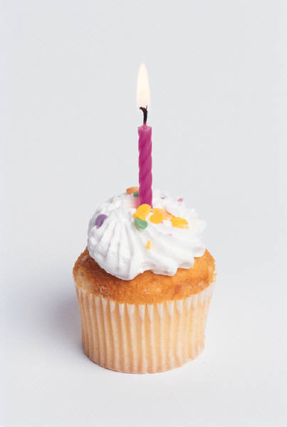

HAPPY

BIRTHDAY