Project Evaluation Plan Template

Rural Health Network Development Program Technical Assistance

December, 2017



525 South Lake Avenue, Suite 320 │ Duluth, Minnesota 55802
(218) 727-9390 │ info@ruralcenter.org
Get to know us better: www.ruralcenter.org/rhi

This is a publication of Rural Health Innovations, LLC (RHI), a subsidiary of the National Rural Health Resource Center. The Technical Assistance for Network Grantees Project is supported by Contract Number HHSH250201400024C from the U.S. Department of Health and Human Services, Health Resources and Services Administration, Federal Office of Rural Health Policy.

TABLE OF CONTENTS
Background and Purpose 3
Instructions 3
Project Snapshot 4
Plan to Measure Key Data 5
Evaluation Results Scorecard 6
Dashboard for Key Measures 6
Communication Plan for Key Results 8

BACKGROUND AND PURPOSE
Rural Health Innovations (RHI), LLC, is a subsidiary of the National Rural Health Resource Center (The Center), a non-profit organization. Together, RHI and The Center are the nation’s leading technical assistance and knowledge center in rural health. In partnership with The Center, RHI enhances the health of rural communities by providing products and services with a focus on excellence and innovation. RHI is providing technical assistance (TA) to the Rural Health Network Development grantees through a contract with the Federal Office of Rural Health Policy (FORHP).
Evaluation of grant funded programs is critical to both the success and sustainability of the project. It is critical to assess impact of the project objectives to demonstrate value, monitor progress toward project goals, and to identify potential best practices and lessons learned. Evaluation results are then used to improve project performance.
This Project Evaluation Plan Template is part of the Evaluation Plan Toolkit and is designed to support the associated Evaluation Plan Guide and Evaluation Plan Samples. This toolkit is supported with an educational webinar: Program Evaluation Plan Toolkit.

INSTRUCTIONS
- Revise this document’s cover page to reflect appropriate and specific program information such as, Evaluation Plan title, date and authors of the plan.
- Change the header to reflect your project’s name.
- Complete the templates provided with relevant information as appropriate.
  - Remove describing paragraphs above each template once appropriate and specific program information has been added.
- Remove the following pages: Background and Purpose (pg. 2) and Instructions (pg. 3).
- Update the Table of Contents when your Evaluation Plan is complete.

[Project Name] Evaluation Plan PROJECT SNAPSHOT
The Project Snapshot sets the context for the Evaluation Plan. The Plan will be built on foundational elements including vision, project goals, strategic objectives and initiatives. Use the table below. Narrative may be used as well, but should be no more than two pages and include the elements in listed below. Add additional rows to this table as needed. See Project Evaluation Plan Sample for an illustration of this section.
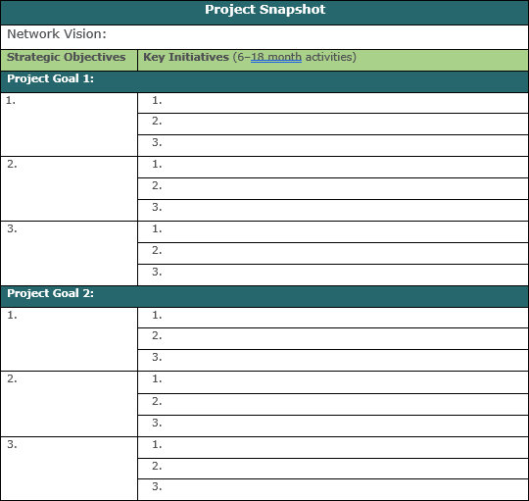

RURAL HEALTH INNOVATIONS 4

[Project Name] Evaluation Plan

PLAN TO MEASURE KEY DATA
A Plan to Measure Key Data identifies both the data needed to monitor the progress of your project’s impact and the tracking of process initiatives that have been implemented and align with the network’s strategic objectives. Selecting process and outcome data while identifying specific and defined measurements is critical to an Evaluation
Plan; this also includes considering when to collect the data and who is responsible. Add additional rows to this table as needed. See Project Evaluation Plan Sample for an illustration of this section.
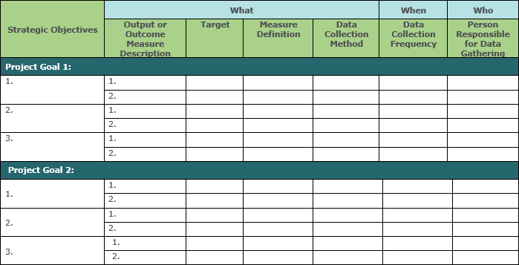

[Project Name] Evaluation Plan

EVALUATION RESULTS SCORECARD
The Evaluation Results Scorecard is a table that includes the results of measures identified within the Plan to Measure Key Data. Not only will it include the “what” and “when”, but will also include a section for the results to be recorded. Prepare this table for use as the project progresses and begin inserting results as they are gathered. Add additional rows to this table as needed. See Project Evaluation Plan Sample for an illustration of this section.
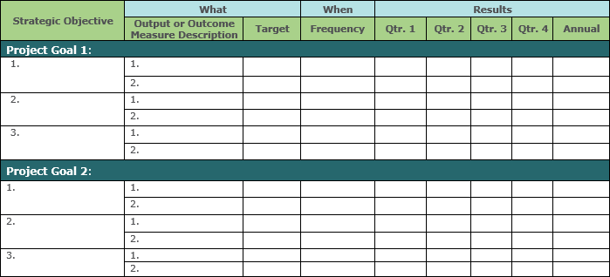

DASHBOARD FOR KEY MEASURES
A Dashboard for Key Measures illustrates the status and progress of project objectives. Visual displays provide a simple communication of achievement, or progress, toward critical project impact. Add additional rows to this table as needed. See Project Evaluation Plan Sample for an illustration of this section.
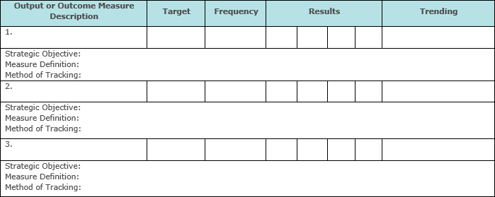

COMMUNICATION PLAN FOR KEY RESULTS
Develop a plan to intentionally and purposefully share key results with network members, partners and stakeholders. Consider using a table to illustrate the Communication Plan for Key Results. Add additional rows to this table as needed. See Program Evaluation Plan Sample for an illustration of this section.
