**Road Trip Invitation**

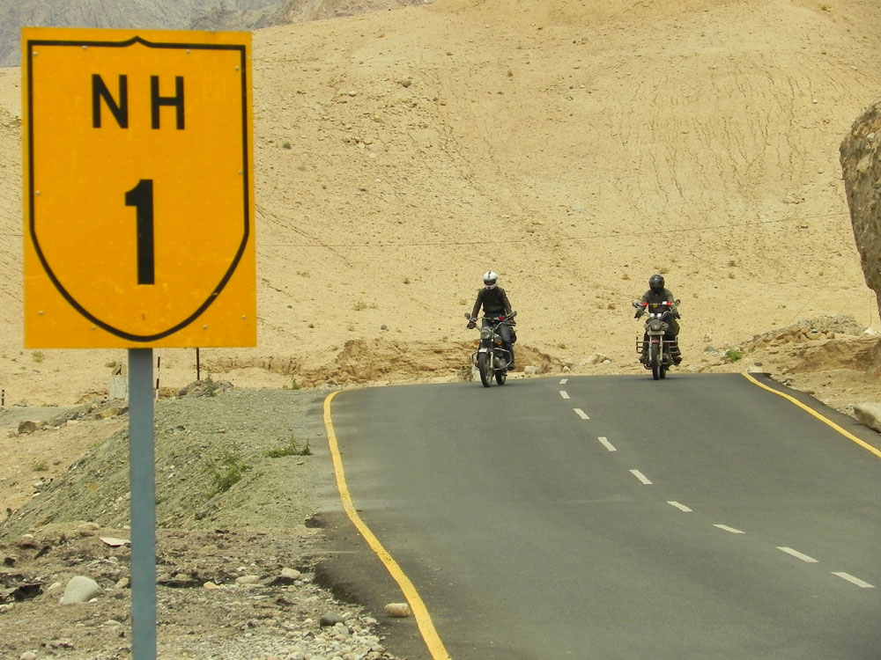

**Please join us in a road trip  
Saturday, July 00, 2015**

**RSVP:** _______________________________