**Chinese Menu**

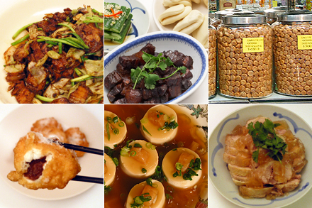

MENU 4

------------------------------

------------------------------

-----------------------------

MENU 5

------------------------------

------------------------------

MENU 6

------------------------------

------------------------------

MENU 7

------------------------------

------------------------------

MENU 8

------------------------------

------------------------------

------------------------------

------------------------------

MENU 2

------------------------------

------------------------------

------------------------------

------------------------------

MENU 3

------------------------------

------------------------------

------------------------------

------------------------------

MENU 1

------------------------------

------------------------------

------------------------------

------------------------------

MENU 2

------------------------------

------------------------------

------------------------------

------------------------------

MENU 3

------------------------------

------------------------------

------------------------------

------------------------------

MENU 1

------------------------------

------------------------------

------------------------------

------------------------------

MENU 2

------------------------------

------------------------------

------------------------------

------------------------------

------------------------------

MENU 3

------------------------------

------------------------------

------------------------------

------------------------------