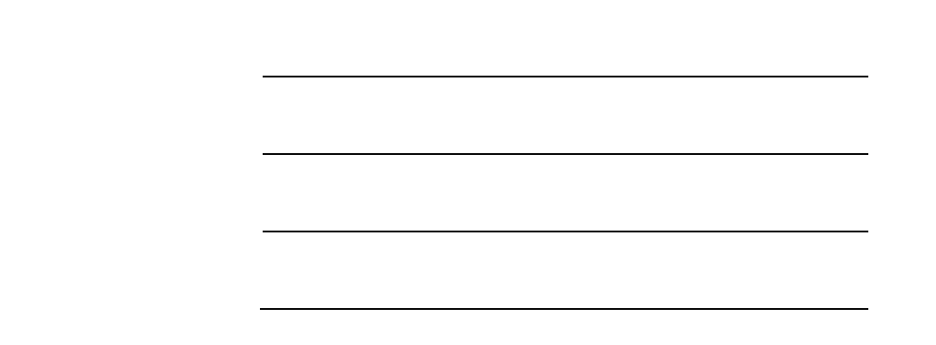
Progressive Payment (Residential)
Name: Agency: Mobile Email

Project: Unit No.: Price:
5%: Upon the grant of Option to Purchase (Downpayment)
Upon signing if the Sales and Purchase Agreement or within 8
15%: weeks from the Option date (Downpayment)

Stamp Fee: (Approx. 3%)

Payment Schedule

10% |  | Completion of foundation work
10% |  | Completion of reinforced concrete framework of unit
5% |  | Completion of brick walls of unit
5% |  | Completion of roofing/ceiling of unit
5% |  | Completion of electrical wiring, internal plastering, plumbing, and installation of door and windows frames of unit
5% |  | Completion of Carpark, roads and drains serving the housing project
25% |  | Issue of Temporary Occupation Permit

15%
Transfer of legal titles and Issue of Certification of Statutory Completion

Repayment (S$) Per S$ 100,000 Loan
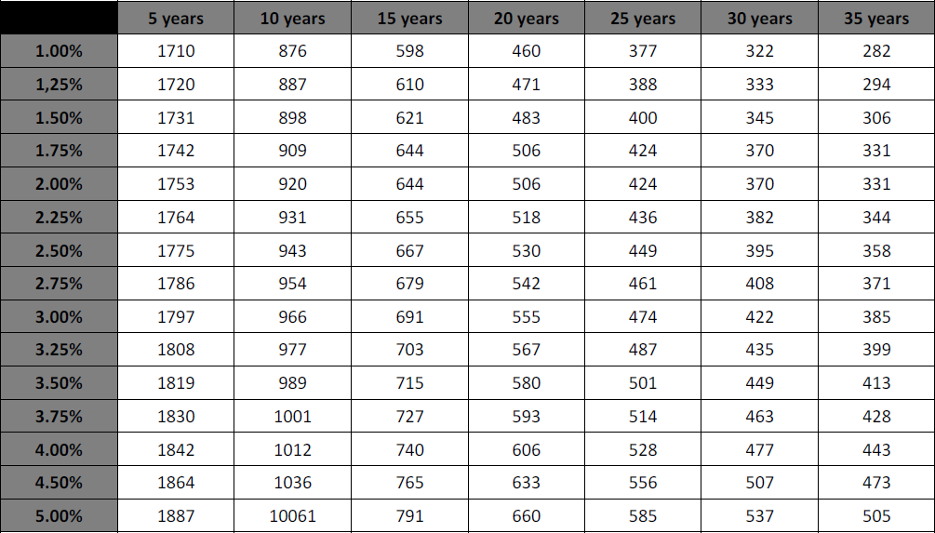
Figures are estimates, and for reference only. (R)

