Wellness Checklist
Use this wellness checklist to help become and stay healthy. Take it slow – gradually add healthy habits and food to your existing regime rather than going cold turkey. Always consult with your doctor before making any radical health changes.

Daily wellness checklist |  |  |  |  |  |  |  |  | Other wellness tips
Did you... | Mon | Tue | Wed | Thu | Fri | Sat | Sun |  | - Get knowledgeable by researching nutrition and supplements.  - Pay attention to your emotions and feelings before going to sleep each night. Keep a diary.  - If something hurts chronically, or if something feels out of whack, your body is talking to you. Listen to it!  - Research pressure point therapy, massage or any other form of energy medicine that you can practice on yourself, your partner, or your children.  - Research and take up daily stress-busting daily practices such as meditation, mindfulness, and affirmations.  - If you’re emotionally in trouble or feel lost or helpless, seek help.
Eat breakfast | ☐ | ☐ | ☐ | ☐ | ☐ | ☐ | ☐
Eat fresh, plant-based, and whole grain foods | ☐ | ☐ | ☐ | ☐ | ☐ | ☐ | ☐
Eat one green food | ☐ | ☐ | ☐ | ☐ | ☐ | ☐ | ☐
Eat organic, free-range chicken, fish, and game | ☐ | ☐ | ☐ | ☐ | ☐ | ☐ | ☐
Eat organic eggs and diary | ☐ | ☐ | ☐ | ☐ | ☐ | ☐ | ☐
Avoid sugary, processed, and refined foods | ☐ | ☐ | ☐ | ☐ | ☐ | ☐ | ☐
Eat good fats: avocados, nuts, seeds, olives, coconut | ☐ | ☐ | ☐ | ☐ | ☐ | ☐ | ☐
Cook with organic, virgin coconut oil, or olive oil | ☐ | ☐ | ☐ | ☐ | ☐ | ☐ | ☐
Avoid deep-frying, stir-frying, and sautéing | ☐ | ☐ | ☐ | ☐ | ☐ | ☐ | ☐
Drink plain coffee or tea | ☐ | ☐ | ☐ | ☐ | ☐ | ☐ | ☐
Drink 7–8 glasses of water per day | ☐ | ☐ | ☐ | ☐ | ☐ | ☐ | ☐
Avoid skipping meals | ☐ | ☐ | ☐ | ☐ | ☐ | ☐ | ☐
Avoid alcohol | ☐ | ☐ | ☐ | ☐ | ☐ | ☐ | ☐
Get at least 6–8 hours of sleep | ☐ | ☐ | ☐ | ☐ | ☐ | ☐ | ☐
Get 20–30 minutes of moderate exercise | ☐ | ☐ | ☐ | ☐ | ☐ | ☐ | ☐ |  | 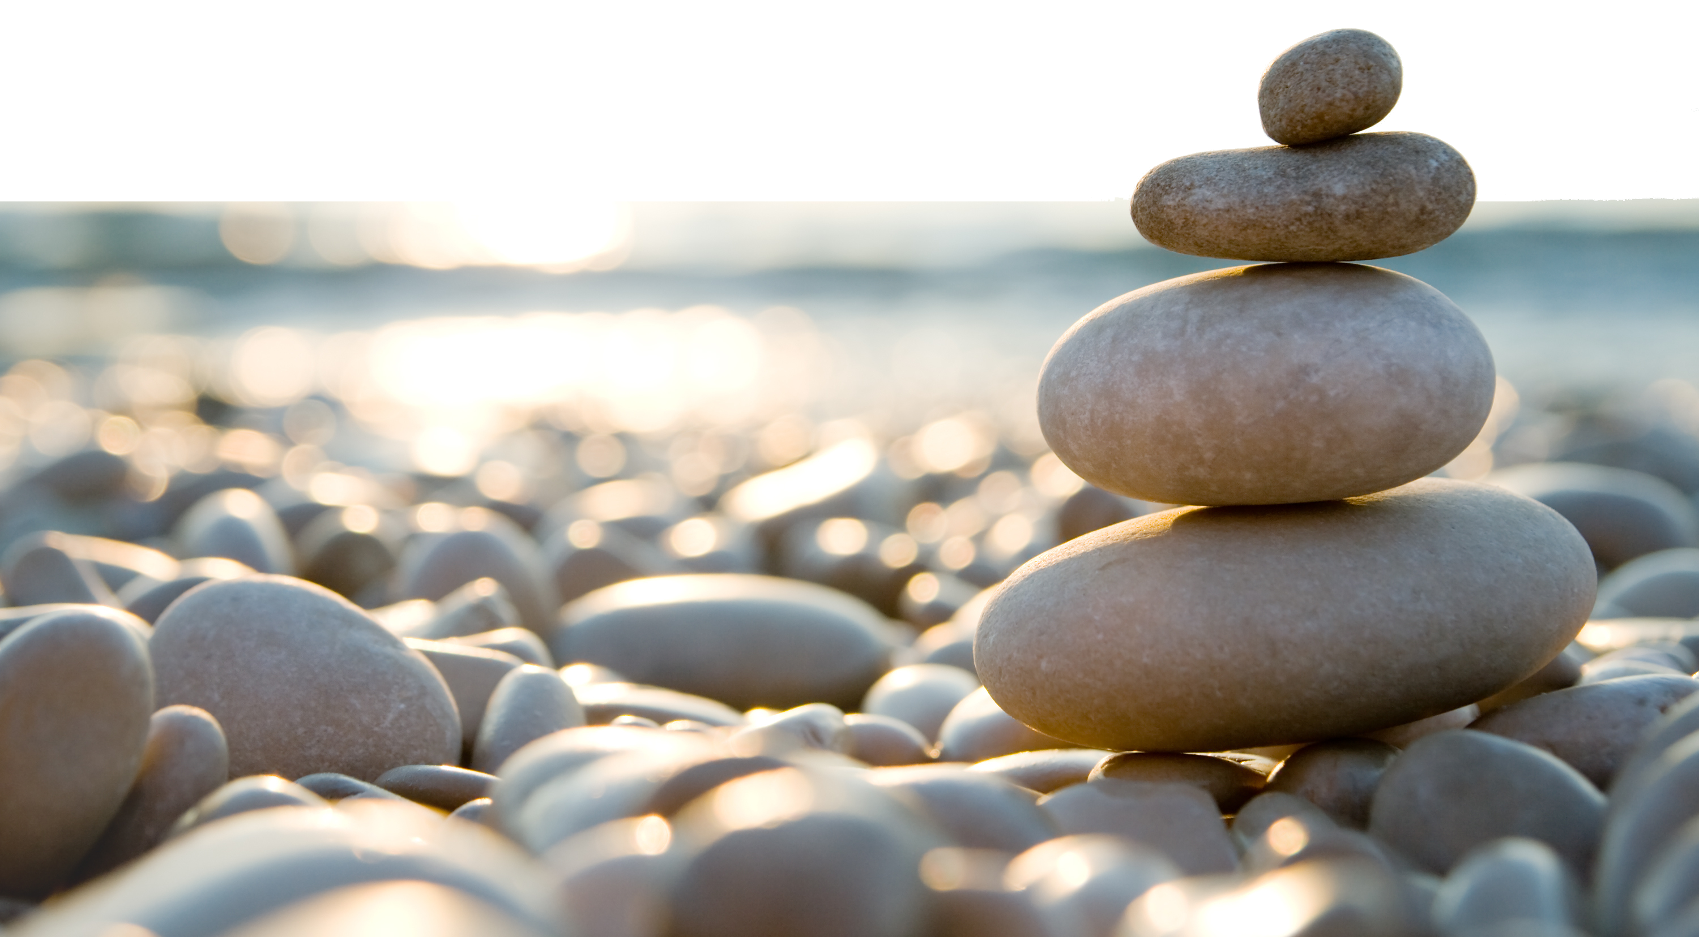
Avoid continuously sitting for more than 55 minutes | ☐ | ☐ | ☐ | ☐ | ☐ | ☐ | ☐
Stretch for a minimum of 5 minutes | ☐ | ☐ | ☐ | ☐ | ☐ | ☐ | ☐
Take the stairs instead of the elevator | ☐ | ☐ | ☐ | ☐ | ☐ | ☐ | ☐
Spend time outdoors | ☐ | ☐ | ☐ | ☐ | ☐ | ☐ | ☐

