Customer Service Report Template
  - Customer Service Report Writing Template
[Type the abstract of the document here. The abstract is typically a short summary of the contents of the document. Type the abstract of the document here. The abstract is typically a short summary of the contents of the document.]
Customer Satisfaction
  - [Pick the date]
Contents
Introduction 2
Objectives 2
Methodology 2
Reliability 2
Communication 2
Competence 3
Responsiveness 4
Understanding Your Customer 4
Accessibility 4
Staffing 5
Correspondence 5
Key Findings 5
Ability to Contact 5
Repeat Contact/Follow-Up 5
Technical Help-Desk 5
Complaints-Handling 5
Customer Behavior 6
Benefits 6
Sample Customer Service Report Template 6
Customer Service Report 6
CSR No. 6
Date: 6
Nature of Problem 7
Service Details 7

Introduction
Customer services the whole activity of identifying customer needs in all their complexity, satisfying them fully, and keeping them satisfied. Customers are people who buy products and services from other people. Customer service has to be a team effort and not just the responsibility of employees who deal with the public directly.
Providing good customer service is a vital part of managing a business. Most customers have the option to go elsewhere if the quality of customer service is lacking. On the other hand, good customer service is a source of competitive advantage.
Good customer service leads to customer satisfaction. Satisfied customers are more loyal and profitable. Dissatisfied customers take their money elsewhere – and tell their friends about the poor service they have received.

Objectives
Upon successful completion of this course, participants will be able to:
- Apply behavioral standards to enrich the customer experience;
- Manage irate customers;
- Contribute meaningfully to the enhancement of customer service in any organization.

Methodology
This course will be delivered using a combination of teaching techniques. These include lectures, open discussions, role play, case studies, individual and group exercises/presentations, audio and visual presentations and training games.

Reliability
Customer service, especially in the shape of a call-center - is to customers one of the most visible and significant aspects of organizational performance. Too many organizations however customer service is one of the most challenging and neglected areas of management, including those with modern call-centers. For customers the quality of customer service determines whether to buy, and particularly whether to remain a customer.
Think for a moment how you yourself behave as a customer. You can perhaps think of an occasion when poor customer service or an unhappy exchange with a call-center has driven you to leave a supplier, even if the quality and value of the product or service itself is broadly satisfactory.

Communication
According to the federal guidelines, a call to a cable system must be answered -- including wait time -- within 30 seconds after the connection is made. If the call is transferred, the transfer time may not exceed 30 seconds. These standards must be met at least 90 percent of the time, measured quarterly, under "normal operating conditions." Also under normal operating conditions, cable system customers may receive a busy signal no more than three percent of the time. Normal operating conditions are those which are within the control of the cable operator. These conditions include special promotions and normal system maintenance and upgrades, but do not include natural disasters, civil disturbances, power outages, telephone network outages, and severe or unusual weather conditions.
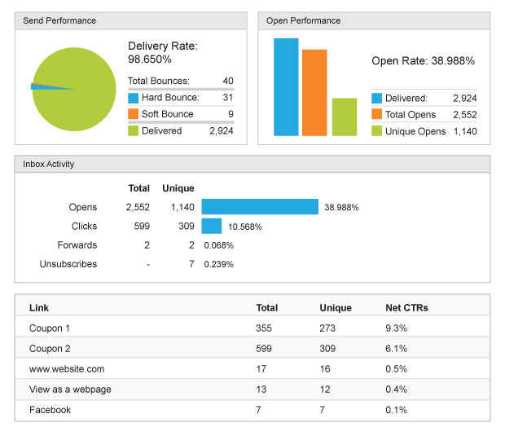

Competence
The competencies are grouped together under categories. Each competency includes a title, a general definition, and several measurable or observable performance statements.
This list is useful as a reference, but is not all-inclusive. The performance statements listed are to be used to generate thought about how the competency is displayed when performed well on the job. The competency descriptions are intended to be tailored to individual positions.
Position-specific competencies are best determined through a job analysis process. Supervisors should talk with their HR office to receive specific direction around competency identification.
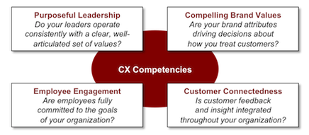

Responsiveness
Keeping your customers happy is the key to ensuring that your current clients don’t become former clients. Failing to meet deadlines or ignoring customer inquiries can increase client dissatisfaction with your company and spur them to investigate your competitors’ services. When customer responsiveness is a priority, you’ll find that opportunities to serve your clients increase, while problems and service issues decrease.

Understanding Your Customer
Using technology, including websites, email and telephone systems, to enable customers to quickly get the information they need is one aspect of customer responsiveness. Websites that are slow or hard to navigate frustrate customers. Complicated telephone queues that require callers to wade through numerous menus before being permitted to speak to a company representative can annoy a caller who just wants to ask a simple question. Prioritizing calls based on the client’s importance to your company will help ensure that your client’s concerns are addressed quickly by a knowledgeable member of your staff. Changing your telephone system to automatically direct important clients to a staff member increases responsiveness to your top tier customers.

Accessibility
The Customer Service Accessibility Standard focuses on policy, training and good communication practices to provide barrier-free customer service. By addressing attitudes, knowledge and basic practices, the goal is to achieve barrier-free customer service in the public and private sectors.
The first standard under The Accessibility for Manitobans Act requires all Manitoba organizations with one or more employees to establish and implement measures, policies and practices that:
- Identify barriers to accessible customer service in relation to the goods and services it provides
- Seek to remove existing barriers so that persons with disabilities can reasonably obtain, use or benefit from the goods or services the organization provides
- If an existing barrier cannot be removed, seek to ensure that persons with disabilities are provided access to the goods or services by alternate means
- Ensure that a fee or charge that relates to accommodating a person with a disability is only imposed if the organization cannot reasonably accommodate the person otherwise

Staffing
If you want to strike the balance between having sufficient staffing to react as needed and doing so economically, this white paper will be helpful. Industry studies indicate that 80% of a typical help desk budget is salary, so staffing appropriately has a major impact on the bottom line.
The common Erlang formulas from queuing theory fall short because of the wide diversity of help desk entry points (call, fax, email, web, walk-ins, and pages).
Using the detailed formulas and methodology presented in this paper, you will be able to calculate the relationship between staffing levels and customer support levels. First, the paper looks at call center flow models to see how the organizational structure affects costs and program performance. Secondly, call volume, time to process a call, and time to resolve a call are used to determine the average number of staff required for a given call volume. A 70% utilization rate is a good starting point, since the inflow of random calls requires some slack capacity.

Correspondence
We will acknowledge all written correspondence within 2 working days and provide a full or interim response within 10 working days

Key Findings

Ability to Contact
- Easy to contact, no time on hold/no queue.
- Out-of-hours/24–7 access to customer service.
- Being able to speak to a person, not a computer.
- Quick access to someone who can handle their issue.

Repeat Contact/Follow-Up
- Not having to repeat the whole process of explaining the problem.
- Being given a reference number to quote.

Technical Help-Desk
- Staff at technical help-desk (especially for internet service) should explain solutions in easy-to understand language.

Complaints-Handling
- Complaints should be handled with respect.
- Complaints should be given priority.
- CSPs should have a specialized complaints department.

Customer Behavior
Other than in the two focus groups of respondents who switched CSPs in the past 12 months, it
Was quite rare for respondents to have taken any decisive actions in response to what they saw as poor customer service. The primary reasons given for this lack of action were: Poor customer service is now seen as the norm, especially by younger respondents who claimed they had never experienced anything else. Poor customer service is common across many sectors—not just telecommunications. Banks and energy suppliers are viewed as equally guilty.

Benefits
The trouble with online shopping is that many customers are disconnected from someone who can answer their questions in real time with precision. Rather than watching potential customers click away from their e-commerce sites, many businesses have been adding live chat support. As it turns out, live chat has the ability to provide the convenient answers that customers want, while also adding significant benefits to the staff and bottom line of companies.
Total No of days per month CSR's answer calls
Total No of calls received per month
Total No of calls per month answered in 30 seconds
Average seconds on hold before reaching CSR
Total No of transferred calls on hold longer than 30 seconds
Total No of calls abandoned by incoming callers
Estimated percentage (%) of time callers received a busy signal
Is local, toll-free or collect-call phone access available 24/7?

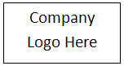
Sample Customer Service Report Template
Company Name
Address Line
Phone No.
Email Address
Company Website

Customer Service Report
CSR No. |  | Date:
Customer Name:
Address:
City: | State: |  | ZIP Code:
Status of Call: Warranty or AMC (Please circle) | Instruction From  Mr._________________ On________________

Nature of Problem
Problem Reported:
System Down: Yes / No (Please circle) |  |  | Equipment Type:
Make: | Model |  | Serial No.
Call Reported by: | Date: |  | Time:
Location of Installation:

Service Details
Service Rendered:

Engineer’ s Remarks: |  |  |  |  | Status after Service:  (Please circle)  Complete/ Incomplete/ Pending for spares/ Under Observation/ Working solution provided
Defects found on inspection:

Events: ( Date & Time) |  | Start of Service: |  | End of service:
PLEASE RATE THIS CALL BY TICKING AN OPTION
Extremely Satisfied | Satisfied |  | Dissatisfied |  | Annoyed
CUSTOMER FEEDBACK
Remarks:

Name : |  |  | Designation: |  | Phone/Fax:
Email:
Signature: |  |  | Date: |  | Place:

