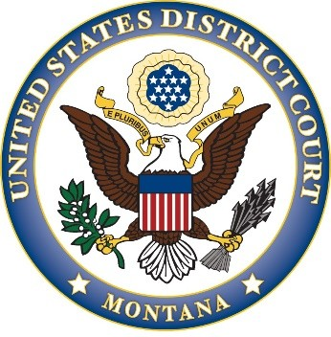

UNITED STATES DISTRICT COURT DISTRICT OF MONTANA

CHARACTER CERTIFICATE

I, the undersigned member of the Bar of the United States District Court for the District of Montana, hereby certify that is of good moral character and a member in good standing of the State Bar of Montana.

(Sponsor’s Signature): _ Sponsor’s Name: Address:

Telephone No.: E-mail Address:

