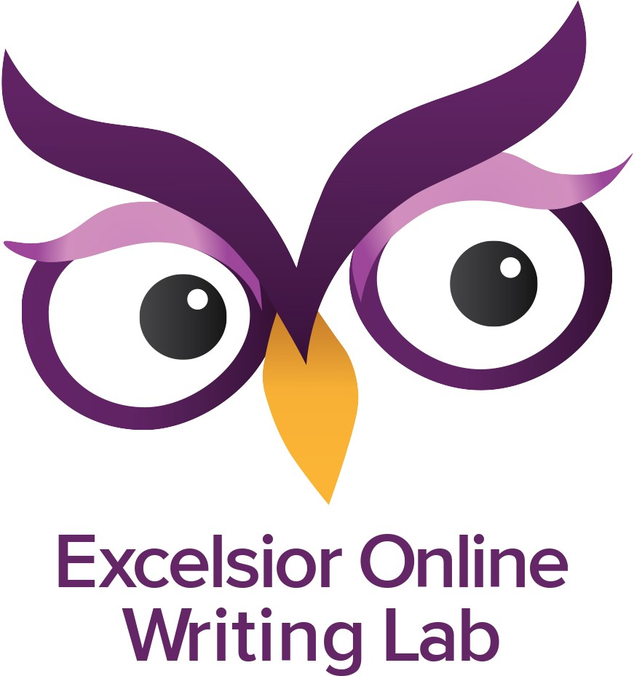
C A R E S Peer Review Feedback Form
Perhaps the most helpful tool in developing logical, readable drafts is a peer review session. Peer Review is effective for both the writer and the reviewer. Depending on the writing assignment, adult readers will review class content, as well as strengthen vital writing and close reading skills. Writers will recognize that good writing communicates effectively with diverse readers.

To remember while viewing:
Note: The least helpful comment to receive from a peer reviewer is "It looks good to me."

- First attend to Higher Order Concerns: thesis, audience, purpose, organization, development (support)
- Then attend to Lower Order Concerns: sentence structure, punctuation, word choice, spelling
- Make comments in spirit of helpfulness. Take comments in spirit of helpfulness.

Writer: Reviewer:

C  Congratulate | What does the writer do well in this assignment? (List one or more aspects.) Also, please write the writer's main claim or focus (thesis) according to what you have read. (It may not be the last sentence of the first paragraph - the traditional place for the thesis.)
A  Ask clarifying questions | What part(s) of the essay were a bit confusing? Why?
 | What specific suggestions (3 or fewer) do you have for revising the unclear parts of this writing? *
R  Request more | What would you like to k | now more about the topic that can enhance the essay and that supports the thesis?
E  Evaluate its value | What specific detail(s) do not work with the essay (e.g. doesn’t support the thesis) or can be moved within the essay?
S  Summarize | Overall, what new information have you learned or how are you thinking differently after this reading

C A R E S Peer Review Feedback Form
Page 2

- You may use the list below for ideas.
(Please identify the paragraph for your suggestion)

  - Thesis needs to better identify the main point of the essay

  - Topic sentence(s) needs to identify the main point of this paragraph

  - Paragraph(s) needs one overall idea (needs more specific evidence, needs more writer's commentary)

  - Words: repeating words, repeating ideas, repeating sentence structure

  - Using vague language, using slang, transition words needed

  - Proofreading: punctuation, spelling, grammar

  - Sources (if used) need to be clearly identified

  - Proper intext / reference format needed

