EditionComparisonMatrix
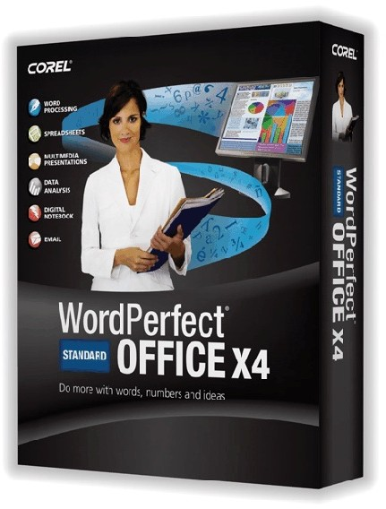
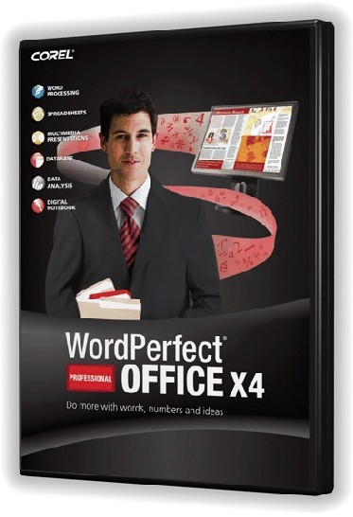
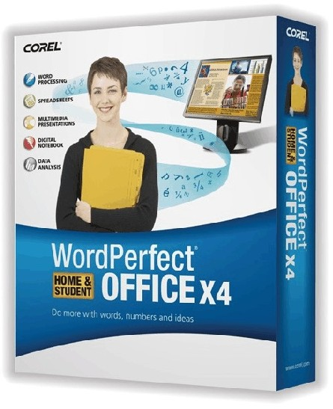
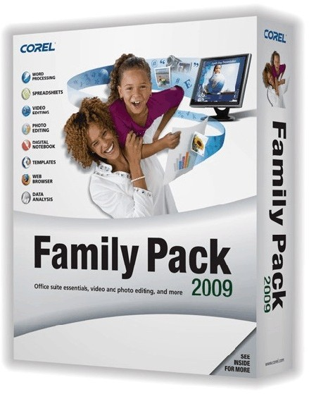

 | Standard | Professional | Home & Student | Family Pack
Create word processing documents like letters, reports, marketing collateral, etc. | / | / | / | /
Build spreadsheets for financial planning, budgets, etc. | / | / | / | /
Create multimedia slide shows & presentations | / | / | /
Context sensitive toolbars in Productivity programs that change automatically depending on task | / | / | / | /
RealTime Preview to see document formatting changes before committing them | / | / | / | /
Data analysis and visualization tools | / | / | / | /
Digital notebook to organize your information | / | / | / | /
Compatibility with applicable Microsoft® Office documents | / | / | / | /
Open scanned PDFs to edit and reuse the content | / | /
Open text-based PDFs to edit and reuse the content | / | /
Turn documents, spreadsheets and presentations into PDFs to share with the world | / | / | /
Leverage business tools and applications | / | /
Photo & video editing tools |  |  |  | /
Database application to gather and provide rich reporting and analysis of data |  | /
Pre-built samples and templates to easily create databases |  | /
Licensed for business use | / | /
Development and custom integration tools to simplify installation and configuration |  | /

WordPerfect® MAIL* application for communication, lightning fast searching and RSS feed usage | /
Presentations™ Graphics X4 graphics manipulation program | / | / | /
Volume license pricing available | / | /
Take notes and capture information and images from the Web, emails and other documents | / | / | / | /
Share information with others and exchange ideas online and off | / | / | / | /
Free postage from stamps.com |  |  | / | /
200 MB free online storage | / | / | / | /
Free 2-hour training CD included | / | / | / | /

Created and Published to PDF in WordPerfect

