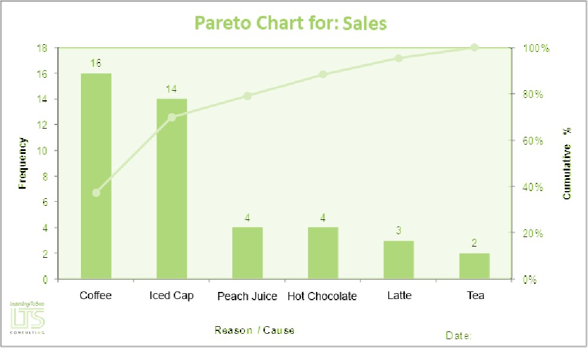Pareto Charts

The Pareto principle is also known as the 80/20 rule or “the Vital few and the Trivial many”. Simply put, it means 80% of problems or defects will be caused by only 20% of the possible “causes” of these problems. The Pareto chart allows us to analyze the data we have collected to identify those causes which have the most significant impact on a particular problem.

Pareto Chart
🢖 Once you have collected all of your data you will group it into “buckets” of reasons.
Remember
The data for a Pareto chart must be a frequency count type of data. This means we would have identified how many times we answered the phone, consulted a patient, called pharmacy etc. This data would then be accumulated and put into rank order largest to smallest from left to right.
🢖 If you are using a computer based program it will do the work for you to create the chart. Make sure you put an appropriate title, and label all the axis.
🢖 A simple hand drawn Pareto chart can be completed on graph paper and is just as effective as a computer program chart.
🢖 Present the data to your team to help make decisions on where to focus your process improvement work.

