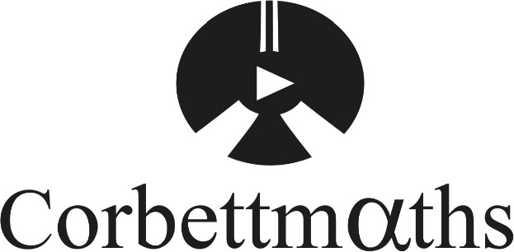
Name:
Exam Style Questions
Ensure you have: Pencil, pen, ruler, protractor, pair of compasses and eraser

You may use tracing paper if needed

Guidance

- Read each question carefully before you begin answering it.
- Donʼt spend too long on one question.
- Attempt every question.
- Check your answers seem right.
- Always show your workings

Revision for this topic

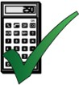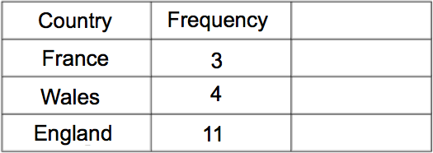

Draw an accurate pie chart to show this information.

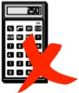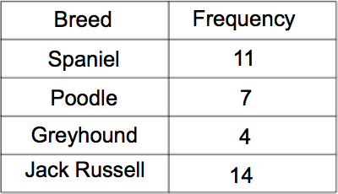

Draw an accurate pie chart to show this information.

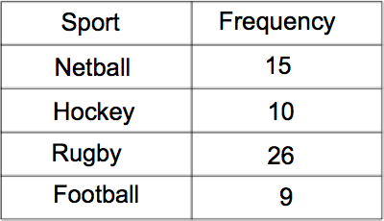

Draw an accurate pie chart to show this information.

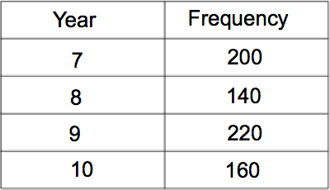

Draw an accurate pie chart to show this information.

- Nigel sells bottles of drinks.
The table shows the percentage of drinks sold on a day.
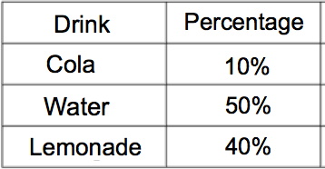

Draw an accurate pie chart to show this information.

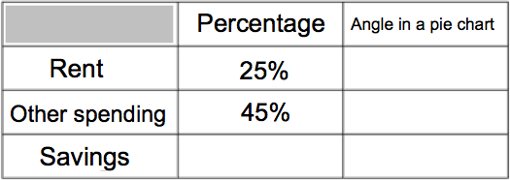

  - Complete the table.

(3)

  - Draw an accurate pie chart to show this information.

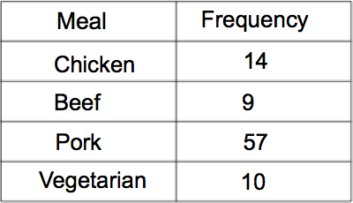

Draw an accurate pie chart to show this information.

