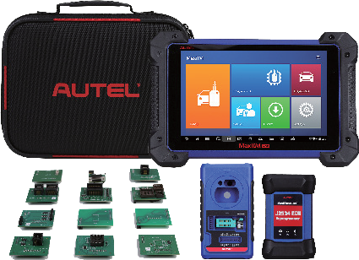
08/062020

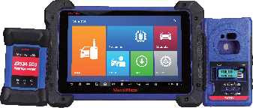
COMPARISON CHART 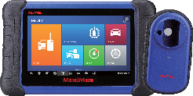

Included Functions Need IMKPA Accessory Kit Need XP400 Pro and IMKPA Accessory Kit
Need XP400 Pro
MaxiIM IM508 MaxiIM IM608
MaxiIM IM608PROKPA
Only Sold in North America

PROGRAMMING

EEPROM Read/Write
Basic Intermediate
Advanced

MCU Read/Write Immobilizer Read/Write Engine Read/Write
Mercedes Infrared Key Read/Write Remote Frequency Detection
Basic
Intermediate Intermediate Intermediate
Advanced Advanced Advanced

IMMO
Smart Mode (Guided and Automated Key Learning Function) Auto Detect Make/Model/Year/System
Read PIN (Add Key/All Key Lost)
Key Generation / Key Learning / Remote Learning IMMO ECU Reset/Adaption
IMMO ECU Refresh/Coding Backup/Restore IMMO Data
Benz 3rd Generation IMMO Add Key, All Key Lost via OBD Read/Write/Erase Benz ESL_W209 / W906 Data
Benz OE NEC Key Learning
Audi Q5/A4/A5 2015-2017 Key Learning via OBD Volkswagen/Audi MQB Add Key, All Key Lost via OBD
Volkswagen/Audi 4th Generation IMMO Add Key, All Key Lost via OBD Volkswagen/Audi 5th Generation IMMO Add Key via OBD
BMW FEM/BDC Key Learning and Adaption BMW CAS4/3/2/1 Key Learning
BMW EWS3 Key Learning
2015-2019 Jaguar Land Rover Write Key via Dump Volvo Smart Key/Fobik Smart Key Learning Volkswagen/Audi/BMW/Benz Key Unlock
OE-LEVEL DIAGNOSTICS

All Systems for Over 80 Makes
MaxiFlash JVCI (J2534 ECU Reprogrammer) ECU Coding
Active Test
Complete Service Functions
FEATURES

Rechargeable Li-ion Battery

Basic

5000 mAh

Intermediate Advanced

15000 mAh 15000 mAh

Internet Updatable Multilingual Support Limited One Year Warranty
Wi-Fi Wi-Fi Wi-Fi

Touchscreen Memory Processor
7-inch 32 GB
Quad-core
10.1-inch 64 GB
Hexa-core
10.1-inch 64 GB
Hexa-core

Camera Resolution
Phone: (855) 288-3587 • USSUPPORT@AUTEL.COM AUTEL.COM • MAXITPMS.COM • MAXISYSADAS.COM
© 2020 Autel U.S. Inc., All Rights Reserved
Follow Us @AutelTools
8.0 Megapixel 8.0 Megapixel
1024x600 1920x1200 1920x1200

