PROPOSAL

Graphic Design for Brite Environmental Consulting

Prepared for: Melody Weaver VP, Marketing

Prepared by: Antonio Coleman
Business Development Manager

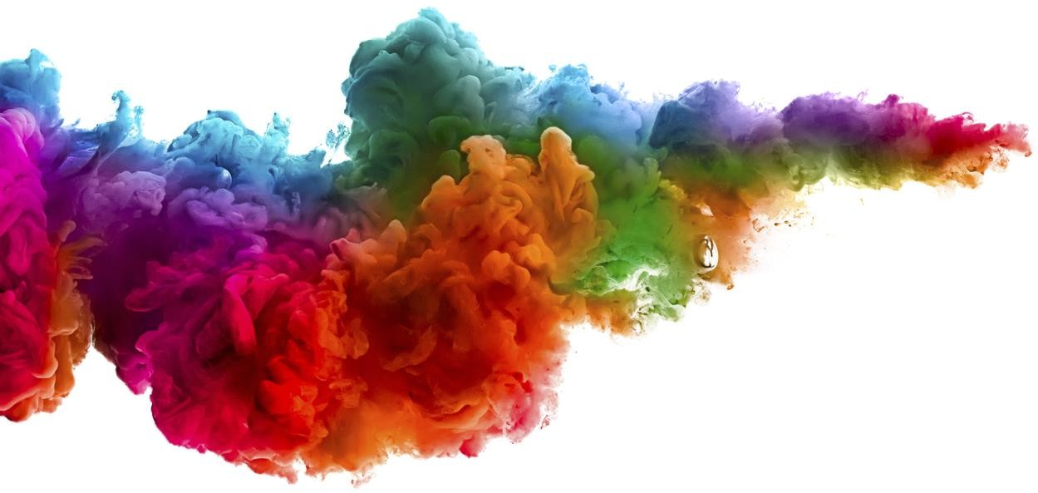

TABLE OF CONTENTS

Needs Assessment 2
Project Deliverables 3
Scheduling 4
Responsibilities 5
Style 7
Cost Summary 8
Process Summary 9
About Us 10
Portfolio 11
Testimonials 12

NEEDS ASSESSMENT

Nu-Gen Graphic Design has identified the following needs for Brite Environmental Consulting.

Needs

Brite Environmental Consulting needs a unique logo to represent its state-of-the-art business identity, and new brochures, stationery, and business cards for use in its correspondence.

Market

Having a unique and easily recognizable logo and associated graphic elements will make Brite Environmental Consulting services easier to find and identify within their marketing niche. A distinctive logo can also elicit a positive “feel” from potential customers and attract new business.

Solution

Nu-Gen Graphic Design has a decade of expertise in developing logos and identities for all types of businesses. We want to be your partner in branding your company.
Working in consultation with you, we will design a unique logo as well as designing and printing business cards, stationery, and advertising brochures. In addition, we can provide consultation on web site design and on future projects such as printed advertising fliers or online ads.

PROJECT DELIVERABLES

The following is a complete list of all project deliverables identified by Nu-Gen Graphic Design.

Corporate Logo

Because all other branding elements (company colors, stationery headers, website design, etc.) stem from the logo, it is our foremost goal to work with you to deliver a distinctive logo to represent your organization. We will share with you the final graphic file of your logo so that you can easily use it on web sites or wherever you wish.

Business Card Design and Printed Cards

After the logo is finalized, we will design distinctive business cards for your employees, and have them printed and delivered to you.

Brochure Design and Printed Copies

Working with copy writers you designate, Nu-Gen Graphic Design will design and layout a general advertising brochure. We will oversee the printing and delivery of brochure copies to your corporate headquarters.

Optional Service: Website Consultation/Design

Our designers are also available to consult with your programmers / IT team to design and implement a new company web site.

Notes

Brite Environmental Consulting and Nu-Gen Graphic Design are equal partners in this endeavor. Our goal is to create a corporate identity that works for you. Please see the Process Summary and Responsibilities page to understand the process we propose to use.

SCHEDULING

The following is our projected schedule:

Schedule for Design Services | Start Date | Duration
Contract Signed Schedule Determined  Initial Payment to Nu-Gen Graphic Design Initial Meeting and Brainstorm Session Development of Logo Ideas  Presentation and Selection of Logo Ideas  Design and Layout of Business Cards and Brochures Final Approval of Business Cards and Brochures Printing Business Cards and Brochures  Delivery of Business Cards, Brochures and Logo File Final Payment to Nu-Gen Design Services | May 19  May 19  May 19  June 4  June 5  June 20  June 21  July 13  July 14  July 25  August 4 | 1  1  1  1  15  1  22  1  11  1  1

Notes

This timely completion of this schedule requires the participation of both Nu-Gen Graphic Design and Brite Environmental Consulting. Please review the Responsibilities page to ensure that we accurately coordinate our personnel schedules.

RESPONSIBILITIES

The following are the responsibilities and duties of Nu-Gen Graphic Design and Brite Environmental Consulting in our graphic design project. Efficient completion of the project requires the coordination and interaction of both parties.

The items below are the same steps shown on the Schedule page of this proposal.

Contract Signed, Schedule Determined, Initial Payment to Nu-Gen Graphic Design –
May 19

Nu-Gen Graphic Design has already delivered a proposed contract and schedule and payment terms to Brite Environmental Consulting for approval.

Brite Environmental Consulting should review the contract, schedule, and payment terms, and approve or suggest changes for approval by May 19.

Initial Meeting and Brainstorm Session – June 4

Nu-Gen Graphic Design designers will attend this meeting with several directions in mind, make suggestions, and listen to Brite Environmental Consulting personnel’s ideas and concerns, taking notes to be followed during the logo design process.

Brite Environmental Consulting personnel should bring samples of logo styles the organization likes to give Nu-Gen Graphic Design designers a definite direction. Samples of logos that are actively disliked are also welcome.

Development of Logo Ideas – 2 Weeks

Nu-Gen Graphic Design designers will work to produce three distinctive logo designs from which Brite Environmental Consulting personnel can choose.

Presentation of Ideas and Selection of Logo – June 20

Nu-Gen Graphic Design designers will present three logo designs to Brite Environmental Consulting and take notes on any changes needed to finalize the design.

Brite Environmental Consulting personnel should be prepared to select a final logo at this time. Our contract terms and schedule allows for only minimal changes at this point.

Design and Layout of Business Cards and Brochures - June 21 (3 Weeks)

In consultation with Brite Environmental Consulting writers or other designated personnel, Nu-Gen Graphic Design designers will design and layout business card templates and a general six-panel advertising brochure.

Brite Environmental Consulting personnel or their subcontractors must deliver the final content (text and graphics) for business cards and brochure on June 21, and work with Nu-Gen Graphic Design personnel to finalize layout of these products.

Final Approval of Business Cards and Brochures – July 13

Nu-Gen Graphic Design designers will make any final changes needed prior to July 13.

Brite Environmental Consulting personnel should be prepared to sign off on business card and brochure layouts at this time.

Printing Business Cards and Brochures – July 14

Nu-Gen Graphic Design designers will make arrangements for and oversee the printing of these materials.

Delivery of Business Cards and Brochures – July 25

Nu-Gen Graphic Design personnel will check print results and after all printing has been completed and approved, deliver products and logo files to Brite Environmental Consulting.

Brite Environmental Consulting personnel will accept delivery and sign off on final payment to Nu-Gen Graphic Design

Final Payment to Nu-Gen Graphic Design – August 4

Brite Environmental Consulting delivers payment to Nu-Gen Graphic Design on or before August 4 to complete the project. Thank you!

STYLE

Style is important. The style and design of corporate logos and associated materials sets the tone for business discussions and often has an effect on public opinion. We’d like to call your attention to the following style elements you should consider.

Color

The most obvious color scheme for an environmental consulting firm would probably be green. But while green inspires trust and is considered a soothing color, it’s not the most dynamic choice for a corporate design. We suggest that you check out the logos of your competitors and partners and see which color combinations suggest the feel you want for your logo. Also, please consider whether you will want to print your new logo on a variety of background colors or always display it on a neutral background.

Shape

Do you want a confined shape, such as a tight circle, square, or triangle? Or would you prefer a “looser” shape, with waves or irregular lines that can suggest movement and “flow”? A confined shape can convey an image of stability and trustworthiness, but a looser image can seem more modern and versatile.

Images

Do you need a specific image incorporated into your logo? For example, do you need a tree, a bird, an ocean wave?

Text

What words need to be incorporated into your logo? For example, do you want your complete company name? Do you want a tag line to always appear with your logo? What style of font do you prefer?

Feel

What sort of “feel” do you want for your logo? Whimsical? Soothing? Serious? We suggest that you come up with three adjectives you’d like your clients to use when describing your organization.

Summary

Nu-Gen Graphic Design has designed logos for organizations that run the gamut from law firms to rock bands. We value your input because we want to design the perfect logo to represent your unique organization.

