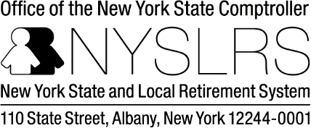
Please type or print clearly in blue or black ink
Received Date
NYSLRS ID Social Security Number [last 4 digits]

XXX-XX-
Change of Address Form

RS 5512

(Rev. 02/23)

Name: | Former Name: (if applicable) |  | Date of Birth: (mm/dd/yyyy)
Old Address Information:
Street Address:
City: | State: |  | Zip Code:
New Address Information:
Street Address 1:
Street Address 2:
City: |  | State: |  | Zip Code:
Daytime Telephone Number: ( ) - |  | E-mail Address:
Signature: |  | Date: (mm/dd/yyyy)

This form cannot be processed without your signature.
Mail this completed form to:
New York State and Local Retirement System Member & Employer Services
Registration- Mail Drop 5-6 110 State Street
Albany, NY 12244

Personal Privacy Protection Law
The Retirement System is required by law to maintain records to determine eligibility for and calculate benefits. Failure to provide information may interfere with the timely payment of benefits. The System may be required to provide certain information to participating employers. The official responsible for record maintenance is the Director of Member and Employer Services, NYS and Local Retirement System, Albany, NY 12244; call toll-free at 1-866-805-0990 or 518-474-7736 in the Albany Area.

*Social Security Disclosure Requirement
In accordance with the Federal Privacy Act of 1974, you are hereby advised that disclosure of your Social Security account number is mandatory pursuant to Sections 11, 34, 311 and 334 of the Retirement and Social Security Law. The number will be used in identifying retirement records and in the administration of the Retirement System.

RS 5512 (Rev. 02/23) Page 1 of 1)

