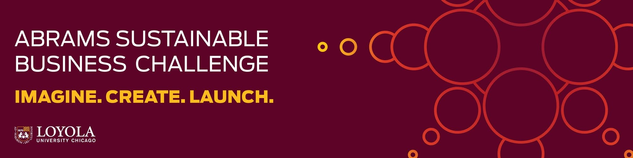

Executive Summary Template
Submissions should be no more than two pages, single-spaced.

Company/Team Name:
Team Members:

Value Creation
Describe the value created by the proposed venture and include the following:
- What significant and critical environmental/social issue does the proposed venture address?
- How does the proposed venture benefit the environment, community, and stakeholders (what sector/s of society will benefit from this venture?)?

Environmental Impact
Describe the positive impact the venture will bring to the environment & society and include the following:
- How will the implementation of this venture benefit the environment, community, and the multiple stakeholders involved?
- What metrics can be used measure the product or venture’s environmental impact?
- Is there potential for a quantifiably significant reduction in waste, greenhouse gas emissions, resource consumption or other environmental impact target upon analysis?

Innovation
Describe how the venture shows an innovative approach to solving an existing problem and include the following:
- How does your proposed venture approach an environmental/social issue in an innovative, original, creative, and comprehensive way?

Venture Viability
Describe how your business idea is viable and implementable and include the following:
- What is the venture’s positioning statement? How will it compete in the market?
- Is the idea itself as well as the business model sustainable (is it realistic and viable over a 5–10- year horizon)?
- Is the venture scalable? To what degree would it need to be scalable for it to compete?
- What type of consumer or customer would be attracted to this venture/product?

Financial Analysis and Forecast
Describe the long-term prospects for viability and success and include the following:
- Does the proposed venture include adequate strategies for revenue generation?
- What type and amount of initial capital investment are required?
- When the venture is scaled, how much additional capital would be required to build it to the point of being a stable venture?

