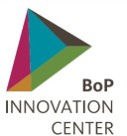

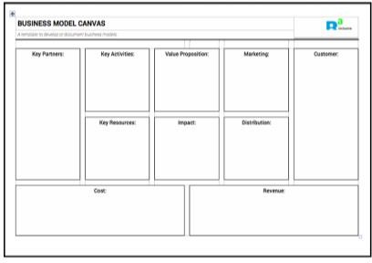
BUSINESS MODEL CANVAS
tool description & worksheet
Version 1.0

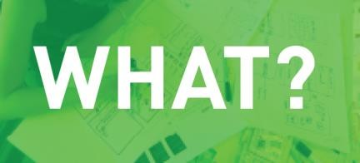
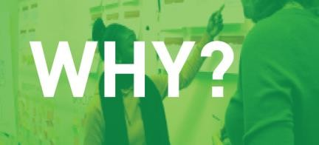

A template to develop or document business models. Helps you describe your customer, the value you bring, how you bring it, how you create revenue and the activities, resources and partners you need to operate.
Offers a quick and straightforward way to discuss and describe your business model and work on it with a larger group of people. Provides a snapshot of your business you can easily present to stakeholders without providing a full business plan.

To fill in the canvas, discuss the following questions:

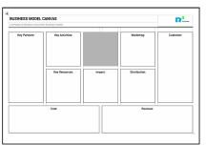
STEP 1: VALUE PROPOSITION
What needs are we satisfying? What problems are we solving? Are we helping customers:
- Satisfy a new set of needs?
- Improve the performance of a product or service?
- Afford something they now can’t?
- Some other way?

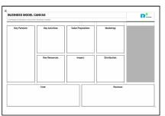
STEP 2: CUSTOMER
Who are our most important customers? Are they:

- A large group with similar needs and problems (mass market)
- A group with very specific, special requirements (niche market)
- A group divided by slight differences in needs and problems (segmented market)
- Made up of very different groups with different needs and problems? (diversified market)
- Made up of interdependent groups (multi-sided markets)

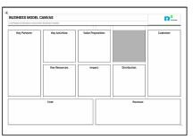
STEP 3: MARKETING
How are we reaching customers and convincing them of the value we offer? How are we:
- Attracting their attention?
- Building their trust?
- Enabling them to experience our product?
- Helping them take action to buy?
- Helping them remember and recommend our product?

STEP 4: DISTRIBUTION
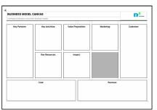
Channels - are we reaching our customers:
- Directly through our own people?
- Indirectly through partners?
- In other ways?
Relationships: What relationships do we have with our customers? Are we:
- Providing personal assistance?
- Offering an automated service?
- Self-service?
- Other?

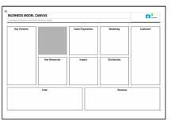
STEP 5: KEY ACTIVITIES
What key activities do our value propositions require?

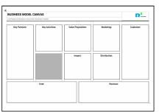
STEP 6: KEY RESOURCES
What key resources do our value propositions require?

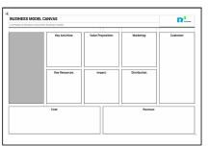
STEP 7: KEY PARTNERS
What is the network of suppliers and others that makes the business work?
What is our goal in working with them? Is it:
- Economies of scale (sharing resources and infrastructure)?
- Reduction of risk?
- Acquisition of resources, skills or activities?
- Another goal?

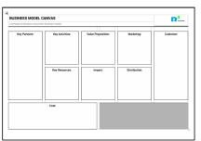
STEP 8: REVENUE
Revenue streams: What are our customers paying for? Are these:
- One-time payments (transaction)?
- Recurring payments (ongoing payments such as subscriptions)?

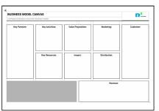
STEP 9: COST
Cost structure: What are the most important costs? Are they:
- Fixed?
- Variable?

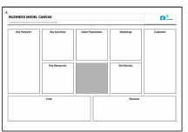
STEP 10: IMPACT
- Social benefits: How will communities as a whole be better off (e.g. occupational safety, female consumer focus)?
- Environmental benefits: How will the environment benefit (e.g. biodiversity, decreased health risks)?
- Economic benefits: How will those involved benefit economically (e.g. greate income through employment, savings, market increase)?

Where uncertainties have come to light, you can research and discuss these in greater depth. Other tools will help focus more closely on these areas.

This tool is based on the ‘Business Model Canvas’:
Osterwalder, Alexander and Peigneur,Yves (2010), Business Model Generation: A Handbook for Visionaries, Game Changers, and Challengers, Hoboken, New Jersey, USA: Wiley

And:
the ‘Link Methodology’:
Lundy, M. et al. (2014) LINK methodology: A participatory guide to business models that link smallholders to markets. Cali, CO : Centro Internacional de Agricultura Tropical (CIAT). Retrieved from http://ciat- library.ciat.cgiar.org/articulos_ciat/LINK_Methodology.pdf

Partners: With support of:

BUSINESS MODEL
CANVAS guidelines for consultants
Version 1.0

The Business Model Canvas is used when creating a new business, or when you need to improve or transform an enterprise or organization. It can be used whenever a broad overview of the enterprise and its network is needed, to uncover opportunities and areas of uncertainty.

To ensure actionable results, keep these guidelines in mind:

PREPARE EXAMPLES IN ADVANCE
Some of the distinctions (for example, between types of customers) can be very abstract and hard to understand. To explain these, you need examples that the people you’re working with will understand.

PROVIDE EXAMPLES ONLY AFTER PARTICIPANTS HAVE GIVEN THEIR INPUT
The examples should be used to help the participants get moving when they are having trouble understanding what to fill in the canvas. Offer examples only after participants have attempted to provide input – otherwise, the examples can be too determining.

ENCOURAGE PARTICIPANTS TO SET PRIORITIES
In each of the sections, it’s important that participants commit to priorities even if they are still uncertain (for example, about which customer segments to focus on). Aim for at least a preliminary decision and commitment.

OTHER TOOLS FROM THE TOOLKIT CAN BE USED TO FILL IN THE SECTIONS
If needed, the following tools can be used to complete sections of the BMC individually, either as preparation or a separate exercises within a workshop:
- Value Proposition
- Customer Persona
- Distribution
- Key Activities & Resources
- Revenue and costs
- Marketing
- Relationship Mapping

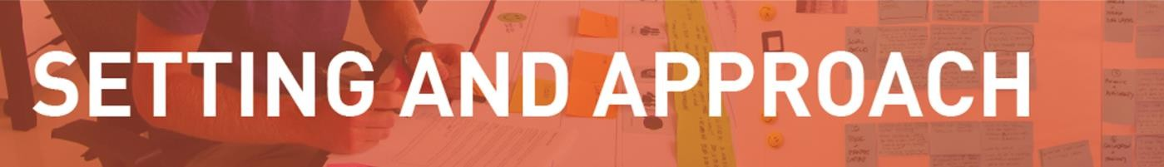

TIME
As little as a 2 hours for a quick exercise, or up to several weeks for ‘deep dives’ into every subject. In a day workshop, for each of the sections you can take between 30 and 90 minutes, with a break to consolidate and discuss results.

MATERIALS
Large print, drawing or slide of the worksheet; pin board or whiteboard; workshop materials (markers, cards, lots of Post-its, etc.)
Keep a set of facilitator cards with examples for each section of the canvas and use these to help participants understand what to fill in.

TEAM
You will need one facilitator and one or more people representing the main parts of the client enterprise.
For larger groups: have people in smaller groups fill in each section and present the outcomes.

DOCUMENTATION
Work with Post-its so you can add and remove elements easily.

Osterwalder, Alexander and Peigneur,Yves (2010), Business Model Generation: A Handbook for Visionaries, Game Changers, and Challengers, Hoboken, New Jersey, USA: Wiley

Partners:

With support of:

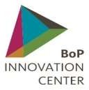
BUSINESS MODEL CANVAS
A template to develop or document business models.
Value Proposition:
Distribution:
Impact:
Key Resources:
Customer:
Marketing:
Key Activities:
Key Partners:
Cost:
Revenue:

