2017
CHRISTMAS
CARDS
PLUS 2018 CHRISTMAS CARD CALENDARS

ALL CARDS ELIGIBLE FOR SEASONAL GREETING CARD DISCOUNT POSTAGE RATE

HIGHEST QUALITY PRINTING
DESIGNED AND MADE EXCLUSIVELY IN AUSTRALIA FREE ENVELOPES WITH EVERY ORDER*
PRICES INCLUDE ARTWORK, GST AND DELIVERY AUSTRALIA WIDE
IN
1710

Part proceeds from every card are donated to The Salvation Army
Red Shield Appeal PRICES INCLUDE ARTWORK,

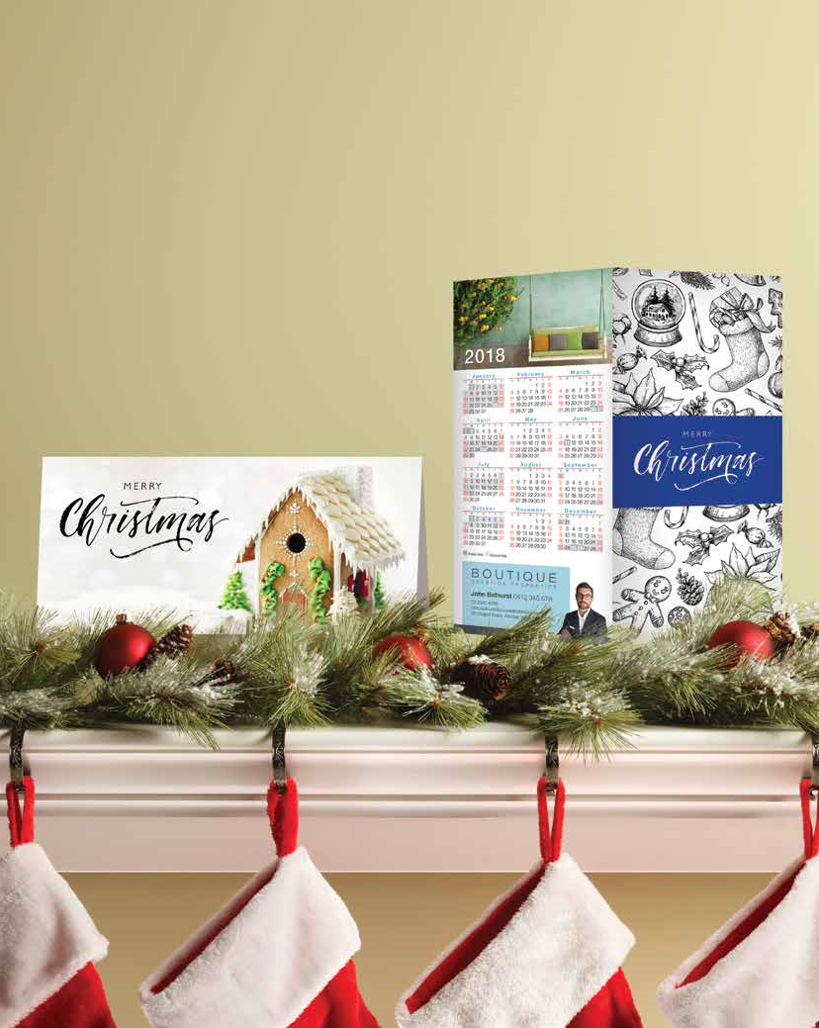Help the Salvos
DELIVERY & GST

Choose your design

Choose from our range of pre-designed Christmas cards. You can still personalise the greeting!

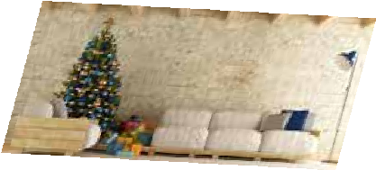Merry Christmas
Photo Christmas Cards
Personalise these templates with your photo.
Christmas Cards with Calendar
Choose your calendar for the back and Christmas card for the front.
Feeling fancy?
Choose one of our Christmas cards featuring gold foil.

Pick your colour

Add your corporate colours to these Christmas Card templates.

Supply your group photo or location shot
to personalise these templates.

Personalise your message
Add your photo and write your own message on the inside.

Choose from one of our flexible designs.
Choose your design
All greetings can be customised to your preference.

Joy to the World.

CH01
CH02

CH03
CH04

CH05

Merry Christmas

CH06
CH07

CH08
CH09

CH10

SEASONS GREETINGS
Happy Holidays.

Seasons Greetings

CH11
CH12

CH13

seasons greetings

CH14
CH15

CH16

Seasons Greetings

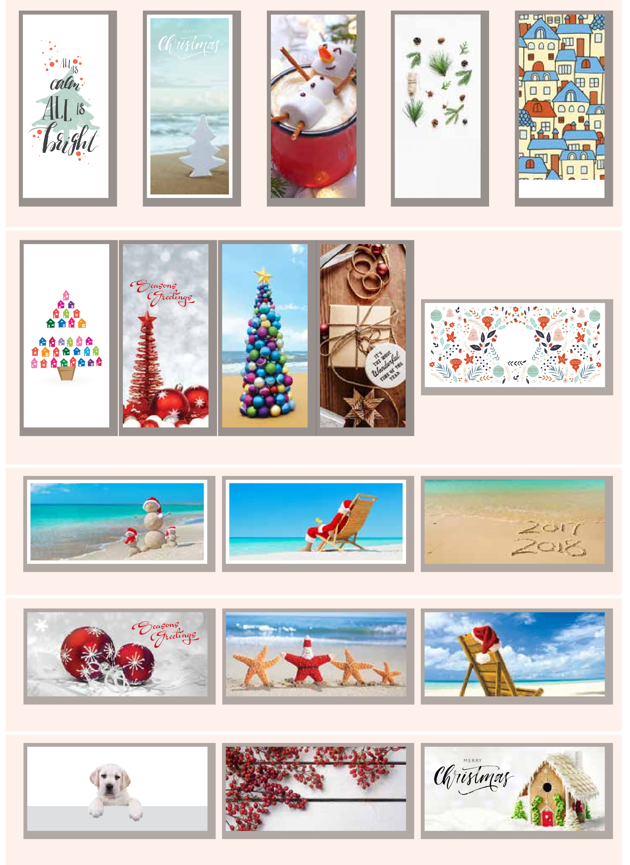CH17
Happy
Holidays
2
18
Year of the Dog
CH18
CH19

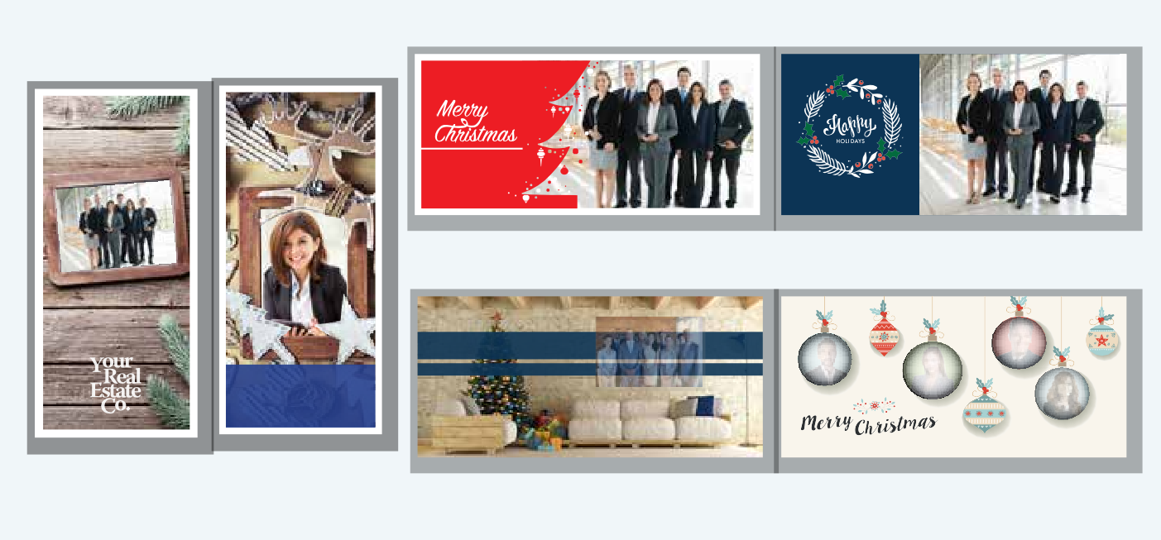Pick your colour
From the Team at Your Realty Co.
From the Team at Your Realty Co.
CH30
CH31
Merry Christmas
From the Team at Your Realty Co.
Merry Christmas
From the Team at Your Realty Co.
CH28
CH29
CH32
CH33
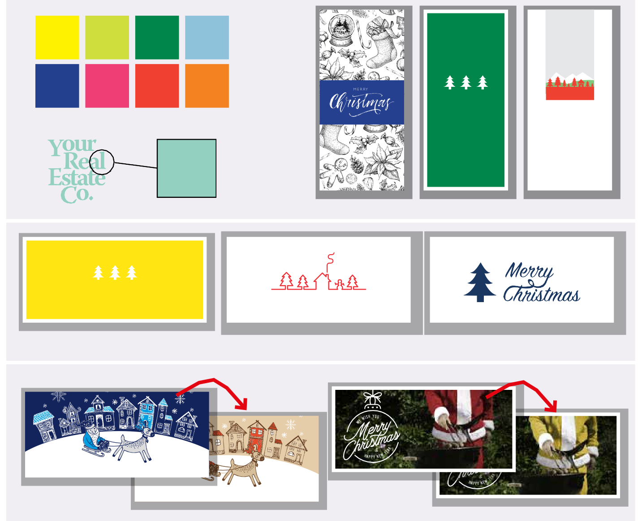
Choose a colour or match your logo!
CH20
CH21
CH22
Merry Christmas
We wish you a very merry Christmas.
CH23
CH24
CH25
Merry Christmas

CH26
Merry Christmas
CH27

Happy Holidays

Merry Christmas
Photo Christmas Cards

Feeling fancy?

QTY Blank Inside Personalised Inside
50 | $106 | $161
75 | $140 | $200
100 | $163 | $229
150 | $214 | $269
200 | $243 | $309
300 | $295 | $389
500 | $483 | $604
750 | $614 | $749
1K | $745 | $894
1.5K $1,008 $1,184

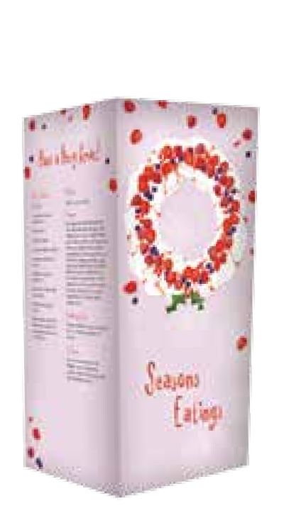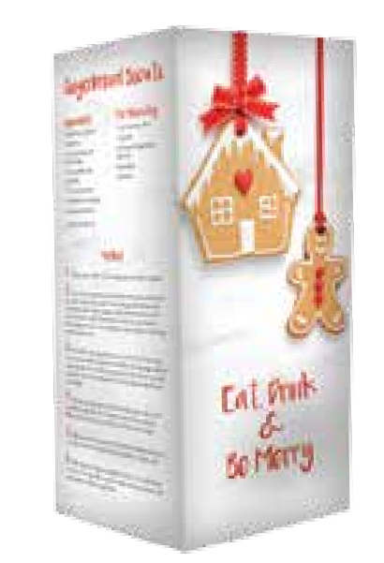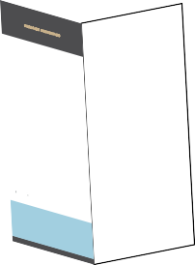Christmas Card Calendars
Choose a linen card featuring
Tis the season to be...
CH34
Christmas
CH35
Recipe Cards
Embrace your inner chef with our
CH36
CH37
Email psutton@printforce.com.au to see our full range of calendars
B O U T I Q U E
J an u ar y Fe b ru a r y M a rc h
A p r il
S M T W T F S S M T W T F S S M T W T F S S M T W T F S
1 2 3 4 5 6 1 2 3 1 2 3 1 2 3 4 5 6 7
7 8 9 10 11 12 13 4 5 6 7 8 9 10 4 5 6 7 8 9 10 8 9 10 11 12 13 14
14 15 16 17 18 19 20 11 12 13 14 15 16 17 11 12 13 14 15 16 17 15 16 17 18 19 20 21
21 22 23 24 25 26 27 18 19 20 21 22 23 24 18 19 20 21 22 23 24 22 23 24 25 26 27 28
28 29 30 31 25 26 27 28 25 26 27 28 29 30 31 29 30
Boutique Prestige Properties
02 2345 6789
info@yourrealestateco.com.au 56 Chapel Road,
Ashdan Valley NSW 2000
M ay J un e
Ju l y
Au g u s t
S M T W T F S S M T W T F S S M T W T F S S M T W T F S
1 2 3 4 5
1 2 1 2 3 4 5 6 7 1 2 3 4
6 7 8 9 10 11 12 3 4 5 6 7 8 9 8 9 10 11 12 13 14 5 6 7 8 9 10 11
13 14 15 16 17 18 19 10 11 12 13 14 15 16 15 16 17 18 19 20 21 12 13 14 15 16 17 18
20 21 22 23 24 25 26 17 18 19 20 21 22 23 22 23 24 25 26 27 28 19 20 21 22 23 24 25
27 28 29 30 31 24 25 26 27 28 29 30 29 30 31 26 27 28 29 30 31
Sep t em b er O c to b e r N ov e m b e r De c e m b e r
S M T W T F S S M T W T F S S M T W T F S S M T W T F S
CX2 Landscape
30 1 1 2 3 4 5 6 1 2 3 30 31 1
2 3 4 5 6 7 8 7 8 9 10 11 12 13 4 5 6 7 8 9 10 2 3 4 5 6 7 8
9 10 11 12 13 14 15 14 15 16 17 18 19 20 11 12 13 14 15 16 17 9 10 11 12 13 14 15
16 17 18 19 20 21 22 21 22 23 24 25 26 27 18 19 20 21 22 23 24 16 17 18 19 20 21 22
23 24 25 26 27 28 29 28 29 30 31 25 26 27 28 29 30 23 24 25 26 27 28 29
© 2017 P17N000000.000 Printforce.com.au (08) 9223 2400
Large magnet attached
CX1 Portrait

Choose portrait or landscape, then your Christmas cover and calendar choice.

Prices
CONTACT INFORMATION
*Free envelopes included with christmas cards only. Must be purchased
separately with Christmas Card Calendars.
 | Silk Matt 300gsm |  |  | Linen 330gsm
QTY  50 | Blank Inside Personalised Inside |  |  | Blank Inside Personalised Inside
 | $85 |  | $135 | $94 |  | $149
75 |  | $110 | $165 |  | $121 | $182
100 | $125 |  | $185 | $138 |  | $204
150 | $160 |  | $210 | $176 |  | $231
200 | $175 |  | $235 | $193 |  | $259
300 | $200 |  | $285 | $220 |  | $314
500 | $325 |  | $435 | $358 |  | $479
750 | $388 |  | $510 | $426 |  | $561
1K | $450 |  | $585 | $495 |  | $644
1.5K | $575 |  | $735 | $633 |  | $809

Personalised Prices are for black only, please phone for quote if other colours are required.

Delivery: 2-7 days from proof approval Front of card full colour | Inside of card full colour

Order yours now:
- Simply Order Online at printforce.com.au
Log In > Office Marketing > Christmas Cards / Calendars

OR fill out the fax form below

EMAIL: christmascards@printforce.com.au FAX: 1800 999 019

Xmas Card with Calendar
QTY 300gsm Artboard
50 $175
75 $205
100 $235
150 $265
200 $295
300 $355
400 $405
500 $455
600 $495
800 $565
1K $615
2K $915
3K $1110
4K $1410
5K $1870
7.5K $2175
10K $2800
10K+ POA
WHITE ENVELOPES
1K $40 / 1000
Delivery: 4 -10 days from proof approval

CHRISTMAS CARD CHOICE
Card Number:

NOTE: If you want a printed message (in black) inside your card, please write a message below. If you are purchasing
“Blank inside” cards, ignore this section.

INSIDE MESSAGE

Contact Person: Date:

Office Name:

Address:

Suburb/Town:

State: Postcode:

Tel: Fax:

Email:

Web Address:

PAYMENT Account, Cheque or Credit Card No

FREE ENVELOPES
White Self Seal White Lik’n’Stik Red Peel’n’Seal
* White Self Seal Envelopes will be supplied by default unless stipulated.

Visa Master Card

Name on Card Card Expiry Date Signature

Information/online ordering assistance

The following message, and Logo, is standard on the inside of every card. If you wish to have this message removed from your Christmas Cards, please tick below.
Please remove the Salvation Army Logo from my cards

Part proceeds from every card are donated to The Salvation Army Red Shield Appeal.
Call 08 9223 2400 or
Email christmascards@printforce.com.au
Order Online

