Sponsorship form

Event name: Event date: Your name: Address:

Postcode:
Telephone:
Email: Your Mind number:
Please tick below if you would like Mind to reclaim the tax you’ve paid on this
donation. Please read the details and declaration at the bottom of the page. Remember: You must provide your full name, home address, postcode and tick the ‘Gift Aid’ box for Mind to claim tax back on your donation.

Full name (please PRINT) | Home address (please PRINT) | Postcode | Donation amount (£) | Date paid | Gift Aid?*  (please tick)

*By ticking the box headed ‘Gift Aid?’, I confirm that I am a UK Income or Capital Gains taxpayer. I have read this statement and want Mind to reclaim tax on the donation detailed above, given on the date shown. I understand that if I pay less Income Tax / or Capital Gains tax in the current tax year than the amount of Gift Aid claimed on all of my donations it is my responsibility to pay any difference. I understand that Mind will reclaim 25p of tax on every £1 that I have given.

Full name (please PRINT) | Home address (please PRINT) | Postcode | Donation amount (£) | Date paid | Gift Aid?*  (please tick)

Payment

Over the phone
Call us on 0300 999 3887 and we’ll happily take a payment. It would be good to hear from you!

Send us a cheque
Make cheques (including any CAF cheques) payable to Mind and send to:
Freepost RTUG-HBJJ-RZLT, Mind Community and Events, 15–19 Broadway, London, E15 4BQ Please include your Mind number and event on the back and post us your sponsor forms.

Pay funds in by Bacs transfer:
NatWest Bank Account no: 5889 6961
Sort Code: 60 40 02
Please use your Mind number as your reference.

Contact us
For more information or support please contact the Mind Community and Events Team:
t: 0300 999 3887
e: community@mind.org.uk / events@mind.org.uk mind.org.uk/events

Download more sponsorship forms at:
mind.org.uk/sponsorshipform

Please tick above if you would like Mind to reclaim the tax you’ve paid on this
donation. Please read the details and declaration below. Remember: You must provide your full name, home address, postcode and tick the ‘Gift Aid’ box for Mind to claim tax back on your donation.

*By ticking the box headed ‘Gift Aid?’, I confirm that I am a UK
Income or Capital Gains taxpayer. I have read this statement and want Mind to reclaim tax on the donation detailed above, given on the date shown. I understand that if I pay less Income Tax / or Capital Gains tax in the current tax year than the amount of Gift Aid claimed on
all of my donations it is my responsibility to pay any difference. I understand that Mind will reclaim 25p of tax on every £1 that I have given.

How we process the information you provide
We take your privacy seriously and will use your data to process your donation, claim Gift Aid (if you want us to) and contact you on any administrative matters that may come up. We promise never to sell your data.
You can find out more about your rights, how we use your personal information and how we keep your details safe and secure by reading our Privacy Policy here mind.org.uk/legal-info/privacy-policy/. For more information, contact our Supporter Relations team at supporterrelations@mind.org.uk
or on 020 8215 2243.

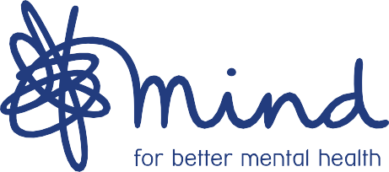
Registered Charity number 219830

