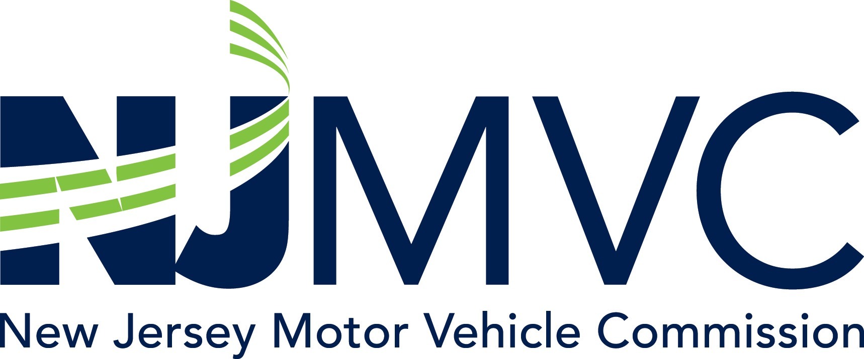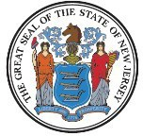

A FFID A V I T

I, the undersigned, certify that I am the surviving spouse or domestic partner of
, as recognized by the State of New Jersey or a competent jurisdiction. The decedent's name and my name,
, appear on certificate of title number
as follows:
. I further certify that from the time my name and the decedent's name appeared on the certificate of title until the death of the decedent on , our relationship was that of a marriage or domestic partnership.

X Signature

Sworn and subscribed before me this

day of , 20

Notary Public of New Jersey

BA-62 (R7/21)

