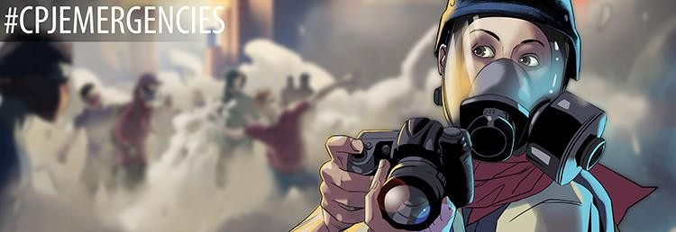
Artwork: Jack Forbes

CPJ Emergencies Risk Assessment Template

This risk assessment form can be used by any journalist, reporting team, or editor planning an assignment. Some of the fields may not necessarily be relevant to your specific assignment -- the form is intended to serve as best practice guidance when completing a risk assessment.

Before completing any risk assessment form, all journalists, including freelancers, should have a conversation with relevant team members/editors or even family members/friends, who should have copies of the completed form.

When completing this form, it is important to document in as much detail as possible the dangers an individual journalist or reporting team may be exposed to; to assess how to mitigate those risks; and to include a contingency plan. For additional details on questions that should be considered and information that should be included in this form, please see CPJ’s Safety Note on Basic Preparedness.

BASIC INFORMATION
Assignment Description
Location(s)
Project Schedule
Please include information about dates, accommodation(s) and transportation (e.g. flight/train numbers)
Team Member(s): Full Name(s) & Contact Number(s)
Emergency Contact Details
Please include the full name, contact number, and relationship of an emergency contact for each team member
PHYSICAL SECURITY
Describe below foreseeable risks that could affect the project during and after broadcast/publication.
Include how you will mitigate the risks.
For good practice, please see the CPJ Safety Kit.

Have you considered the potential threats related to conflict and violence?
How do you plan to mitigate these threats?

Please see CPJ’s Safety Note on War Reporting for more information.
Is there a risk of terrorist attacks? How do you plan to mitigate this risk?

Please see CPJ’s Safety Note on covering Terrorist Attacks for more information.
Have you considered threats related to crime (including the threat of kidnapping)? How do you plan to mitigate this risk?
Are there any potential issues associated with past reporting done by any individual involved in the assignment that may increase the risk to that individual or to the reporting team?
How do you plan to mitigate these threats?
Have you researched the risk of infectious diseases and/or other health issues in the location you're reporting from? What action will you take to mitigate these risks?
Are there any risks associated with potential protests or rallies? How do you plan to mitigate these risks?

Please see CPJ’s Safety Note on covering Civil Disorder for more information.
Have you considered whether there is a need for personal protective equipment (PPE) during this assignment? If there is a need, what PPE do you plan to use? Does everyone on the team know / have training on how to use the
recommended PPE?
Are there risks of verbal, physical and /or sexual intimidation? How do
you plan to mitigate these risks?

Please see CPJ’s Safety Note on Mitigating Sexual Violence for more information.
Is there a risk of arrest or detention? How do you plan to mitigate this risk?
Have you considered transportation issues? Please describe your contingency plan here.

Are there any risks associated with corruption? How do you plan to mitigate these risks?
Are there any risks regarding the weather or other environmental hazards?
How will you mitigate the associated risks?

Please see CPJ’s Safety Note on Natural Disasters and Extreme Weather for more
information.
Have other journalists previously encountered issues covering this story? If so, identify the issue(s) and what steps you will take to mitigate the risks.
Review your online profile. How could your profile put you at risk with regards to this story?

Provide details on how you will reduce this risk.
DIGITAL SECURITY
Describe below foreseeable digital security risks that could affect the project during and after broadcast/publication.
Include how you will mitigate the risks.
For good practice, please see the CPJ’s Digital Safety Kit.
Have you researched online threat actors linked to your story or location?
How will you mitigate this risk?
Have you thought about how to communicate securely with sources? What tools will you use and why will
you use them?
Do you have a plan for the secure backup and transmission of data?
Provide details on how you will do this.
Have you thought about how you will carry out online research securely? What steps will you take to mitigate
risk?
Do you know what information is on your devices and how that puts you at
risk?
Are you aware of best practice for crossing borders with devices? What steps will you take to mitigate the risk?

Please see CPJ’s Safety Note for Journalists Crossing the U.S. Border for more information.

PSYCHOLOGICAL SAFETY
Describe below foreseeable psychological risks that could affect you or team members during and after broadcast/publication.
Include how you will mitigate the risks.
For good practice, please see CPJ’s Safety Note on Psychological Safety.
Have you considered psychosocial risks linked to the story, including any risks associated to online harassment or any other digital threats?

Please see CPJ’s Safety Notes on Psychological Safety and Online Harassment and How to Protect Your Mental Health for more information.
Is there a plan in place for debriefing all members of the reporting team, including freelancers, photographers, and editors, following the assignment?
If necessary, is there a plan in place for helping secure psychosocial or trauma support for all members of the reporting team, including freelancers,
photographers, and editors?
CHECK-IN PROCEDURES & EMERGENCY CONTACTS
Please complete the following section with as much detail as possible
Please indicate your check-in times and the agreed point of contact. You should include telephone numbers for each member of the reporting team, the point of contact, the time zone/s where you will be operating, and the agreed-upon mode of communication (Signal,
WhatsApp, SMS).
Please include information on relevant insurance
(please include the provider's 24-hour emergency assistance phone number, as well as the policy number and dates of validity)

For more information on insurance schemes available to freelance journalists and local
media, please visit the insurance page from the ACOS Alliance.
Please indicate other useful contacts in case of an emergency (include telephone numbers).
Please include detailed emergency and medical procedures here.

If applicable, please include emergency legal contacts here.
Please indicate any other relevant information.

CPJ’s online Safety Kit provides journalists and newsrooms with basic safety information on physical, digital, and psychological safety resources and tools. Journalists who need assistance should contact CPJ via emergencies@cpj.org.

If you would like to subscribe to receive periodic email from CPJ on safety information, please sign up here and select “CPJ safety advisories.” You can also follow #CPJEmergencies for up- to-date information on physical, digital, and psychological safety.

