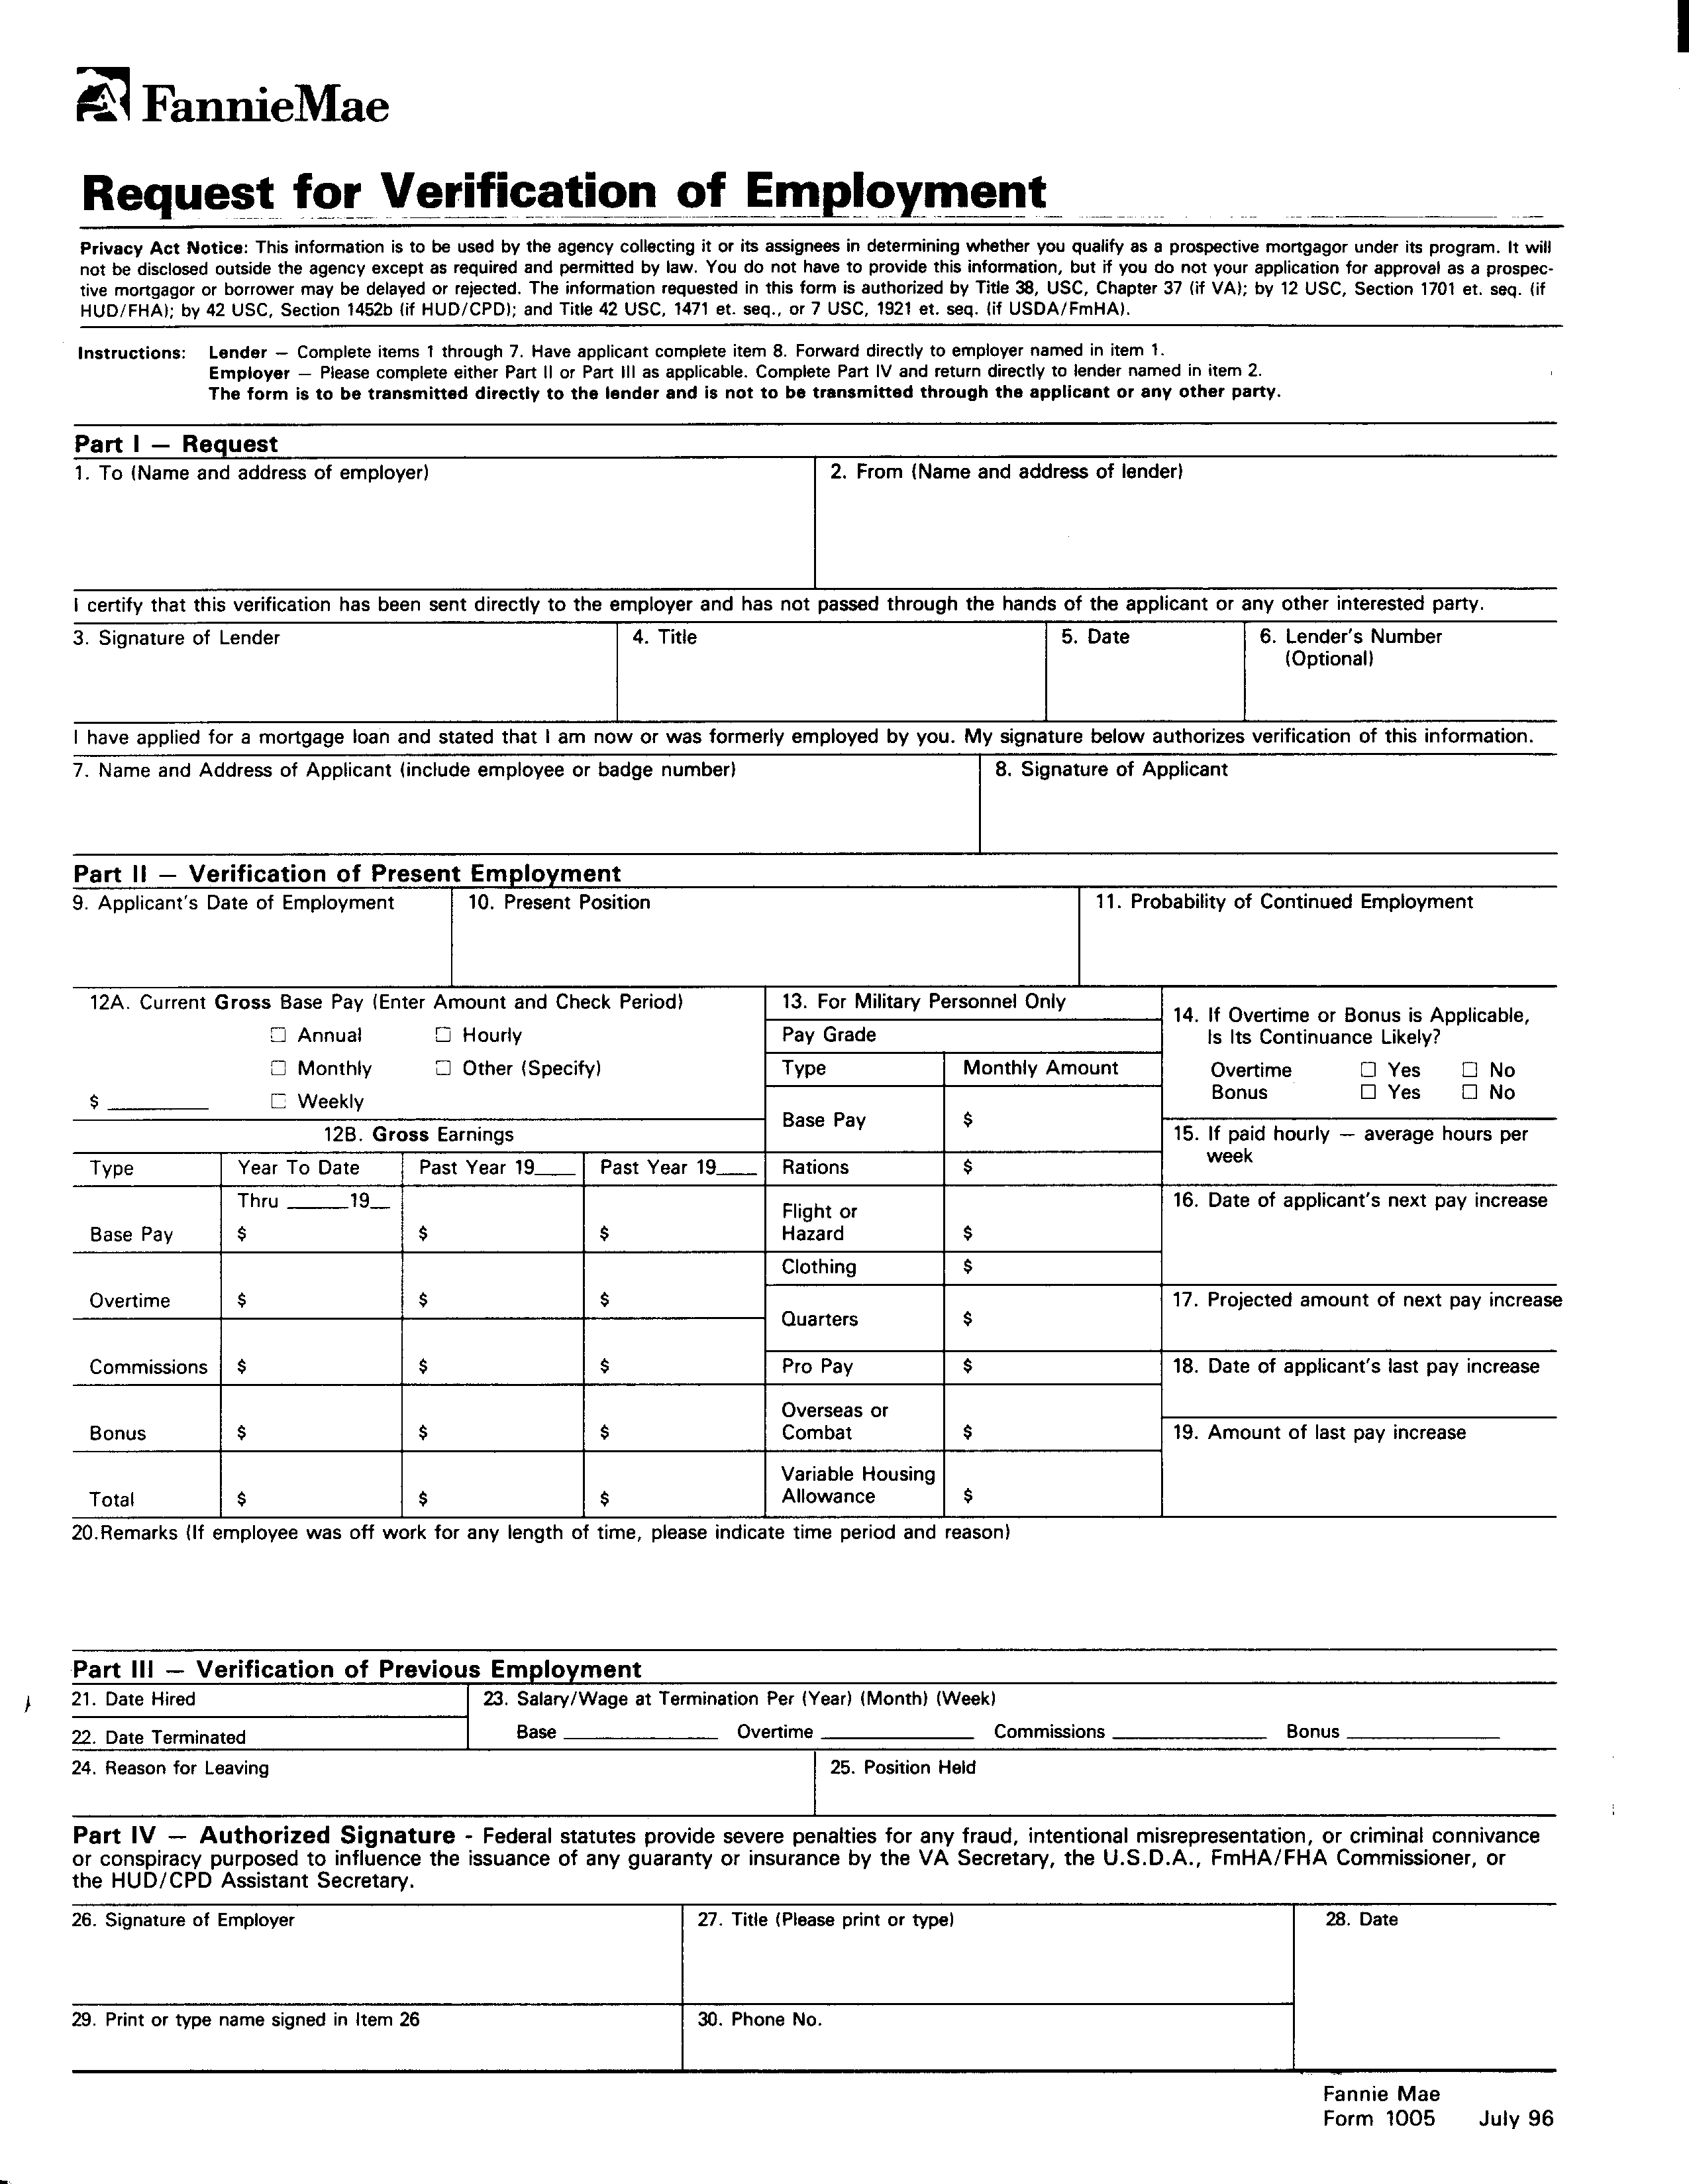

0.00 0.00 0.00

Verification of Employment
Instructions

The lender uses this form for applications for conventional first or second mortgages to verify the applicant's past and present employment status.

Copies
Original only.

Printing Instructions
This form must be printed on letter size paper, using portrait format.

Instructions
The applicant must sign this form to authorize his or her employer(s) to release the requested information. Separate forms should be sent to each firm that employed the applicant in the past two years. However, rather than having an applicant sign multiple forms, the lender may have the applicant sign a borrower's signature authorization form, which gives the lender blanket authorization to request the information it needs to evaluate the applicant's creditworthiness. When the lender uses this type of blanket authorization, it must attach a copy of the authorization form to each Form 1005 it sends to the applicant's employer(s).

For First Mortgages:
The lender must send the request directly to the employers. We will not permit the borrower to hand-carry the verification form. The lender must receive the completed form back directly from the employers. The completed form should not be passed through the applicant or any other party.

For Second Mortgages:
The borrower may hand-carry the verification to the employer. The employer will then be required to mail this form directly to the lender. The lender retains the original form in its mortgage file.

Instructions Page

