How to Read an American Wine Label

Grown Entirely On The Estate

Grape Variety

Vintage
Winery Name

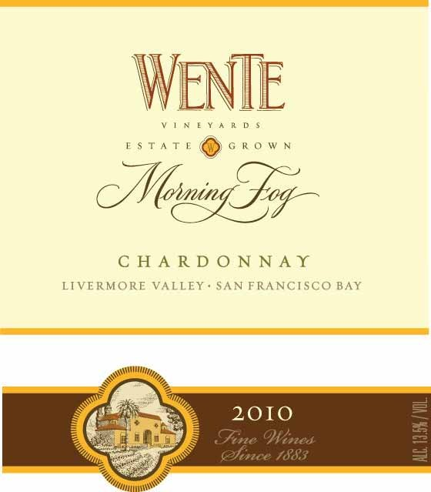Denotes Special Vineyard Designation

A.V.A. American Viticultural Area

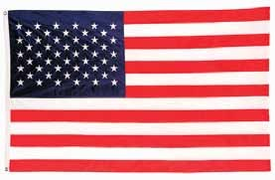

Alcohol Content

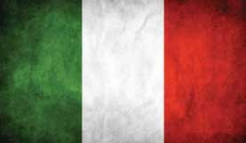
How to Read an Italian Wine Label

Standard of Quality Indicator
Name of Wine Grape Variety
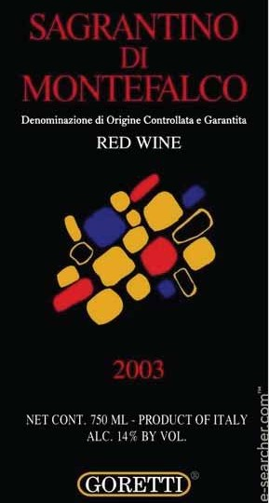/Blend

Contents of Bottle Alcohol Content
Vintage
Country of Origin Name of Producer

How to Read a French Wine Label

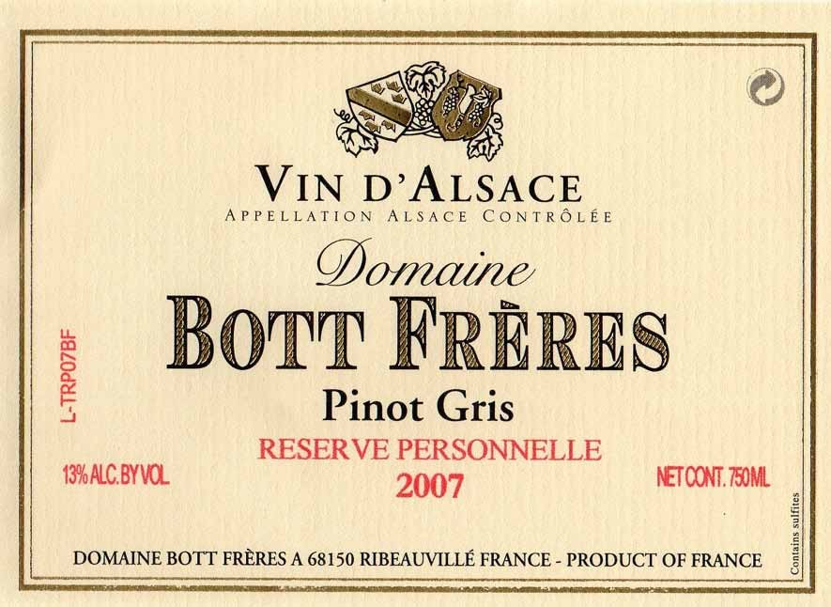Standard Of Quality Indicator

Name Of Domaine

Alcohol Content
Name Of Wine

Contents Of Bottl

Address Where the Wine Was Bottled
Country Of Origin

How to Read a German Wine Label

Producer (Winery)

Vintage

Varietal Sugar Level
Country Of Origin Address Where the

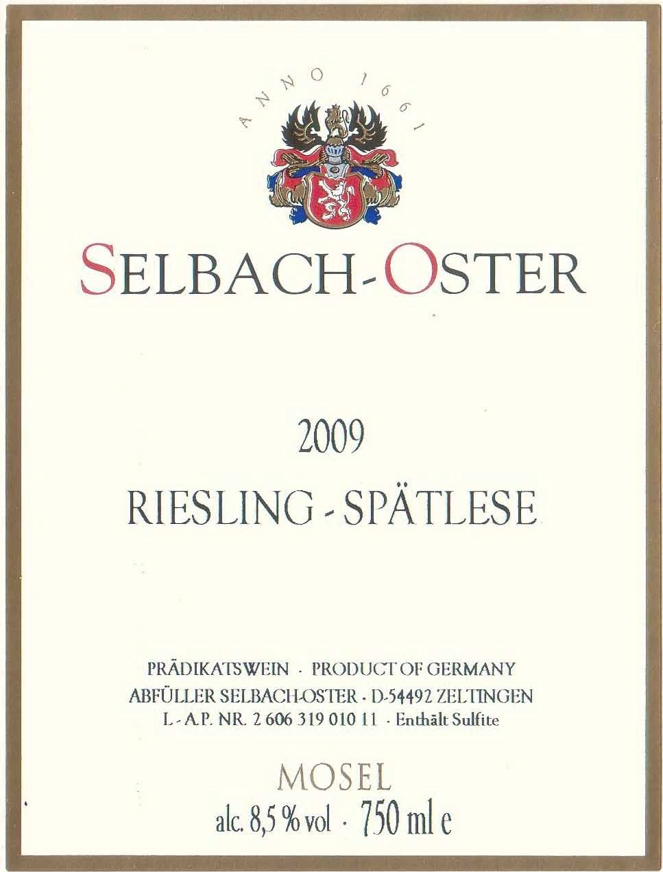Region/Appellation Contents Of Bottle
Wine Was Bottled

Alcohol Level

