GOZNYM SUBJECTS

COMPUTER FRAUD CONSPIRACY; WIRE AND BANK FRAUD CONSPIRACY; MONEY LAUNDERING CONSPIRACY
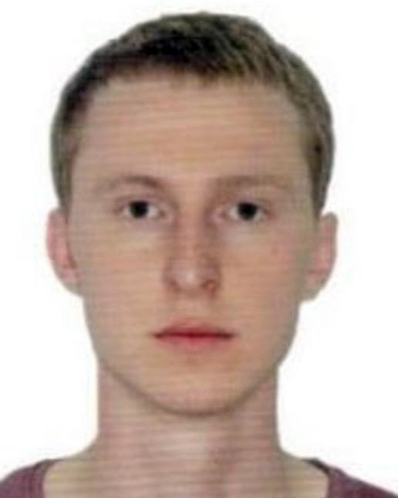
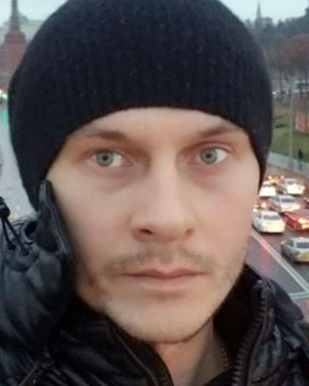
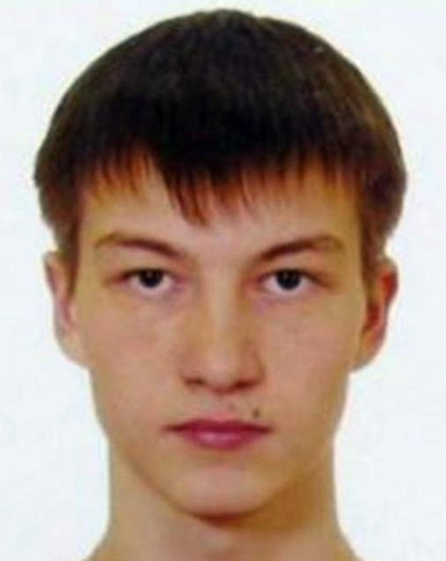
Viktor Vladimirovich Eremenko Vladimir Gorin Ruslan Vladimirovich Katirkin
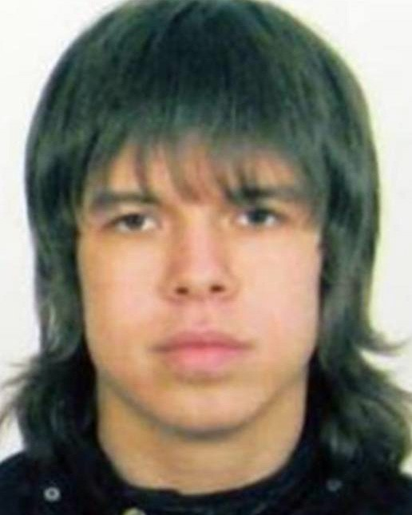
Farkhad Rauf Ogly Manokhin Konstantin Volchkov

DETAILS
On April 17, 2019, a federal grand jury sitting in the Western District of Pennsylvania returned an indictment against five Russian nationals for their alleged roles in a sophisticated computer hacking campaign that used GozNym malware to steal millions of dollars from victims in the United States, primarily businesses and their financial institutions. The indictment charges that, from October of 2015 through December of 2016, Viktor Vladimirovich Eremenko, aka “nfcorpi”, Vladimir Gorin, aka “Voland”, “mrv”, and “riddler”, Farkhad Rauf Ogly Manokhin, aka “frusa”, Konstantin Volchkov, aka “elvi”, Ruslan Vladimirovich Katirkin, aka “stratos” and “xen”, and five others, allegedly conspired to infect victims’ computers with GozNym malware designed to capture victims’ online banking login credentials; use the captured login credentials to fraudulently gain unauthorized access to victims’ online bank accounts; and steal money from victims’ bank accounts and launder those funds using United States and foreign beneficiary bank accounts controlled by the conspirators. The indictment charges these defendants with computer fraud conspiracy, wire and bank fraud conspiracy, and money laundering conspiracy. On April 18, 2019, the United States District Court for the Western District of Pennsylvania in Pittsburgh, Pennsylvania, issued a federal arrest warrant for each of these defendants upon the grand jury’s return of the indictment.

THESE INDIVIDUALS SHOULD BE CONSIDERED AN INTERNATIONAL FLIGHT RISK AND AN ESCAPE RISK
If you have any information concerning these individuals, please contact your local FBI office or the nearest American Embassy or Consulate.

Field Office: Pittsburgh

www.fbi.gov

