Terminology Services

EDITOR’S TRAINING MANUAL

Data Standards Branch
EPA / Office of Environmental Information

April 2013

TABLE OF CONTENTS
EPA Terminology Services 1
Training Overview 1
Introduction to EPA Terminology Services 1
What is a Vocabulary? 3
Roles and Permissions 4
Finding out More ~ Related Resources 5
  - GETTING STARTED – LOGGING IN, SELECTING A TASKVIEW & SEARCHING, LOGGING OUT6
  - Logging into the Terminology System 6
  - Viewing Existing Terms 6
  - Finding a Term in a Specific Vocabulary 8
  - Viewing All the Terms in a Vocabulary 9
  - Logging out of a Vocabulary 10
  - CREATING AND MODIFYING GLOSSARIES AND LISTS OF TERMS & DEFINITIONS 10
  - Adding Terms and Definitions to an Existing Vocabulary 10
  - Adding Definitions to an Existing Term 12
  - Deleting Definitions and Terms 14
  - Adding and Deleting categories to an existing term 16
  - CREATING AND MODIFYING TAXONOMIES AND THESAURI 17
  - Adding Terms to an Existing Hierarchy 17
  - Adding Term Relationships 18
  - Modifying Term Relationships 21
- PUBLISHING A VOCABULARY/CREATING REPORTS 23
- SETTING UP A NEW VOCABULARY 29

EPA Editors’ Training Manual, April 2013 Page i

EPA TERMINOLOGY SERVICES

Training Overview
The EPA Terminology Services is a system to create, modify, manage and publish terminology systems, including glossaries, classification schemes, taxonomies, and thesauri.
This training manual consists of the following main sections:

- An Introduction to EPA Terminology Services
- Getting Started – Logging on, Selecting a Taskview and Searching
- Creating and Modifying Glossaries & Lists of Terms and Definitions
- Creating and Modifying Taxonomies and Other Hierarchies
- Publishing a Vocabulary
- Setting Up a New Vocabulary

The training begins with a general introduction to the EPA Terminology Services. This is followed by two modules—one for vocabularies that are simple terms and definitions and the other for vocabularies that have hierarchical structures. You may work through both components or focus on the vocabulary type in which you are most interested.
Each training module provides step-by-step instructions on performing a series of functions.
- Steps that you should perform are presented in bold.
- Strings to be entered as exact input are presented in Underline.
- The system response is presented or described in italics.
- Explanatory text is in regular font.

Introduction to EPA Terminology Services
The EPA Terminology Services is a web-based system and suite of services for creating, maintaining, searching and publishing vocabularies. It consists of five components:

Content

The EPA Terminology Services is a repository of terms of importance to the EPA, its stakeholders and partners. It currently includes a selection of vocabularies, including those that were in the system’s predecessor, the Terminology Reference System (TRS). Some vocabularies have been archived until their quality can be assessed. The remaining vocabularies are in an Active Vocabularies taskview. A taskview is a pre-selection of vocabularies related to specific task. The vocabularies that you can see and the functions you can perform are managed by a series of taskviews which group vocabularies together and by permission levels assigned to your user account.

The content includes:

- Terms and definitions from environmental regulations and laws
- Glossaries, term lists and hierarchical terminology resources produced by EPA programs
- Classification schemes produced for use in SoR services
- Glossaries, term lists, and hierarchical terminology resources from state and other partners
- The GEMET (General Multilingual Environmental Thesaurus) from the European Environment Agency, including the Americanized English version contributed by EPA

Tools

The main tool of the EPA Terminology System is Synaptica® by Synaptica LLC, a commercial- off-the-shelf product to create, store, maintain, and distribute vocabularies. The functionality provided by the Synaptica tool is the main focus of the Editors’ Training Manual which is available at https://ofmext.epa.gov/sor_extranet/registry/termreg/, click on “Outreach and Education” tab, click “Educational Resources”, then “Manuals”.

Figure 1: Terminology System High Level Data Model
Meta Data
Vocabulary & Relationship Definition & Rules
Terms Subjects, Names, etc.
Relationship Links
Extended Attributes
Notes fields, etc.

Used with permission of Synaptica LLC. This diagram is proprietary and not for redistribution.

The terminology system is based on a data model that can accommodate various types of vocabularies from simple code lists to terms and definitions to complex hierarchies (see Figure 1). The system also contains metadata about each vocabulary. The vocabularies contain terms which may be linked by one or more relationship types. Terms may have extended attributes such as note or source fields.

Currently, there are two main types of vocabularies in Terminology Services:

- Terms and definitions (non-hierarchal)
- Terms organized into hierarchies, such as taxonomies and thesauri

Governance

Collaborative governance approaches are being developed that will support consistent development of vocabularies across EPA in order to promote search and reuse; and bring communities of interest together to create terminology, definitions, and mappings/documentation of differences. Several governance structures have been developed to date, and can be accessed via the Terminology Services website. Additional information about best practices in vocabulary development and governance is provided in Best Practices in Terminology Development and Management: A Guide for Editors and Stewards. (See https://ofmext.epa.gov/sor_extranet/registry/termreg/, click on “Outreach and Education” tab, click Educational Resources, then “Manuals”. The manual is found at the bottom of the page.)

Services

Machine-to-Machine Services

APIs and Web Services are available that allow other systems to access the vocabularies managed in the Terminology Services. For API and Web Services documentation, see the Terminology Services Automated Services website. (See https://ofmext.epa.gov/sor_extranet/registry/termreg/automatedservices/)

Vocabulary Training and Development Services

A series of other services are available to support your vocabulary efforts. Individual or group training sessions can be provided tailored to the needs of your group. In addition, the Terminology Services team within the Data Standards Program is available to consult with you about the design of your vocabularies, to discuss appropriate governance structures and procedures, to discuss the integration of your vocabulary with other systems, to help with the import of existing vocabularies into the terminology system, and to develop customized reports to support the management or publication of your vocabulary.

What is a Vocabulary?
A vocabulary is a grouping of terms that have something in common. Vocabularies may come from a particular subject area, such as drinking water; a document or event, such as a law or regulation that has been passed; or the work of a particular EPA program, project, stakeholder, or partner, such as a glossary published by an EPA Regional Office.

Each vocabulary in Terminology Services is described in the Vocabulary of Vocabularies, a taskview maintained by the Terminology Services Coordinator that consists of the Vocabularies file which contains metadata for each vocabulary. Included in the Vocabularies file is the language(s) of the terms, the source, the publishing organization, the editor’s contact information, etc. This file is accessed by the read-only interface to provide a list of the vocabularies and information about them. Each vocabulary is given a vocabulary type, which is closely related to the structure. The vocabulary types are managed in the Vocabulary Type file. For example, of the types listed below, the Glossary and Key Word Lists are simple terms with or without definitions. Taxonomies and Thesauri have hierarchical structures and may or may not have definitions. Abbreviation and Acronym List are acronyms or abbreviations paired with

its spelled out term without definitions. To date, the following vocabulary types have been defined for Terminology Services:

.

Vocabulary Type | Definition
Abbreviation and Acronym List | Terms, abbreviations, and acronyms from a subject, field, or project. These terms do not have definitions. The abbreviations and acronyms are paired with their  expanded term using associated relationships.
Glossary and Key Word List | Terms from a subject, field or project which may have definitions.
Taxonomy | Terms organized into broader-narrower relationships based on some presumed natural order.
Thesaurus | Terms related by broader-narrower, synonymous,  associated (related) and other more specific relationships based on international or national standards.

Roles and Permissions
The Terminology Services Coordinator is responsible for supporting vocabulary developers by maintaining the terminology system and providing related services. They set general guidance for the use of the system and promote the use of the system through training and outreach. The System Administrator supports the Coordinator by performing specific activities for vocabularies in Terminology Services. These functions include creating vocabularies, extending the attributes, assigning and modifying permissions, creating new relationship types, and supporting the development of reports.
Your profile within the system dictates which vocabularies you can access and what you can do with each vocabulary. Levels of access and permission ensure that the changes to the vocabularies in the system are performed by the appropriate people and as part of an agreed upon workflow. These profiles are created by the Terminology Services Coordinator.

The following list provides a general description of the roles and general functions that can be performed.

- Administrator
  - Set up vocabulary metadata
  - Replicate vocabulary models
  - Add data elements to vocabularies
  - Control taskviews (user profiles)
  - Set permissions
- Editor
  - Add, deactivate and delete terms
  - Add and modify relationships
  - Add, delete, and modify other content such as definitions
- “Public”

  - Read-Only Access depending on taskview
  - Comment to the editor or the Terminology Services Coordinator via standard comment box

The vocabularies, roles, and permissions are controlled by the user’s taskview. The taskview provides flexibility in that a person can have editor’s access (creation and modification privileges) to one vocabulary and read-only access to another. The taskview allows the same vocabularies and permissions to be granted to a group of users.

Finding out More ~ Related Resources

Additional information about EPA’s Terminology Services is available from the Terminology Services Outreach and Education, Educational Resources website (https://ofmext.epa.gov/sor_extranet/registry/termreg/outreachandeducation/educationalresources/). It provides access to the other manuals mentioned in this document, more detailed manuals from the vendor, and presentations about this project.

For more information, contact:

Angelina Hurst
Terminology Services Coordinator EPA, Office of Information Collection hurst.angelina@epa.gov
(202) 566-0701

GETTING STARTED – LOGGING IN, SELECTING A TASKVIEW & SEARCHING, LOGGING OUT
The first steps in accessing EPA Terminology Services are the same regardless of the type of vocabulary. This section will teach you how to:

    - Log into Terminology Services
    - View existing terms
    - View a whole vocabulary
    - Log out of the system

The following sections and the practice exercises are based on a series of personal training vocabularies in the Training Taskview. This vocabulary allows you to make additions and changes without impacting other vocabularies. If you do not have access to the Training Taskview or a training vocabulary assigned to you, contact the Terminology Services Coordinator to have one created.

Logging into the Terminology System

Enter the Terminology System by entering https://etss.epa.gov from your browser. Note that the system works best if you use Internet Explorer.
A windows log-in box is displayed.
Enter your User ID and Password. Your User ID and Password are the same as your EPA Portal Login/Password. If you do not have EPA Portal access, go to http://portal.epa.gov and request access using the Terminology Services Coordinator as the EPA contact. If you have EPA Portal access and do not have access to Terminology Services – Synaptica KMS, contact the Terminology Services Coordinator.

If the User ID and Password are accepted, the editor’s page is displayed. This page presents all the taskviews available under your account.

Viewing Existing Terms

Select a Taskview. In this case, the Training Taskview

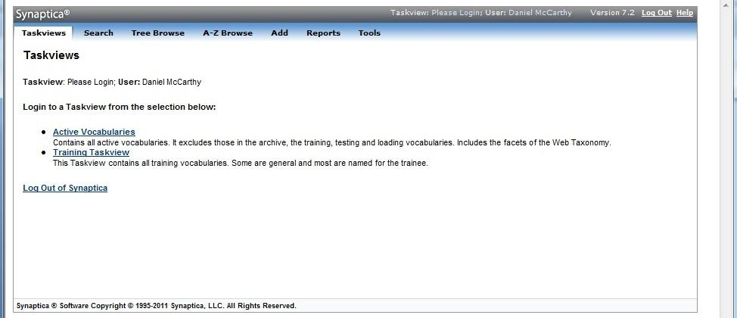

Click on SEARCH in the upper left portion of the screen.

A search form will open in the left frame.

Enter Water in the search box. Choose a Search Mode:
There are six search modes available for creating searches from the most general to the most specific.

- SMART: This mode retrieves all terms that contain words or parts of words entered in the search field (1-3 search terms are allowed).

For example: Entering “water drink” in the search field yields 45 results, including “drinking water,” “Safe Drinking Water Act,” and “Primary Drinking Water Regulation.”
- BEGINS: This mode retrieves all terms that begin with the characters entered in the search field.
For example: Entering “drink” in the search field yields results, including “drinking water,” “Drinking Water Glossary,” and “drinking water supply.”

- CONTAINS: This mode retrieves all terms that contain the characters entered in the search field.
For example: Searching “water” results in “waterbody use,” “waters,” and “watershed.”
- EXACT: This mode retrieves all terms that exactly match the search word or phrase

For example: Entering “watershed” in the search field yields all of the instances of the term “watershed” in the Terminology Services vocabularies.

- RANGE: This mode retrieves all terms within an alphabetical range, and cannot be used with any terms in the search box.

For example: Selecting “G” in the “Begin” filed and “H” in the “End” field yields all the terms beginning with the letters “G” and “H.”
- SPECIFIC UID: All terms in Synaptica® have a UID (Unique ID), which is unique and persistent to the term and its object class across all object classes. This mode retrieves terms based on their UID; if used, all other criteria are ignored when the search is initiated.
For example: Entering “1001180” in the specific UID search field yields the term that has that UID.

Once a search mode has been chosen, Select START SEARCH at the bottom of the page.

A list of terms from all vocabularies in the taskview is displayed on the right side of the page with the vocabulary in parentheses after each term.

Click on a term to view its details, including a definition, if available.

Finding a Term in a Specific Vocabulary

Follow the steps in Section 1.2 above, but prior to selecting the start search button, select an Object Class (Vocabulary).

Select the vocabulary from the list in the middle of the search screen. (To select multiple vocabularies, hold down the control key.)

A list of “water” terms from only that vocabulary/vocabularies chosen is displayed on the right side of the page.
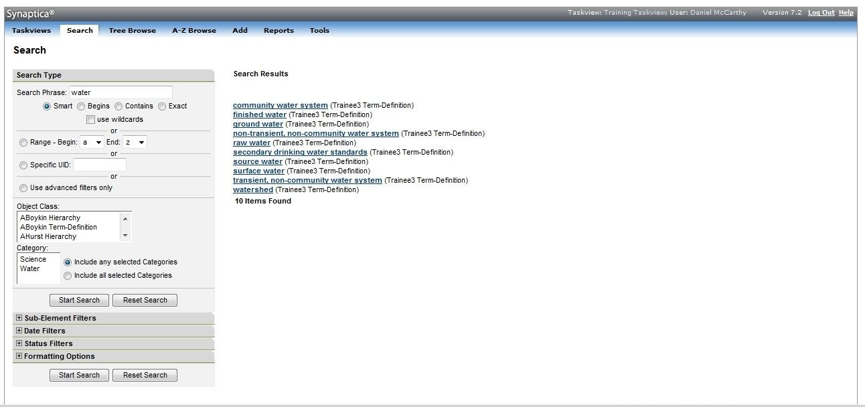

Click on a term to view its details and definition.

Viewing All the Terms in a Vocabulary

Click on the Training Taskview and select your Term-Definition Vocabulary from the list. If you do not find this vocabulary, contact the Terminology Services Coordinator to have it created.
Click SEARCH.

Select the Range search mode, with the default range A to Z.

Click on the Object Class. Select the TRAINING DRINK WATER GLOSSARY.
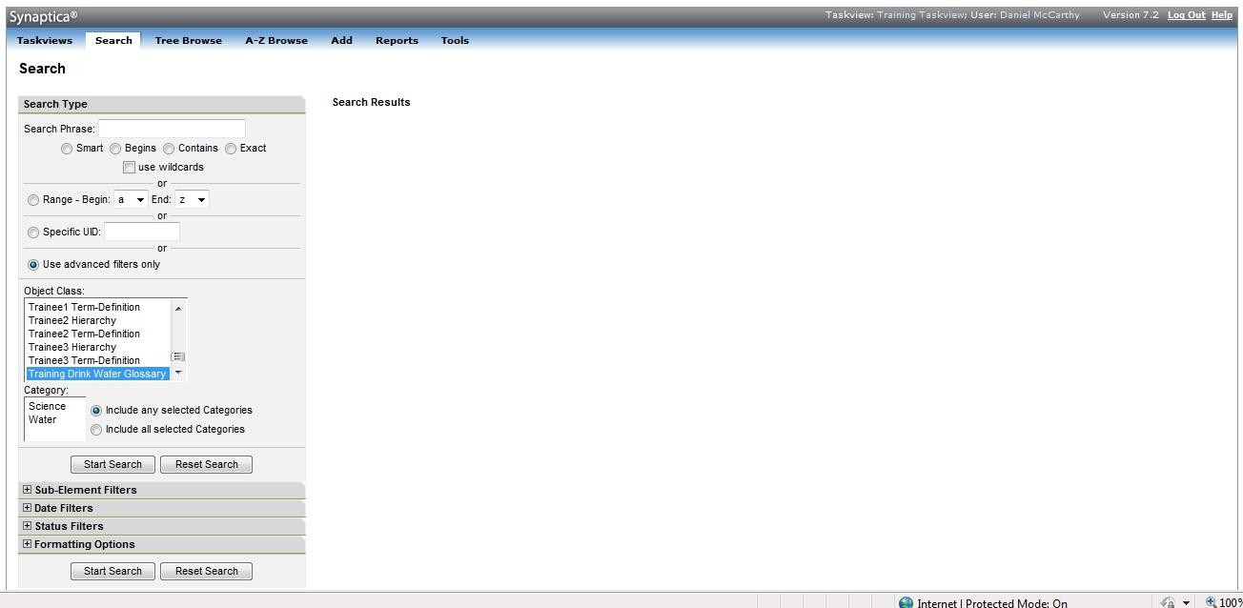

Click START SEARCH.

All the terms in the TRAINING DRINK WATER GLOSSARY are displayed.

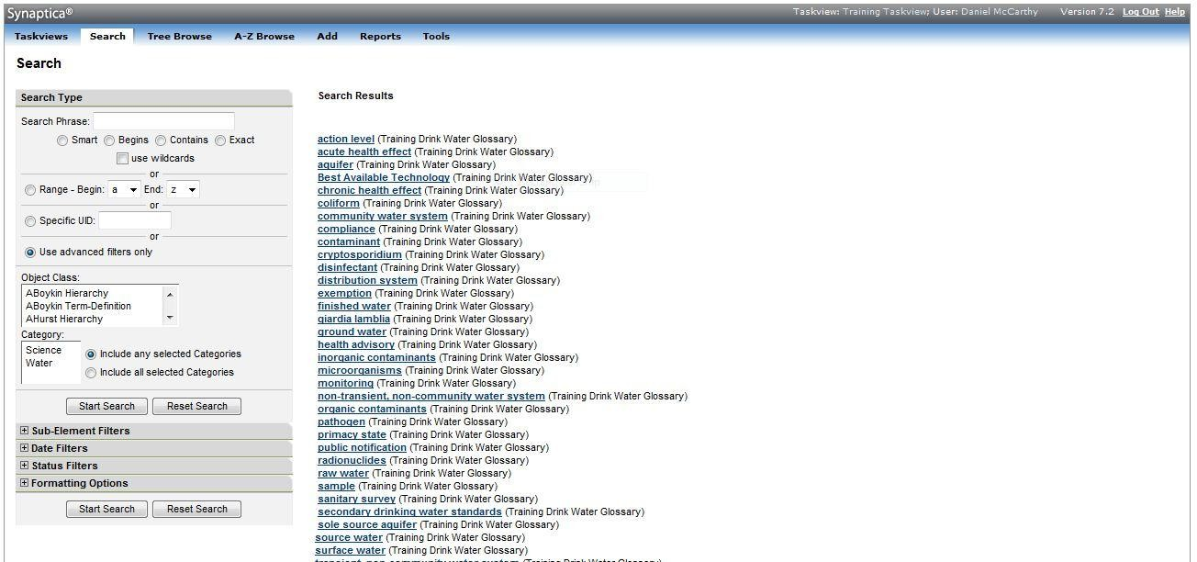

Logging out of a Vocabulary

To log out of the vocabulary and the system, click the LOG OUT at the right upper corner of the screen.

CREATING AND MODIFYING GLOSSARIES AND LISTS OF TERMS & DEFINITIONS
Many of the vocabularies in Terminology Services are simple terms and definitions. These vocabularies may be entries extracted from EPA environmental glossaries, which are terms and definitions in a particular domain.

This training will teach you how to:
    - Add terms and definitions to an existing vocabulary
    - Add definitions to an existing term
    - Delete terms and definitions
  - Adding Terms and Definitions to an Existing Vocabulary Select the Training Taskview.
Click on ADD from the top menu bar.
Select your Term-Definition vocabulary from the pick list. Example: JSmith Term- Definition

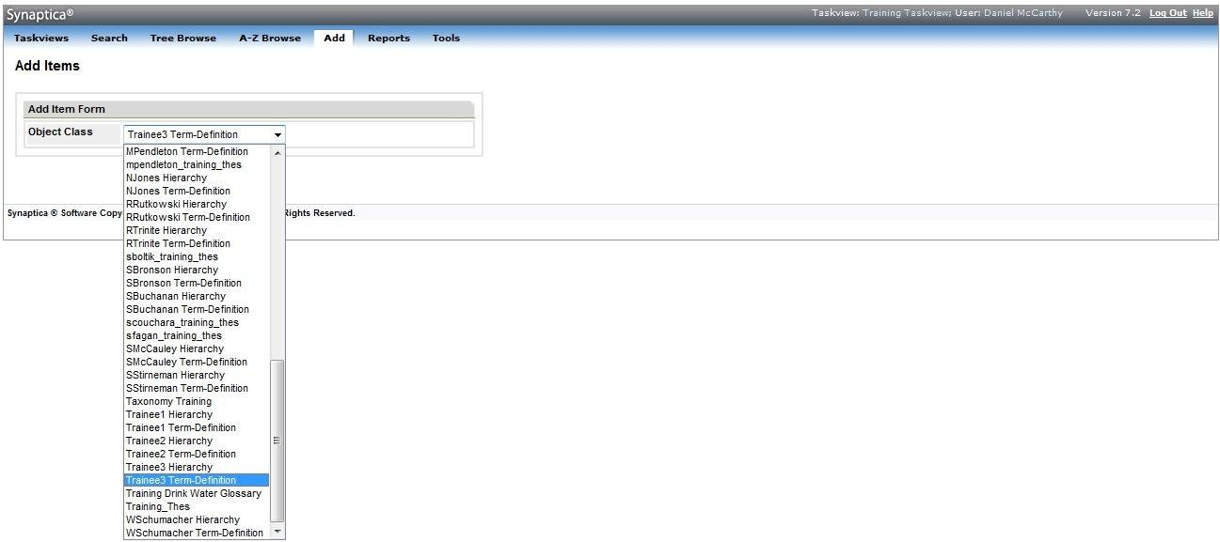

The page will refresh with an Add Items display.

Enter the term into the Descriptor field. For this example, enter Brackish Water.
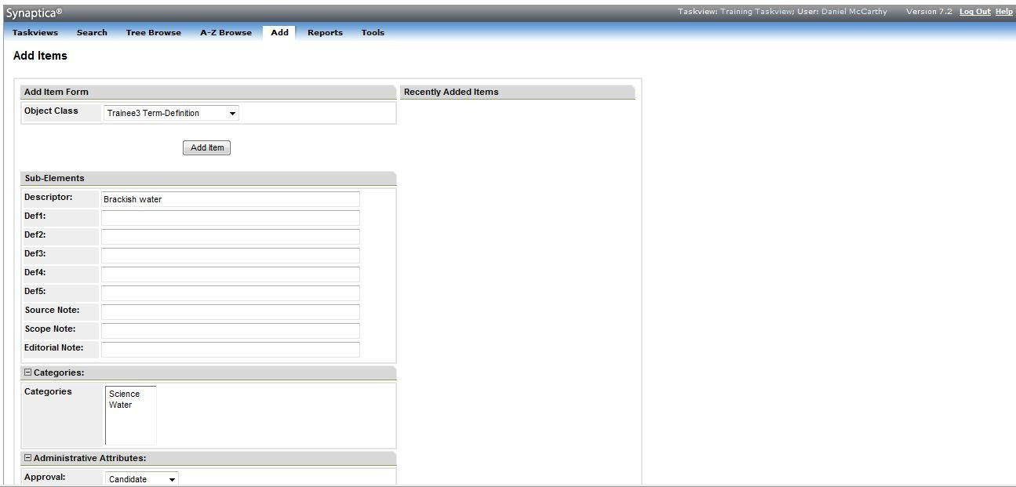
Click on the ADD ITEM button, which is displayed at both the top and bottom of the screen.

If the term already exists in the selected vocabulary, the system will alert you with the
statement: “error - unable to save term. An active term with the descriptor “Brackish water” already exists in the object class”. If you receive this message, check to make sure that you have selected the correct vocabulary (object class) and that you have correctly spelled the term you wish to enter.

Once the term is added, the screen will automatically refresh to show the new term on the Add Items screen. Note that the term is also listed as a “Recently Added Term” on the right side of the screen.
  - Adding Definitions to an Existing Term Select the Training Taskview.
Click on SEARCH.

Enter Brackish Water in the search box.
Select the Exact Search Model.

Select the vocabulary (object class) where the term is recorded (if you know it, otherwise the search defaults to search in all object classes). In this example, select your Term- Definition vocabulary.

Click START SEARCH

All records containing the search term appear on the right side of the page, with respective vocabularies (object classes) in parentheses after each term.

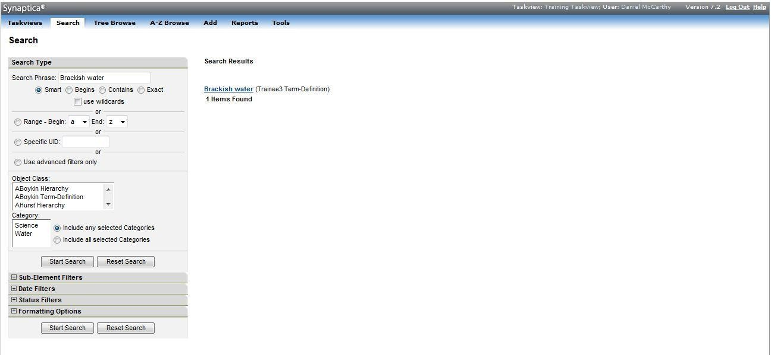

Click on the desired term.

An Item Summary window will appear.
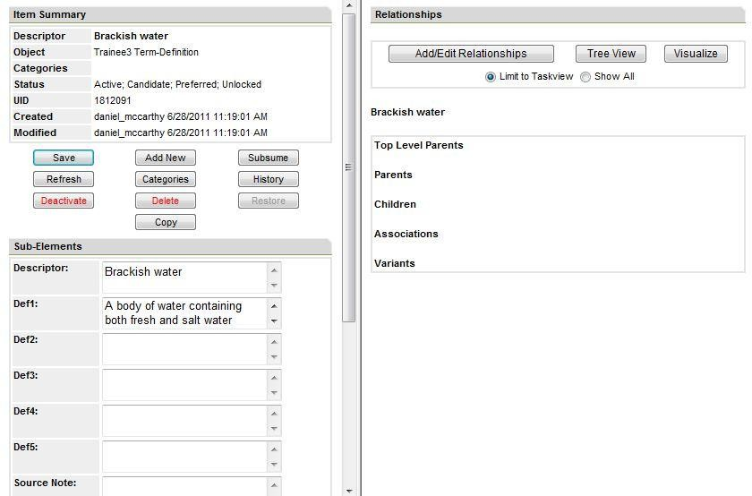

Enter a definition in the Def1 field. For this example, enter “A body of water containing both fresh and salt water.”

Click SAVE.

The definition has been saved when the Modified field has updated to reflect the change.

Deleting Definitions and Terms

To Delete a definition only: Select the Training Taskview. Click SEARCH.
Enter the term Brackish Water.
Select the Exact Search Mode.

Select the vocabulary (object class) where the term is recorded (if you know it, otherwise the search defaults to search in all object classes). In this example, select your Term- Definition vocabulary.

Scroll down to the bottom of screen and click START SEARCH.

All records where the term appears are displayed on the right side of the page, with the respective vocabulary (object class) in parentheses after each term.

Click on the desired term.

The Item Summary window appears.
Insert the cursor into the Def1 field, highlight the definition, right click, and select CUT to erase the text or use the delete button on your keyboard NOTE: Do not click the DELETE button in the Item Summary to delete text in the definition field, as this will delete the term. See below for steps to DELETE the term.

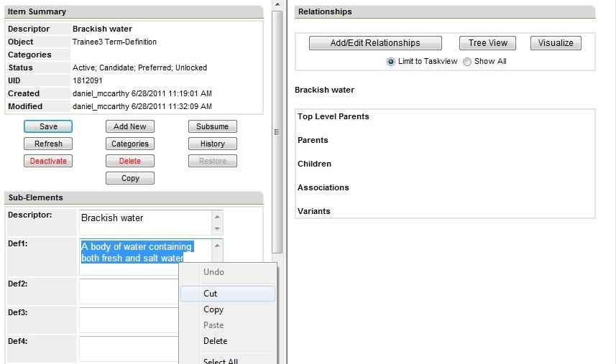

Click SAVE.

The definition has been deleted when the Modified field has been updated to reflect the change.

To Delete a term:

Follow the steps above for locating a term in a particular vocabulary.

Click on the desired term. In this example, select Brackish Water (your Term-Definition). Select the term.
The Item Summary window appears.
Click DELETE. Delete is highlighted in red font on the item summary page. A confirmation message appears.

Click YES to confirm.

NOTE: The term and all its information will be retained in a deleted status. To find deleted terms within an object class, use the status filters under the SEARCH tab, change the STATUS field to DELETED. The deleted terms will appear in the results list. To restore a deleted term to active status, click on the deleted term from the results choose the RESTORE button in the Item Summary. This button only appears in records of terms that have deleted or deactivated (temporarily unavailable) status. Only system administrators can restore deleted or deactivated terms. If you ever have trouble locating a term that you think should be in the vocabulary;

contact the Terminology Services Coordinator to arrange to have a system administrator search for the term in deactivated status. Only administrators can view terms in this status.
  - Adding and Deleting categories to an existing term Select the Training Taskview.
Click on SEARCH.

Enter Brackish Water in the search box.
Select the Exact Search Model.

Select your Term-Definition from the list of vocabularies (object class). Click START SEARCH
All records containing the search term appear on the right side of the page, with respective vocabularies (object classes) in parentheses after each term.

Click on the desired term.

An Item Summary window will appear.

Click CATEGORIES

The right frame will now present a list of categories.
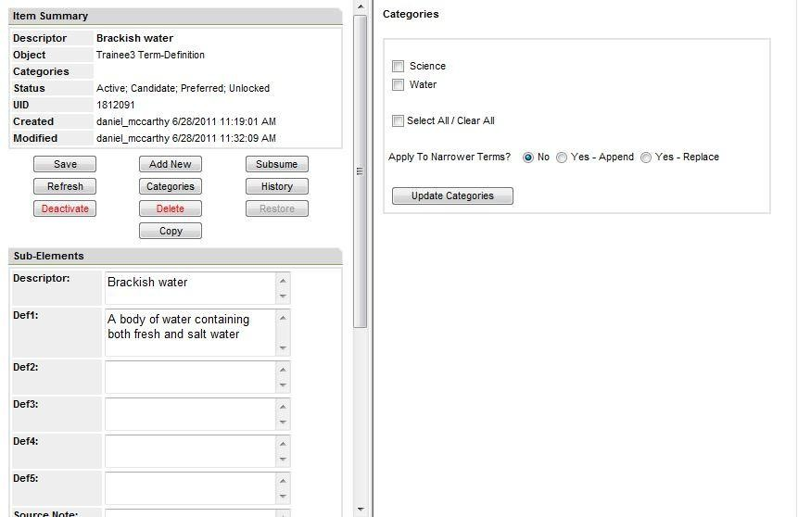

If categories are already applied to the term there will be a check in the box next to the category name. To add a category, select 1 or more categories that apply to the term. To delete a category, de-select the category. Click UPDATE CATEGORIES. The system will refresh.
Click SAVE

CREATING AND MODIFYING TAXONOMIES AND THESAURI
Terminology Services also includes terms in hierarchies, such as taxonomies and thesauri. This training will teach you how to:
    - Add terms to an existing hierarchy
    - Add relationships between terms that are already in a hierarchy
    - Modify relationships

Adding Terms to an Existing Hierarchy

Enter the appropriate Taskview. In this example, click on the Training Taskview.

Click the ADD button.

The page will refresh with an Add Items display.

Select the object class from the drop down. For this example, use your Training Hierarchy.
Enter all of the details for the new term. For this example, use the descriptor name Home Environment and the definition text, “ Environment in the home”.
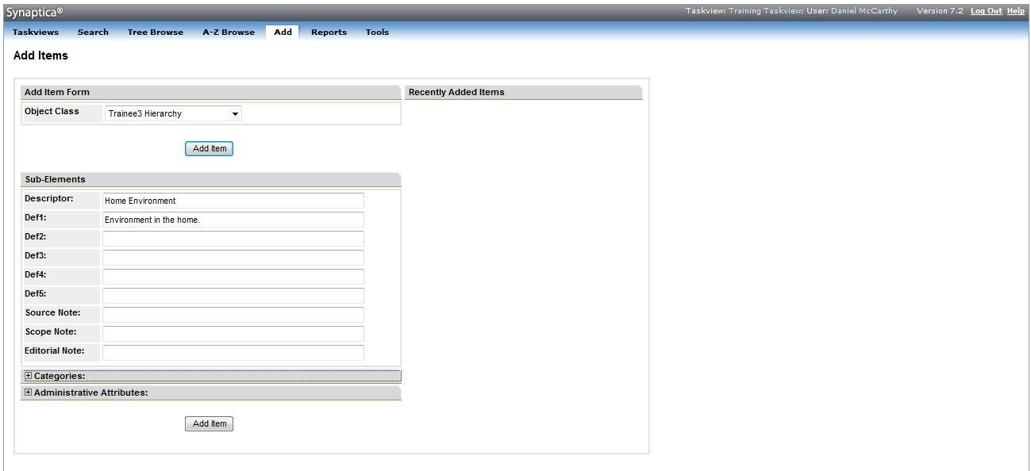

Click on the ADD ITEM button, which is displayed at both the top and bottom of the screen.

The system will check to make sure that there are no duplicates of the new term in the vocabulary before the term is accepted. The screen refreshes to a clean Add Item template with the new term listed as a “Recently Added Item” to the right of the screen. The term may be clicked on to review its record.

Adding Term Relationships

In this example, add the term “Home Environment” in an NT (narrower term) relationship to “Children’s Health.”

Enter the appropriate Taskview. In this example, click on the Training Taskview.

Click SEARCH. Enter the term Children’s Health in the search box. Select your Training Hierarchy from the object class pick list and then click START SEARCH.

The results of the search will appear on the right panel of the screen. Select the appropriate term. An Item Summary popup window will appear.

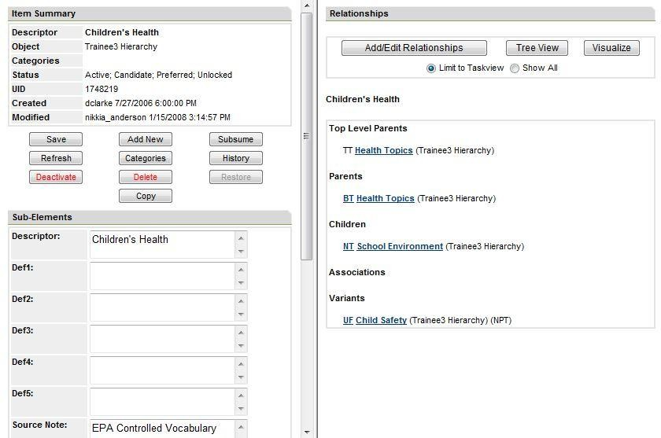
Select the ADD/EDIT RELATIONSHIPS button in the right frame.
Enter the term Home Environment into the search phrase box and click the
SEARCH button. The system will check to see if the term already exists. All records where the term appears are displayed, with the respective vocabulary (object class) in parentheses after each term. If the system finds that the term does not exist, the system will ask if you want to add the term.
Press the Add Item button, or click on the term you need.

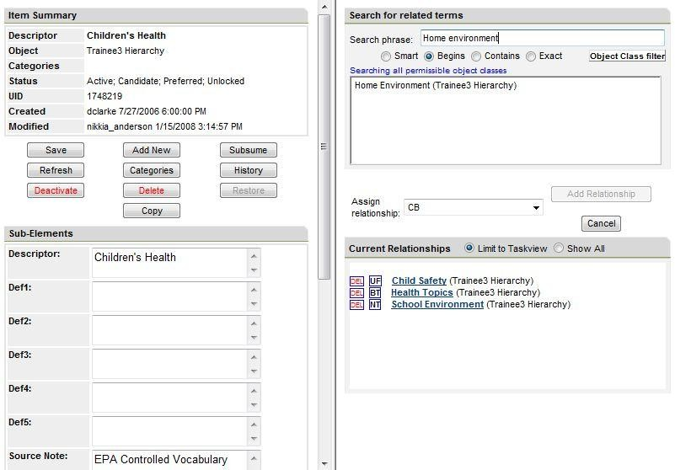

The right frame will now present your options to assign and then add a relationship type.

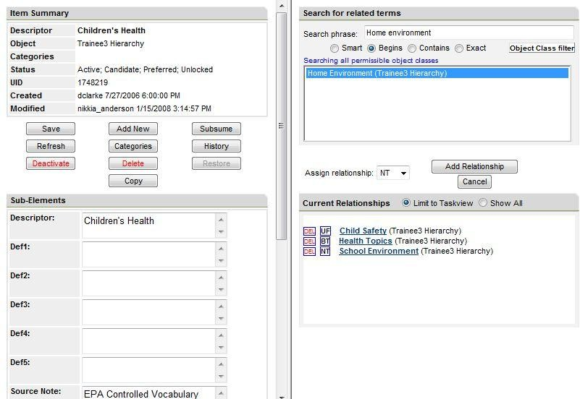

Select the NT (“narrower than”) relationship type and click ADD RELATIONSHIP.

You have now created your first relationship: CHILDREN’S HEALTH NT HOME ENVIRONMENT
To view the changes, click on the term Children’s Health which should be listed under Current Relationships.
The system will automatically build the reciprocal relationship HOME ENVIRONMENT BT CHILDREN’S HEALTH.
To add another term relationship to the term Home Environment, enter another term in the search phrase box and repeat the directions above to choose and add the new relationship.

Modifying Term Relationships

To edit or delete a relationship link for a term, bring up the relevant item in the Item Summary popup window. For this example, bring up the term “HOME ENVIRONMENT.”

Click on the relationship abbreviation for the relationship link you want to change. For this example, select BT (“broader than”).

Depending on the type of relationship selected, a Relationship Edit Options window opens with the appropriate editing fields in the pane.

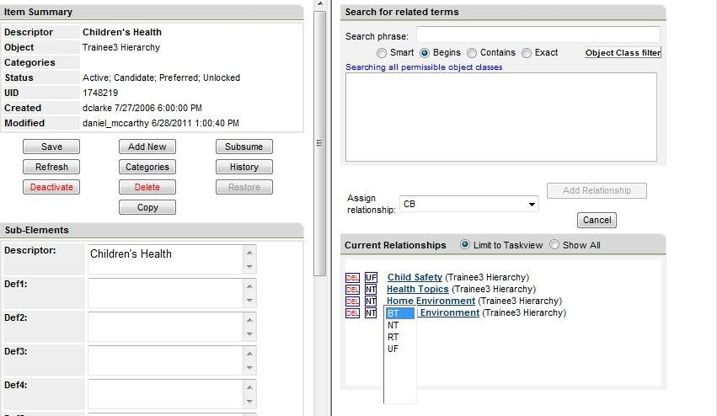

Relationships between terms can be either CHANGED or DELETED.

To Change a relationship:

Change the relationship type and click on the CHANGE LINK button.

For this example, change the BT relationship to RT by clicking on RT and then the CHANGE LINK button.
You will see a prompt asking if you are sure you want to make the change. Click OK.

A screen will appear exhibiting the change you have made. You may click on either term to view more detail, or click REFRESH in the Item Summary.

To Delete a relationship:
Display the term in the Relationship Edit Option Screen as above. For this example, we will delete the relationship between the terms “HOME ENVIRONMENT” and “CHILDREN’S HEALTH.”

Select the DELETE LINK button.

You will receive a prompt asking you to confirm that you want to delete the relationship. Click OK. You will receive a confirmation message that the relationship link is deleted.

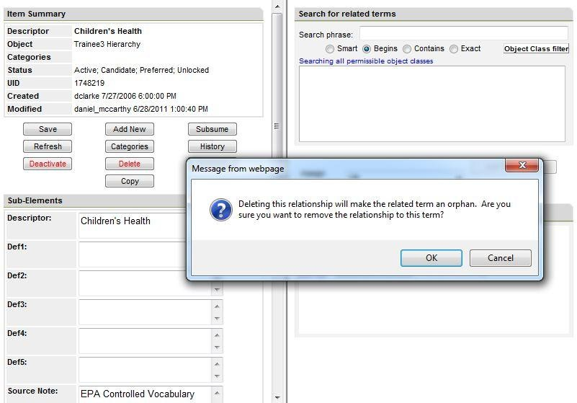

To view the change, click on REFRESH in the Item Summary window.

PUBLISHING A VOCABULARY/CREATING REPORTS
A vocabulary can be compiled and saved on a hard drive for publishing, sharing, or record- keeping purposes. Publishing a vocabulary requires two steps—creating a report and outputting the report in the desired format.

To Create a report:
Click on a Taskview. In this case, the Training Taskview.

Click on REPORTS in the top menu bar.

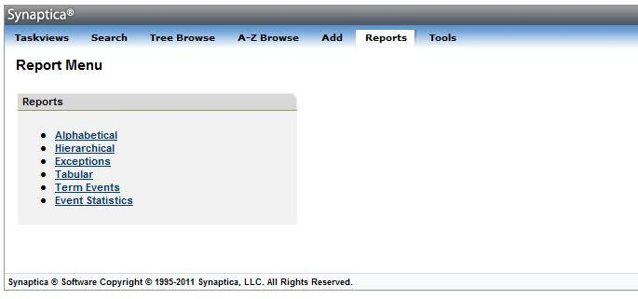

To obtain a glossary and key word list:

Click ALPHABETICAL VIEW from the Reports Menu.

The Alphabetical Report screen appears
Ensure that the “use advanced filters only” radio button is selected.

Select a Vocabulary (Object Class) to output. For this example, select your Term- Definition vocabulary.

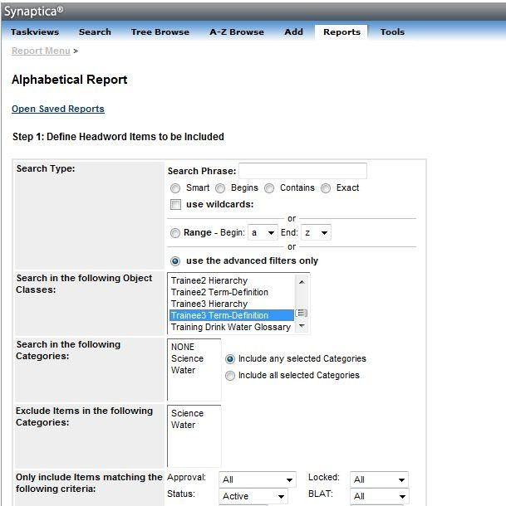

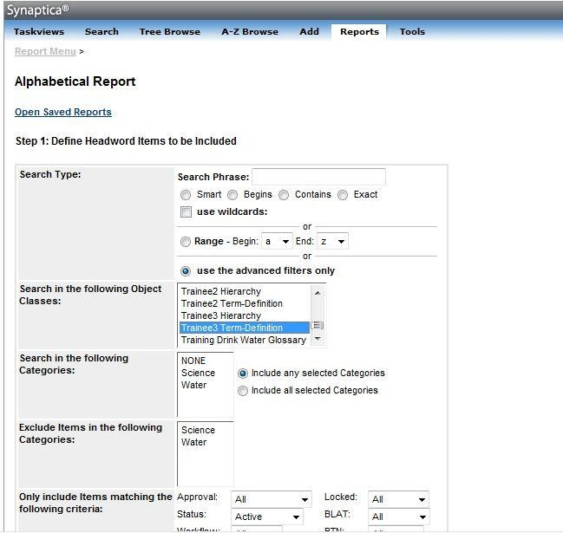

Scroll all the way to the bottom of the page and click CONTINUE.

In Step 5, Click on the “SUB-ELEMENT” field and select the Def1 field to include the definitions of the terms in the output. If you want multiple definitions printed, select one or more of the additional Def fields.

For a taxonomy or thesaurus vocabulary:

Click HIERARCHICAL VIEW from the Reports Menu.

The Hierarchical Report Screen appears
Select your Hierarchy under Object Class in Step 1 and Step 2.

Skip to the bottom of the page and click CONTINUE.

In Step 6, select the sub-elements you would like to include in the output.

For both alphabetical and hierarchical output:

Select HTML as the output format. If the report should appear in plain print format, uncheck the “DISPLAY RESULTS WITH HYPERLINKS” box; otherwise leave the default.
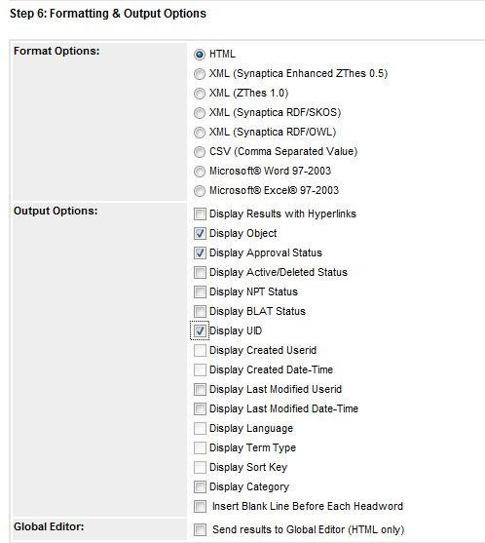

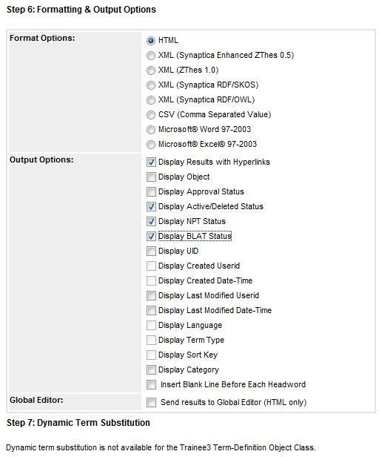
Click the CREATE REPORT button.

The report appears in a new window to the left of the screen.

Outputting the vocabulary:
Output your vocabulary by saving the report to your hard drive.

Select the FILE link on the top of the web browser window containing your report.

Click SAVE AS, browse to the folder where you want to save the file, and enter a name for your report. Ensure the file extension matches the format of your output. In this case,
.HTML or .HTM. Click SAVE.

The file will be saved to your hard drive from which it can be modified, distributed, printed, etc.

Other file formats can be used to distribute the report. For example, the CommaSeparatedVariable (CSV) format can be saved and then imported into an Excel spreadsheet or an Access database. XML can be selected to share the output with another application or for use with style sheets. SKOS (Simple Knowledge Organization System)/RDF format can be selected to interchange the vocabulary with others and to make it accessible via SKOS-oriented Web Services. Microsoft Word or Microsoft Excel are also available. Note: Hierarchical Report output options also include Visualization outputs in Hyper Tree, Word Tree, or Tree Map. Additional information about import and export can be found in the Synaptica Import Guide available from the Terminology Services – Synaptica KMS, select the Tools tab under “Searchable Documentation and User Guides”.

SETTING UP A NEW VOCABULARY
The previous functions have been performed on existing vocabularies. If you need to create or import a new glossary, thesauri, or taxonomy, contact the Terminology Services Coordinator. The Coordinator will add the vocabulary to the Vocabularies file. The Coordinator will provide information on importing a vocabulary into Synaptica.

In addition, the Coordinator will need to know who should have access to the vocabulary and with which permissions. If there are new users who do not currently have access to Terminology Services, the Coordinator will need their contact information and a statement about the reason they will be accessing the system.

