Research Proposal Funding Rates 2015-2016
Funding rates have been calculated from the number and value of research proposals announced or rejected between 1 April 2015 and 31 March 2016. In this period, EPSRC considered 2,425 research grant proposals through peer review and provided funding for 784, giving a funding rate of 32%¹. This amounted to a demand of £1,646 million, with funding of £509 million and a funding rate by value of 31%¹.
Where outline proposals have been submitted (in response to a call for outline proposals) the funding rate is calculated from the number and value of full proposals short-listed after the sifting of outline proposals. The data excludes Fellowship awards and Training awards.
Funding rates (in terms of number and value of research proposals) are presented by Theme; for the total portfolio and for each HEI which has received research grant funding in the financial year 2015-2016.
During the year there was an average of 11 people constrained by the Repeatedly Unsuccessful Applicants policy. At March 2016 the number of constrained people was 12 and the number of people who were close² to becoming constrained was 115.
- Funding Rates by Number of Proposals
- Funding Rates by Value of Proposals
- 2015-2016 Individual Research Organisation Research Proposal Funding Rates

1
Excludes institution grants awarded by algorithmic methods.
2 People with 2 applications that meet the policy criteria.

1

Funding Rates by Number of Proposals
37%
33%
39% 39% 38% 40%
29%
30%
34%
29%
30%
Rejected
Authorised
Challenge
Capability
None
20%
10%
0%
67%
70%
71%
66%
70%
71%
61% 61% 62% 60%
67%
63%
70%
60%
50%
40%
30%
33%
100%
90%
80%
Digital Economy
Energy
Global Uncertainties
Healthcare Technologies
Living with Environmental Change
Manufacturing the Future
Engineering
Information and Communication
Technologies
Mathematical Sciences
Physical Sciences
Research Infrastructure
Quantum Technologies

Challenge
Digital Economy | 37%
Energy | 33%
Global Uncertainties | 39%
Healthcare Technologies | 39%
Living with Environmental Change | 38%
Manufacturing the Future | 40%
Capability
Engineering | 29%
Information and Communication Technologies | 30%
Mathematical Sciences | 34%
Physical Sciences | 29%
Research Infrastructure | 67%
Quantum Technologies | 30%

Funding Rates by Value of Proposals
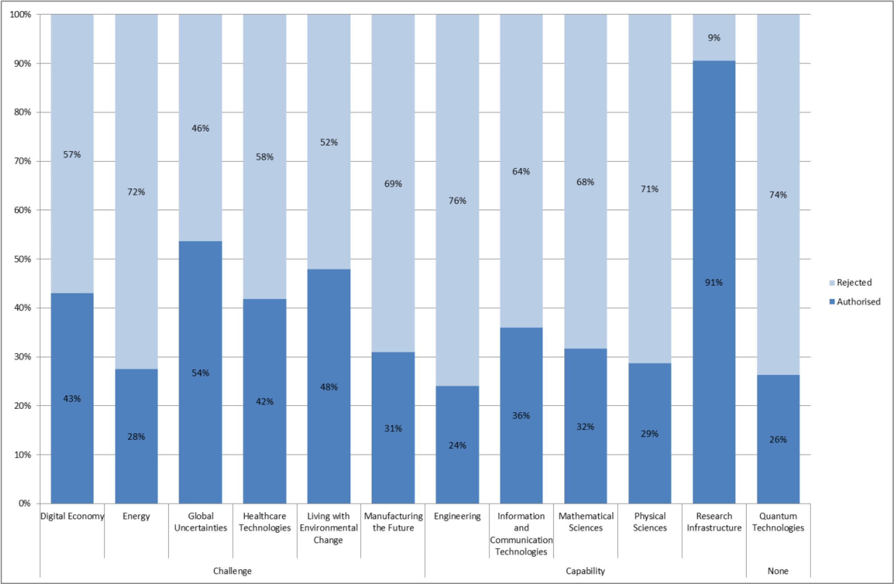

Challenge
Digital Economy | 43%
Energy | 28%
Global Uncertainties | 54%
Healthcare Technologies | 42%
Living with Environmental Change | 48%
Manufacturing the Future | 31%
Capability
Engineering | 24%
Information and Communication Technologies | 36%
Mathematical Sciences | 32%
Physical Sciences | 29%
Research Infrastructure | 91%
Quantum Technologies | 26%

2015-2016 Individual Research Organisation Research Proposal Funding Rates

Organisation | Total number of research proposals  considered | Number of research proposals  funded | % Funding rate by  number | Total value of research proposals considered | Value of research proposals  funded | % Funding rate by value
Aberystwyth University | 2 | 1 | 50% | £334,573.68 | £254,962.64 | 76%
Albert Ludwig University of Freiburg | 1 | 1 | 100% | £89,180.88 | £89,180.88 | 100%
Aston University | 12 | 2 | 17% | £4,994,553.77 | £346,831.95 | 7%
Bangor University | 3 | 0 | 0% | £1,068,149.60 | £0.00 | 0%
Birkbeck College | 3 | 0 | 0% | £686,643.30 | £0.00 | 0%
Bournemouth University | 4 | 0 | 0% | £1,089,512.10 | £0.00 | 0%
Brunel University London | 31 | 7 | 23% | £22,520,533.67 | £11,460,399.18 | 51%
Cardiff University | 53 | 13 | 25% | £24,969,810.05 | £4,594,908.03 | 18%
City University London | 23 | 8 | 35% | £5,878,566.65 | £1,619,610.37 | 28%
Coventry University | 7 | 2 | 29% | £4,320,842.81 | £120,391.41 | 3%
Cranfield University | 22 | 7 | 32% | £13,679,937.86 | £3,808,337.15 | 28%
De Montfort University | 5 | 2 | 40% | £1,690,919.98 | £193,808.22 | 11%
Diamond Light Source | 3 | 0 | 0% | £545,973.33 | £0.00 | 0%
Durham University | 29 | 12 | 41% | £21,503,197.17 | £5,733,818.82 | 27%
Edinburgh Napier University | 2 | 0 | 0% | £694,815.77 | £0.00 | 0%
Glasgow Caledonian University | 3 | 0 | 0% | £1,314,418.14 | £0.00 | 0%
Glasgow School of Art | 1 | 0 | 0% | £187,872.48 | £0.00 | 0%
Glyndwr University | 2 | 0 | 0% | £1,987,997.41 | £0.00 | 0%
Heriot-Watt University | 49 | 17 | 35% | £30,598,364.85 | £9,266,637.70 | 30%
Imperial College London | 153 | 58 | 38% | £118,260,959.71 | £34,342,236.77 | 29%
Institute of Cancer Research | 3 | 3 | 100% | £1,297,380.24 | £1,297,380.24 | 100%
Institute of Food Research | 1 | 0 | 0% | £154,217.41 | £0.00 | 0%
John Innes Centre | 1 | 1 | 100% | £402,975.16 | £402,975.16 | 100%
Keele University | 4 | 0 | 0% | £1,965,908.88 | £0.00 | 0%
King's College London | 46 | 16 | 35% | £19,022,960.22 | £4,402,233.39 | 23%

Kingston University | 1 | 0 | 0% | £193,500.00 | £0.00 | 0%
Lancaster University | 38 | 15 | 39% | £32,563,188.89 | £10,893,836.58 | 33%
Leeds Beckett University | 1 | 1 | 100% | £301,001.25 | £301,001.25 | 100%
Liverpool John Moores University | 11 | 2 | 18% | £1,855,776.55 | £428,941.68 | 23%
London School of Economics & Pol Sci | 3 | 0 | 0% | £2,788,225.68 | £0.00 | 0%
London South Bank University | 2 | 0 | 0% | £748,511.71 | £0.00 | 0%
Loughborough University | 44 | 11 | 25% | £33,888,621.77 | £6,197,487.16 | 18%
Manchester Metropolitan University | 8 | 2 | 25% | £3,132,540.88 | £826,916.75 | 26%
Middlesex University | 10 | 2 | 20% | £2,580,564.09 | £196,793.29 | 8%
National Oceanography Centre | 2 | 0 | 0% | £1,185,015.31 | £0.00 | 0%
NERC British Geological Survey | 2 | 0 | 0% | £4,094,515.05 | £0.00 | 0%
Newcastle University | 65 | 20 | 31% | £46,345,709.08 | £21,296,989.54 | 46%
Northumbria University | 9 | 2 | 22% | £2,749,738.51 | £195,883.78 | 7%
Nottingham Trent University | 9 | 4 | 44% | £2,817,238.09 | £573,598.96 | 20%
Open University | 8 | 1 | 13% | £4,180,629.58 | £30,890.19 | 1%
Oxford Brookes University | 2 | 1 | 50% | £784,335.90 | £150,017.26 | 19%
Queen Margaret University Edinburgh | 1 | 0 | 0% | £25,122.84 | £0.00 | 0%
Queen Mary, University of London | 31 | 9 | 29% | £18,282,056.05 | £3,675,948.85 | 20%
Queen's University of Belfast | 47 | 15 | 32% | £32,365,111.20 | £3,476,313.02 | 11%
Royal Holloway, Univ of London | 10 | 4 | 40% | £6,664,355.16 | £3,072,606.28 | 46%
Royal Veterinary College | 1 | 0 | 0% | £301,509.39 | £0.00 | 0%
Sheffield Hallam University | 4 | 0 | 0% | £1,136,573.22 | £0.00 | 0%
STFC - Laboratories | 4 | 2 | 50% | £4,456,460.05 | £81,839.14 | 2%
Swansea University | 28 | 11 | 39% | £17,045,717.39 | £5,583,710.72 | 33%
Teesside University | 2 | 1 | 50% | £200,363.75 | £100,459.50 | 50%
The Robert Gordon University | 3 | 0 | 0% | £556,921.54 | £0.00 | 0%
The University of Manchester | 92 | 30 | 33% | £68,915,141.11 | £15,063,969.02 | 22%
University College London | 132 | 47 | 36% | £105,629,150.36 | £39,782,360.65 | 38%
University of Aberdeen | 14 | 6 | 43% | £5,270,072.04 | £1,128,517.15 | 21%
University of Abertay Dundee | 1 | 0 | 0% | £35,757.19 | £0.00 | 0%

University of Bath | 54 | 18 | 33% | £37,447,548.49 | £9,768,207.04 | 26%
University of Bedfordshire | 4 | 0 | 0% | £930,073.53 | £0.00 | 0%
University of Birmingham | 67 | 22 | 33% | £56,755,592.81 | £15,786,495.13 | 28%
University of Bolton | 2 | 1 | 50% | £632,294.11 | £99,845.39 | 16%
University of Bradford | 11 | 2 | 18% | £8,522,750.77 | £474,359.82 | 6%
University of Brighton | 6 | 0 | 0% | £2,688,309.84 | £0.00 | 0%
University of Bristol | 47 | 20 | 43% | £39,422,497.45 | £12,461,596.90 | 32%
University of Cambridge | 81 | 29 | 36% | £68,982,020.12 | £21,340,008.26 | 31%
University of Central Lancashire | 8 | 0 | 0% | £1,276,129.62 | £0.00 | 0%
University of Chester | 3 | 0 | 0% | £1,928,893.65 | £0.00 | 0%
University of Derby | 2 | 0 | 0% | £320,058.65 | £0.00 | 0%
University of Dundee | 21 | 7 | 33% | £10,670,087.10 | £3,458,520.59 | 32%
University of East Anglia | 11 | 3 | 27% | £3,317,813.50 | £1,032,510.17 | 31%
University of Edinburgh | 76 | 24 | 32% | £52,576,963.76 | £15,871,511.85 | 30%
University of Essex | 7 | 0 | 0% | £3,909,394.33 | £0.00 | 0%
University of Exeter | 28 | 14 | 50% | £19,855,408.79 | £6,518,677.42 | 33%
University of Glasgow | 48 | 16 | 33% | £48,917,714.48 | £13,824,869.39 | 28%
University of Greenwich | 4 | 1 | 25% | £2,140,663.38 | £100,297.06 | 5%
University of Hertfordshire | 7 | 2 | 29% | £2,723,953.47 | £2,064,322.77 | 76%
University of Huddersfield | 5 | 0 | 0% | £1,977,357.24 | £0.00 | 0%
University of Hull | 13 | 3 | 23% | £4,984,289.78 | £1,089,052.59 | 22%
University of Kent | 16 | 5 | 31% | £5,802,166.73 | £947,031.37 | 16%
University of Leeds | 67 | 18 | 27% | £56,120,219.06 | £20,780,059.19 | 37%
University of Leicester | 17 | 4 | 24% | £8,897,641.07 | £2,894,578.09 | 33%
University of Lincoln | 5 | 1 | 20% | £829,711.14 | £98,742.56 | 12%
University of Liverpool | 51 | 19 | 37% | £41,564,321.93 | £15,916,868.11 | 38%
University of Nottingham | 99 | 33 | 33% | £62,224,787.86 | £21,677,862.21 | 35%
University of Oxford | 79 | 36 | 46% | £72,950,603.34 | £34,037,654.94 | 47%
University of Plymouth | 10 | 2 | 20% | £4,930,180.45 | £899,089.55 | 18%
University of Portsmouth | 8 | 3 | 38% | £2,491,560.95 | £583,176.34 | 23%

University of Reading | 24 | 8 | 33% | £7,049,199.27 | £2,679,525.57 | 38%
University of Salford | 9 | 0 | 0% | £3,590,562.16 | £0.00 | 0%
University of Sheffield | 98 | 32 | 33% | £61,938,778.25 | £18,372,387.49 | 30%
University of South Wales | 1 | 1 | 100% | £79,017.66 | £79,017.66 | 100%
University of Southampton | 104 | 37 | 36% | £83,189,094.95 | £37,736,662.82 | 45%
University of St Andrews | 28 | 6 | 21% | £14,165,587.30 | £1,590,855.84 | 11%
University of Stirling | 4 | 1 | 25% | £786,784.35 | £100,064.16 | 13%
University of Strathclyde | 54 | 16 | 30% | £37,733,977.73 | £10,007,431.94 | 27%
University of Surrey | 58 | 24 | 41% | £41,908,838.70 | £20,439,204.40 | 49%
University of Sussex | 15 | 4 | 27% | £12,635,015.84 | £1,950,969.49 | 15%
University of the Highlands and Islands | 1 | 0 | 0% | £621,231.60 | £0.00 | 0%
University of the West of England | 8 | 3 | 38% | £2,684,134.69 | £822,919.79 | 31%
University of the West of Scotland | 2 | 1 | 50% | £572,533.17 | £290,447.09 | 51%
University of Ulster | 10 | 1 | 10% | £4,094,328.17 | £375,834.63 | 9%
University of Warwick | 71 | 22 | 31% | £37,388,427.00 | £12,183,622.97 | 33%
University of Westminster | 2 | 0 | 0% | £469,468.22 | £0.00 | 0%
University of Wolverhampton | 3 | 0 | 0% | £404,870.33 | £0.00 | 0%
University of York | 28 | 9 | 32% | £30,515,489.92 | £9,575,411.09 | 31%
Total | 2425 | 784 | 32% | £1,645,972,035.41 | £508,921,484.35 | 31%

Data based on the number and value of research grant proposals which were funded or unfunded between 01/04/15 and 31/03/16.

