HEADS UP CONCUSSION ACTION PLAN

IF YOU SUSPECT THAT AN ATHLETE HAS A CONCUSSION, YOU SHOULD TAKE TAKE THE FOLLOWING STEPS:

- Remove the athlete from play.
- Ensure that the athlete is evaluated by a health care professional experienced in evaluating for concussion. Do not try to judge the seriousness of the injury yourself.
- Inform the athlete’s parents or guardians about the possible concussion and give them the fact sheet on concussion.
- Keep the athlete out of play the day of the injury. An athlete should only return to play with permission from a health care professional, who is experienced in evaluating for concussion.

“IT’S BETTER TO MISS ONE GAME, THAN THE WHOLE SEASON.”

CONCUSSION SIGNS AND SYMPTOMS

Athletes who experience one or more of the signs and symptoms listed below after a bump, blow, or jolt to the head or body may have a concussion.
SYMPTOMS REPORTED BY ATHLETE
  - Headache or “pressure” in head
  - Nausea or vomiting
  - Balance problems or dizziness
  - Double or blurry vision
  - Sensitivity to light
  - Sensitivity to noise
  - Feeling sluggish, hazy, foggy, or groggy
  - Concentration or memory problems
  - Confusion
  - Just not “feeling right” or is “feeling down”

SIGNS OBSERVED BY COACHING STAFF
  - Appears dazed or stunned
  - Is confused about assignment or position
  - Forgets an instruction
  - Is unsure of game, score, or opponent
  - Moves clumsily
  - Answers questions slowly
  - Loses consciousness (even briefly)
  - Shows mood, behavior, or personality changes
  - Can’t recall events prior to hit or fall

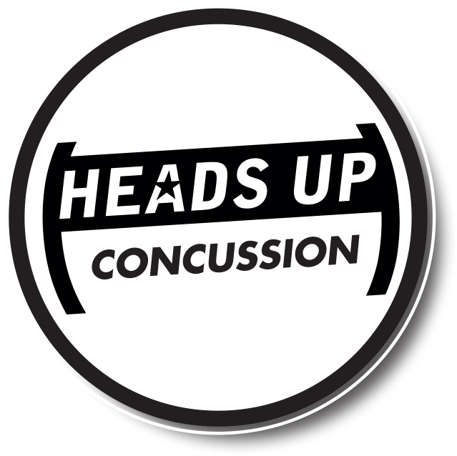
JOIN THE CONVERSATION AT
www.facebook.com/CDCHeadsUp
Content Source: CDC’s Heads Up Program. Created through a grant to the CDC Foundation from the National Operating Committee on Standards for Athletic Equipment (NOCSAE).
TO LEARN MORE GO TO >> WWW.CDC.GOV/CONCUSSION

[ INSERT YOUR LOGO ]

