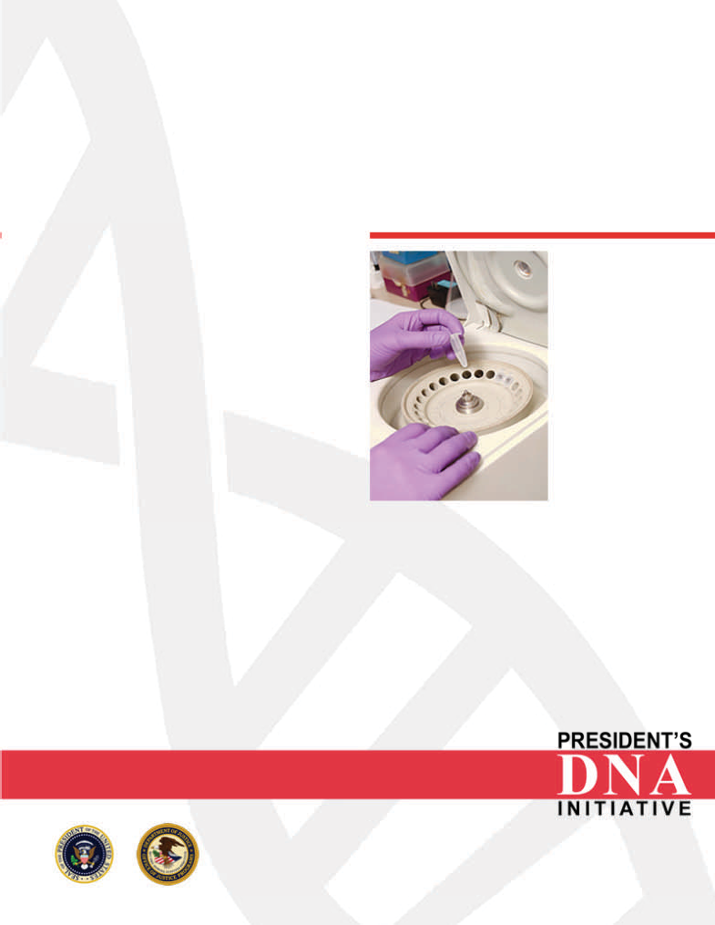

DNA Analyst Training
Forensic Biology Screening Workshop

Protocol 2.18
Leucomalachite Green Presumptive Test for Blood

This laboratory protocol (or part thereof) has been provided as an example of a laboratory SOP, courtesy of the National Forensic Science Technology Center. It has been included for training and example purposes only.

INTRODUCTION
The leucomalachite green presumptive test for blood is a catalytic test which is based on the peroxidase-like activity of hemoglobin. Hemoglobin has the ability to cleave oxygen molecules from H₂O₂ and catalyze the reaction from the reduced form of leucomalachite green to the oxidized blue-green colored product.

SAFETY CONSIDERATIONS

- Hydrogen Peroxide 30% - Danger! Corrosive!

- Zinc powder or dust in contact with water or damp air evolves hydrogen. The heat of reaction is sufficient that the hydrogen may ignite. Therefore, zinc should not be discarded in the wastebasket. The following procedure should be followed for less than 20 grams of zinc dust:

  - Follow standard laboratory chemical handling practices and work in the hood with the hood on, wearing safety glasses and rubber gloves. With the zinc in a large beaker, add small amounts of concentrated hydrochloric acid with a pipette. The solution will bubble and give off heat. Proceed slowly. Allow time for the bubbling and heat to dissipate before adding more acid. Continue slowly adding acid until no more bubbles are formed and no gray powder is visible (about 3 milliliters hydrochloric acid (HCl) for 1 gram of zinc).

  - When all the zinc has dissolved (forming soluble zinc chloride), cautiously neutralize the acid solution by adding small amounts of sodium carbonate. Again, foaming will occur. Continue slowly adding sodium carbonate until no more bubbling occurs (about 2 g. sodium carbonate for 1 gram of zinc). At this point, all the zinc should now be in the form of zinc carbonate, a white precipitate.

  - The zinc carbonate may be filtered out of solution and disposed of in a trash can since zinc carbonate is nontoxic.

PREPARATIONS
Leucomalachite Green reagent Add:
Leucomalachite Green 0.25 g
Glacial acetic acid 100 ml
Distilled water 150 ml
Zinc dust 5 g

Mix, add a few boiling chips and boil under reflux 2-3 hours or until the solution has lost all its color. Cool and decant into a bottle containing some zinc to keep it in the reduced form.

Hydrogen Peroxide 3%

- Measure out 10 ml of 30% hydrogen peroxide
- Add 90 ml of deionized water
- May be stored at room temperature or refrigerated - expiration date one year.

INSTRUMENTATION

  - Top loading balance

MINIMUM STANDARDS & CONTROLS

  - Positive control (known blood stain)
  - Negative control

PROCEDURE OR ANALYSIS
- Swab the suspected blood stain with clean filter paper or a swab, which may be moistened if necessary with deionized water, ethanol or saline.

- Apply 1-2 drops of the LMG reagent.

- Note any blue-green color change. A blue-green color change at this step indicates a chemical oxidant and the test should be considered inconclusive. If there is no color change, proceed to the next step.

- Add 1-2 drops of 3% hydrogen peroxide.

- Note any immediate blue-green color change

- An immediate blue-green color change indicates a positive result. No color change indicates a negative result. A negative result indicates that either no blood is present or is below the limit of detection of the test.

Return to Protocol Index

